Sydling School

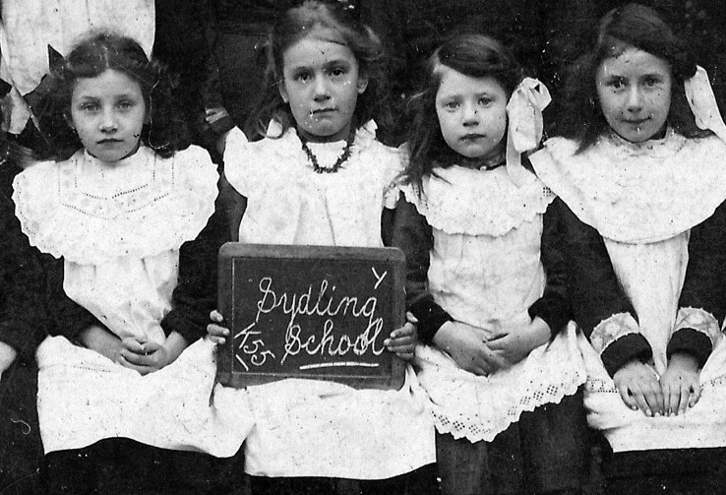

In 1795 John Barber, a poor Sydling boy who had made good in the Isle of Wight, bequeathed the interest on a sum of money to the vicar and church-wardens of Sydling for the maintenance of a schoolmaster to teach children to read and write and instruct them in catechism. Winchester College gave premises for “the Sydling Charity”. A former Dissenting meeting house was converted into four rooms for the use of a master and adjoining room for 120 pupils. They could come at five-years-old on the recommendation
of the minister and were also to be taught arithmetic and needlework. Pupils had to attend Sunday school and church and were not allowed to frequent the Dissenting meeting house.
In 1836 there were 116 pupils on the books and the average daily attendance was seventy. All left as soon as they were able to work. The mistress had held the situation for twenty years and, in addition to her residence, had an income of £20 per year.
The logbooks show that the original purpose of the school was never forgotten.
A report in 1931 declares that “One feels all the time that the scripture period is
the most important period of the day, the one thing that really matters. All of
which is exactly as it should be.” The fees were 2d weekly for those over five years old.

In 1876 the infant mistress had a salary of £9 per annum, also £1 for sweeping the school rooms. The senior monitor was paid £4 per annum and the junior, Charles Spriggs (a well-known Sydling name), £2.8.0d per annum. Sydling teachers had to be hardy. In 1932 there is an entry in the log that the head teacher did not arrive until 9.40 am due to a heart attack.

Children were encouraged to take care of such equipment as was provided. In
1873 a new rule was made that slates and other school things broken through
want of care should be paid for by the children. Great care was taken to
preserve paper from those not considered fit to use it. In 1881 we hear that the
third class, standard one, began to write on paper once a week on
Thursday afternoons.
Arithmetic did not appear to be a strong subject. Take this entry for 1874: “The sums worked very inaccurately, only two out of twenty worked a simple subtraction sum correctly”
Poetry seemed to be the most depressing lesson. In 1889 a popular choice was “The graves of a household” The next year was no more cheery, featuring ”He never smiled again” and ‘A night with a wolf;.”
Needlework was obviously an economical lesson. The Inspector’s report for
1908 commented that in order to illustrate the purpose of patching, a hole should
be cut in the material before putting on the patch. An innovation in 1876 was “moral instruction.” In the first lesson a picture entitled “The Industrious Family” was used. The timetable was altered to make sure the infants did not miss out. Moral Instruction was inserted on Tuesday afternoons instead of singing.

There was no drainage before 1950. Until then the bucket and chuck it method
was used. When drainage arrived, flush toilets and washrooms replaced the iron
sink and cold tap. The new conveniences were very susceptible to freezing. The children were not sent home if the school was frozen up, but only when the Sydling stream became too smelly.

The last headmistress of Sydling School was Isabel Bowring, who took over in 1942, when there were sixty to eighty children, including some evacuees. She was head mistress for 24 years. There were two other teachers, Miss Crabb and Mrs Bastable. The rooms were heated by tortoise stoves burning coke. Meals were cooked in Cerne Abbas and served at the bakery over the road, and later in the village hall, which was also used for drama and physical education. The school closed in 1966, becoming an artist’s studio and eventually a domestic dwelling. Mrs Bowring, still lived in the village until 1993.

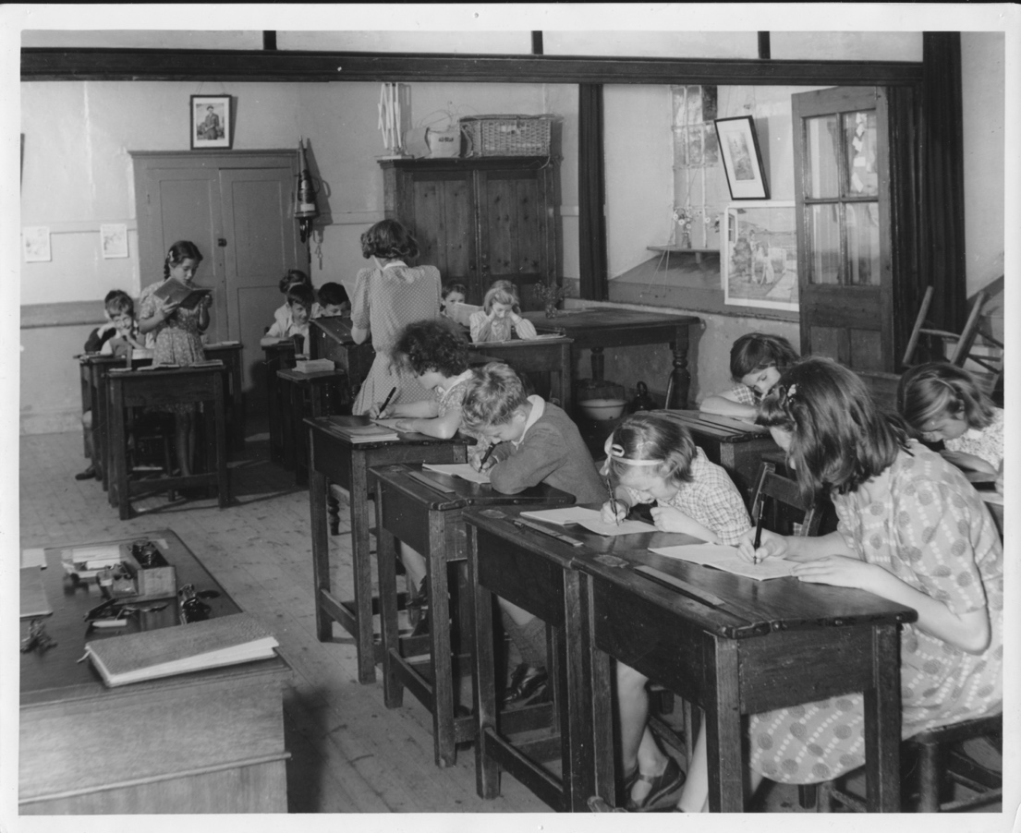
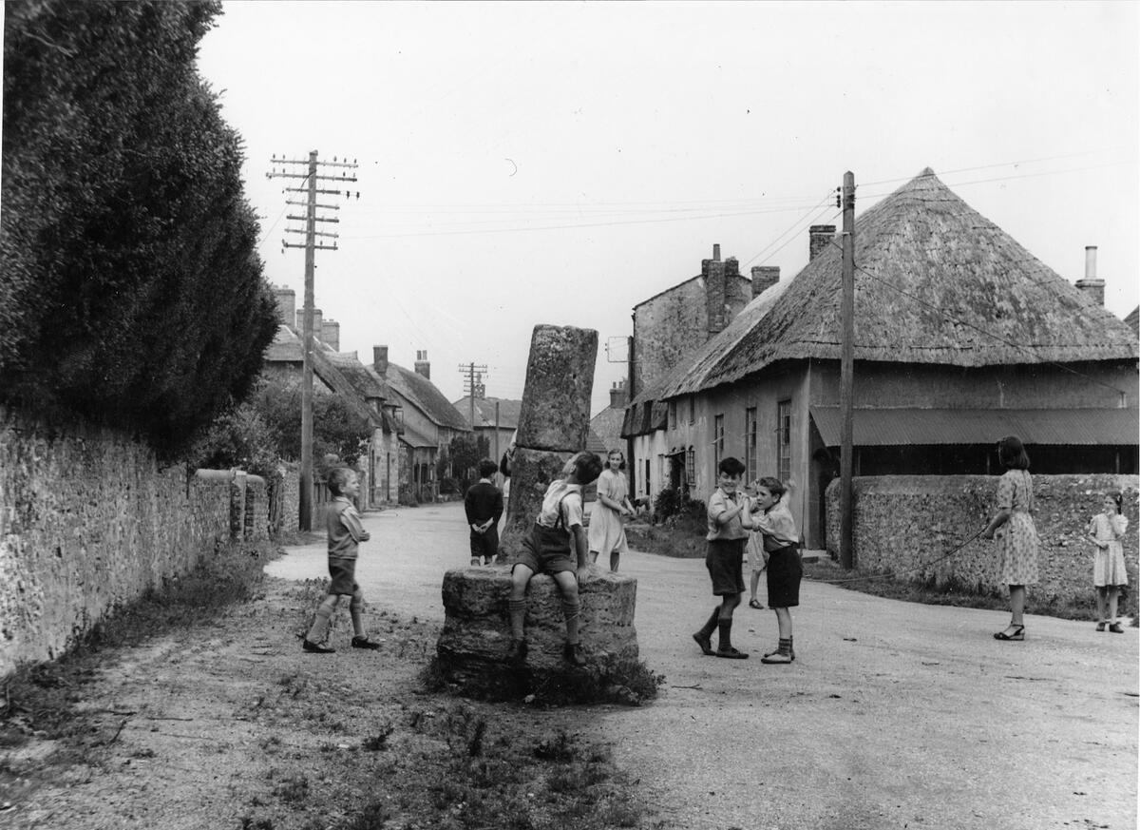

Above: Children playing outside the school
Below: The Old School today



Extracts from School Inspectors’ Reports and School Logbooks

Below are a selection of entries over a 70 year period, which give a good, often humorous overview of life for children at the time. They feature death from infectious disease, poor sanitation, poverty and a good dose of Victorian and Edwardian morals. But also childish misdemeanours, school absences at haymaking and harvest time, and a good smattering of familiar old Sydling names.

1873
Oct 8. Commenced teaching Grammar – a subject not before taught at the school.
Oct 22. Object lesson on candles which the children appeared very much interested
it being the first time object lessons had been introduced at the school.
Oct 30. A new rule made that slates and other school things broken through want of
care should be paid for by the children.

1874.
Nov 30. Elder children taken to church in the afternoon – day appointed for special
prayers for ministrations to the heathen.
Dec 2. Geography lesson substituted for one on the Bear. The lesson suggested by
a Bear pausing in the village a few days ago.
March 23. The children remained an additional 20 minutes in the
playground to give them an opportunity to see the Hounds which met at Sydling
Court.
July 7. Fred Croad (left school April 5 to work) has been troublesome and
disobedient since his return to school. This morning he was corrected and punished
for idleness in attention and disobedience when he attempted to kick the mistress.
He was sent home. His mother was sent for but did not come. The boy is to be
expelled from the school.
Nov 12, 4 boys kept back after 12oc to write 40 lines for absenting themselves from
school the previous afternoon. “A Show” was staying in the village which tempted
them to stay away.

1876
September 29, Miss Harn resigned her post as teacher in the infant class. Her place
to be filled by Eliza Smith for 3 months on trial.
Oct 4. The first lesson in Moral Procrastination’

1877
Jan 15. Readmitted, Alfred Croad who has been working nearly 2 years, readmitted
also younger brother, Charles, same day.
July 4. The elder boys irregular in their attendance owing to haymaking.
Sept 10. School re-opened – several children absent due to harvest not being over.
The school fees raised to 2d per week for scholars above 5 years of age.
Oct 2 Several scholars absent taking up potatoes.

1879
Bessie Churchill has been absent from school three weeks ill with brain fever.
March 31. Bessie Churchill died Saturday March 29
May 27. James Thomas punished for tearing arithmetic card in two – corporal
punishment not needed for 18 months.

1880
July 5. On account of the continued illness of the mistress, the school was closed
and the holiday was given now for one month instead of August as in former years.
Sept 3. Still smaller average attendance during the harvest and gleaning.
Sept 21. At the request of the School Attendance Officer made out a certificate to be
shown to the Magistrates certifying that Fred Critchell has not attended school since
last April.

1881
Feb 8. Commenced learning the song, “God bless the Schools of England.”
Feb 22. Frank Hyde in the Infant Class died from Whooping Cough and
was interned today.
March 14. Alice Dubbin left school – gone to America with her sister.

1882
May 8. William Spriggs, Junior Monitor, and Samuel Spriggs left to go to America.
June 30. The average attendance low. Some children absenteeism account of hay
making.
October 24/25. It has been necessary to close the school 2 days on account of the
floods. The first day, the schools were under water and the 2nd day they were far too
dangerous to be used.

1883
July 20. George Critchell sent home again because his brother Fred is sick with
Scarlet Fever. Sent home Charles Skinner who has ringworm and Theresa Croad
who is suffering from Mumps.
Sept 17. Re-opened school after the harvest holidays. A very few children present as
the harvest not yet over.
Sept 24. Some children who have returned this week seemed to have forgotten a
great deal.
Nov 7. Edith and Elizabeth Hansford having missed bringing their school money for
several weeks were sent home for it but did not return.
Dec 19. The numbers have rather fallen off since the rule of sending children home
who come without their school fees has been strictly observed.

1885
Sept 21. Albert Croad severely punished for impertinence and attempting to rush out
of school during a lesson.
Sept 28. The boys are so troublesome this week – rudely answering under breath
nor so frequently heard as before.

1887.
Nov 9. Alice Long Standard III died shortly after leaving school on Wednesday –
cause of death apparently certified to be an Epileptic Fit.
Nov 14. School dismissed at 3oc to attend funeral of Alice Long.

1888
Feb 13. Snowfall – so few attended that it was decided to close.
May 14. Tom Woodford aged 9 died on Saturday.
Nov 5-9. Began on Monday in this week to close books at 1.45pm as there is no
artificial light and dark comes too early.

1889
March 29. Sent a list of 25 absentees to the Attendance Officer.
April 8-12. The Attendance Officer has not yet looked at up the absentees. Dr Kerr
refused to send the school clock to be repaired as it cost 3/6d a year ago.
May 20-25. The Attendance Officer called and took away a list of 25 absentees.
June 3-7. The school became flooded and it was sometime before we could be reached
from outside but owing the goodness of Mr Stroud in sending a waggon and horses
the children were all conveyed to their houses.

1890
July 17. School Attendance Officer has not visited the school for months, the
mistress wrote to him concerning 3 children who were absent and has received no
reply. Rev.Blandford has written since and still no reply.
July 25. Attendance poor this week. Many children employed in haymaking.
July 31. Received letter from the School Attendance Officer to say he would look up
the absentees if I would forward the names again. This is the 4th time the names
have been sent.

1891
July 24. Children are wanted at home to carry refreshments to their parents working
in the hayfields.
Sept 21. Admitted Fred Barker aged 6 and does not read his letters.
Nov 27. Legg of Up Sydling still very irregular

1892
Poetry – Standard I : “All things bright and beautiful.”
Standard II: “A night with a wolf.”
Standards III & IV: “Nelly’s shilling.”
April 8. Emily Bowring resigned this afternoon.

1894
Jan 18. Up Sydling children absent, roads are flooded.
Feb 8. All boys present except for Lovell – he’s absent with toothache.

1896.
Nov 6. Attendance poor as many of the older boys had asked permission to go
hunting.
Nov 20. Visiting of Lord Archbishop of Salisbury. His Lordship wished to hear the
children sing the song “We’re that’s gay and happy.”

1897
Dec 20. Two returned after 13 weeks absence with Typhoid Fever.

1898.
Jan 4. Percy Spriggs returned to school after 9 weeks illness and Charles Legg after
an interval of 6 weeks.
Jan 31. Eliza Legg returned after 12 weeks illness.
June 24. Received notice that Cerne School committee have decided that children
under 13 must obtain a labour certificate before leaving school.

1899
Feb 14. Several children absent at Dorchester Fair.

1901
March 8. Mr Sherry, one of the school managers detained his boy Ernest from the
school because he had been caned during the morning for an alleged slight offence.
I told him that I, who saw the offence was the best judge of whether the boy
deserved caning or not and that he had no right to keep him home without consulting
me.

1902
June 25. Closed the school for 2 days on account of the Coronation.

1904
May 19. 3 children sent home by doctors’ orders as their brother had Diphtheria – he
has since died.
Sept 16. Reg Thomas absent through Typhoid Fever.

1906
Jan 7. Resumed work having been absent through Typhoid Fever.
Feb 15. Several children absent through Ringworm

1907
March 22. The Sanitary Inspector inspected the WC’s
Apr 8. The offices need attention. The girls’ offices are directly over the stream which
runs through the village and the boy’s small stone urinal also drains into it.
The boys’ privy is dark and unventilated but apparently does not drain into the
stream.
The girls’ closet should be moved and the privy given light and ventilation.
Sept 27. Boys’ new urinal installed.

1909
The girls’ urinal contains 2 unreported seats adjoins the infants’ classroom and the
teacher complains of the smell. The fire in the infants’ room is not properly guarded.

1910
April 13. Three children left for Canada,
Jun 16. Coronation holidays began.

1913
24 Apr. Report: This is a noisy school – the freedom with which they chatter and
move about is sometimes disconcerting… the girls with 2 or 3 exceptions are quite
silent while the boys shout out the answers.

1914
Oct 3. The children have collected £3 for wool and are knitting for soldiers.
Oct 15. Fire first lighted.

1916
March 20. Boy fined 2/6d for bad attendance.
Sept 8. Nellie Huriworth absent this week with a poisoned finger contracted from the
dressing of wounded soldiers at Holnest Red Cross Hospital where she spent her
holidays
Nov 8. P.T. Leslie Sherry awarded the Military Medal for bringing in wounded under
fire.

1918
Oct 18. Influenza – sent notice of closure.
Oct 21. Closed.
Nov 4. Reopened – attendance normal.

1919
Aug 1. Closed school for 6 weeks – an extra week given for Peace Celebration.
Oct 28. Girl taken to Poor Law Institution while the mother is in prison for 2 months
for neglect of her children.

1921
May 4. One child excluded 5 times.
May 26. Inspector of P.C. to children called to see the child who has been so many
times excluded.
Sept 27. Health Visitor – every child present and examined. No one excluded “a
remarkably clean school.”
Nov 29. Term Exams are being held early this year for fear of closure for fever.
Dec 21. Poor attendance – 7 children excluded for Scarlet Fever.

1923
Jan 8. The closets have been provided with buckets and the girls’ closet partitioned
off during the holidays.
Sept 19. Punished a boy for molesting a girl on their way home – 4 strokes.

1925
July 21. School closed all day for Village Pageant to celebrate the 1,000th
anniversary of the opening of the church.

1926
July 27. Tank provided to hold drinking water for the children.

1927
Jun 30. A stack on Sydling Mill of thatching reed was destroyed 22 June by fire. The
local constable visited the school today for information. All scholars were exonerated
except Maurice Bugler 17, who lighted a small fire at some distance from the stack.
The damage is considerable.
E.Hawkins of Court Farm has kindly placed a playing field at the disposal of the
school.
Jul 6. The local constable called to enquire about windows broken at the Chapel.
Dec 8. Ian Wellspring received two strokes this morning on the same hand the wrist
of the other hand being hurt.
Dec 9. Mrs Wellspring came into school this morning without permission and used
abusive language… I requested her to leave the school premises. She refused to do
so and continued using violent and abusive language. I referred her to the managers
for further information regarding my duties as Head Mistress.

1931
Jan 9. Dec. scripture report “It is a great pleasure to get into a school where the
teaching of the faith is regarded as the most the most important part of the day’s
work.”
Mrs Diment Bowring died suddenly this morning Diment called to ask me to break
the news to 3 children in the school.
Jan 26. A representative of Horlicks Malted Milk called to explain the firm’s school
scheme.
Feb 12. Received 4 dozen mugs and mixer, an oil stove and a 20s tin of
Horlicks… and started serving Horlicks this morning break at 1/2d per child, per day.
Nov 23. Cyril Davey jumped off the playground wall and fell on Ronald Pitts whose
head was hurt. Ronald went home and fainted.

1932
Jan 25. Jack Durden, six and a half, said he had swallowed a small tin whistle in the
playground this morning.
Jan 27. Mrs Durden sent a message that the whistle had been recovered having
passed through the child.
Feb 3. Head Teacher late – arrived about 9.40 am due to heart attack.
May 25. Empire Day… at 3pm Major Miskin gave an address about India and
brought Indian weapons and Idols for the children to see and handle.
June 7. C and W.Davey left because family have been admitted to Dorchester Union
for a time for family reasons.
Nov 10. Charles Hansford reprimanded in front of school for cutting off half a kitten’s
ear with scissors. Later warned not to associate with Cyril Davey.

1936
Sept 7. During holidays new offices have been erected in the girls’ playground.
Nov 16. I caned C.Davey for repeated disobedience and disturbing the whole class.

1937
Feb 5. At 11.50am I sent ………. (14 yrs 4 mths) home from school. He had done
nothing since 11.30 and is a bad influence. I readmitted him at 1.30pm.

Sept 30. The Attendance Officer called for Margaret Gayland, who milked 7 cows before
school in the morning. She leaves school with the other infants at 3.35 pm.
Both she and her father admit she can and does milk in the afternoon “when she
likes to.” Letter said she left at 3.30 pm. Knowing the complaint was sent by the
school manager.

1938
June 30. This afternoon the Police Sergeant at the school in consequence of a letter.
I wrote to the Superintendent reporting …….. for immoral conduct with a pig. I gave
him a signed statement made to me by an eye-witness

