Carlisle Canal (1823-1853)
The River Eden although partly navigable is tidal and during low tide Carlisle is not able to be reached by large ocean going ships. Plans were put in place to build a canal between Carlisle and the Solway in the first instance and then to connect this canal from Carlisle to the River Tyne on the East coast at a later date this never came about.
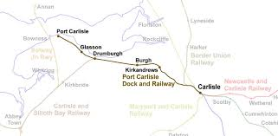
Map of the route of Carlisle Canal
In 1819 a port was constructed at Fisher’s Cross, later called Port Carlisle and in 1821, the Carlisle Navigation Canal was built to take goods to Carlisle. In 1823 the 11.25 mile route from Carlisle Basin to Port Carlisle was opened. The finished lock had a total of 8 locks which were 60 feet along and the canal was able to accommodate sea going ships from 80 to 100 tons. The canal was 18 feet 4 inches wide and 8.5 feet deep, fell a height from Carlisle to the Solway by 70.5 feet. The ships were pulled along the canal by horses.
Initially the canal was successful with ships carrying cargo of timber, bricks, coal, iron, slates, salt and the exports of grain, flour, meal, oak bark, alabaster, freestone, lead, staves. The cotton wool manufactured here is brought chiefly from Liverpool, processed in Carlisle and then exported. A custom-house and spacious bonding warehouses, for wine, spirits, groceries, and tobacco, were erected at the canal basin.

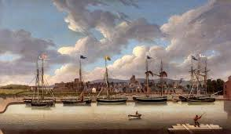
Painting of view of sea fearing ships along the River Eden and in Carlisle Basin.
In 1825, a proposal was made to build a railway between Newcastle and Carlisle, one of the first railways in the world. This ended the proposed plan of extending the canal from Carlisle to the east coast.
In 1826 a packet service began which became very popular and a hotel, the Solway, was built at Port Carlisle to accommodate the passengers. The Carlisle to Newcastle railway was opened in 1839 and was extremely profitable.
By 1845 the canal had becomes less profitable as other railways in the area were taking custom. It was decided to build a new railway on the bed of the canal. The canal was closed in 1853 and much of it was in-filled by the Port Carlisle Railway Company who constructed a railway.

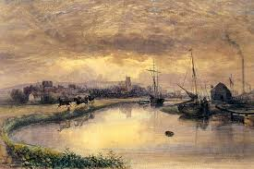
Painting of view of sea fearing ships along the River Eden and in Carlisle Basin.
Little of the features of the canal remain today as many were destroyed in order to construct the railway. The canal bridges that were retained were raised to accommodate the extra height of the railway trains. Several buildings and structures associated with the canal workings still survive for example a lock cottage and a warehouse. At Ratlingate, Ratlingate Farm House used to be a manure and bone works and a varnish works. In Ratlingate wood some of the structure of the reservoir remains. The reservoir would have fed water into the canal to replace water as the ships entered and exited the locks. The control value for the reservoir still exists in the scout campsite. In Port Carlisle, the Solway Hotel is now Solway House a residential property. Also at Port Carlisle remnants of the old sea lock can still be seen.
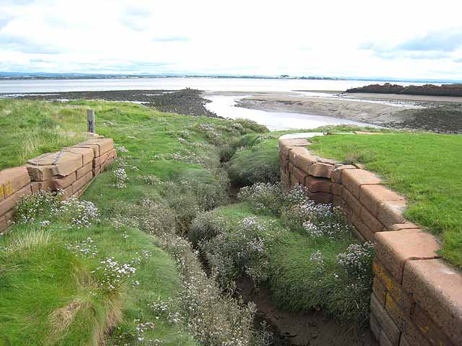
The old sea lock at Port Carlisle

