An obituary of Margaret Vickers, a community lady devoted to Guides
Written by David Guide in News and Star on 9th December 2005

AN ENTHUSIASTIC and very active Girl Guide over many years, Margaret Vickers became the movement’s county commissioner for Cumberland and its area camp adviser for North West England.

Her hard work in administration will be remembered by many and so will her more hands-on role as hostess when Guides camped at her own home, Braelees, in Kirkandrews-on-Eden.

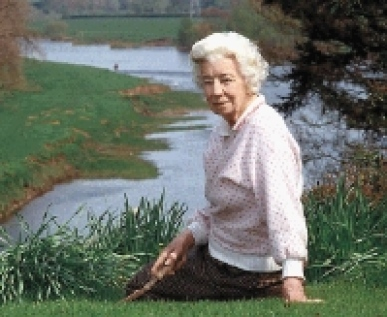
Devoted to Guiding as she was, she still found the time to serve her community in other ways and was awarded the OBE for her efforts. She was a founder member of the Women’s Institute at Kirkandrews-on-Eden and was County WI chairman from 1965-72, before becoming county president from 1980-82. She represented the county WI federation on many public committees.

Appointed a magistrate in 1960, she soon became a much-respected figure on the Carlisle bench.

When she was very young, she moved with her family from County Durham to Cumberland where she lived in Wetheral and, from 1925 onwards, in Kirkandrews on Eden.

A gifted artist, needle-woman and a knowledgeable gardener, she played an active part in the life of the village and in that of the church at nearby Beaumont. Many years ago she officially opened the Kirkandrews-on-Eden Village Hall.
She was also godmother to wine expert Jancis Robinson whose family she was great friends with.

Miss Vickers was 101 when she died in the Lanercost House care home, where she had lived for the past six years.

Her funeral service and interment took place at St Mary’s Church, Beaumont, with George Hudson and Sons, Carlisle, making the arrangements.

