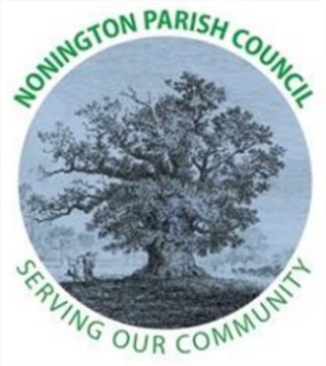
NONINGTON PARISH COUNCIL

ANNUAL MEETING OF THE COUNCIL (AGM)

6th May 2026 at 7pm
Nonington Village Hall

AGENDA

- ELECTION OF CHAIRMAN AND VICE CHAIRMAN FOR THE COUNCIL YEAR 2026/27

- THE CHAIRMAN’S WELCOME AND APOLOGIES FOR ABSENCE

- DECLARATIONS OF INTEREST

- REVIEW OF PREVIOUS ACTION POINTS

- PUBLIC FORUM: The chairman will invite any members of the Public in attendance to ask questions or make statements.

- FINANCE:
  - Accounting Statements for 2025/26
    - Annual Income
    - Annual Expenditure
  - Payments and Receipts:
    - Precept received of £14,050 on 8th April 2026.
    - Bank Balance as of 26th April 2026: £33,726.68 (£14,991.91 current account and £18,734.77 savings account)
  - VAT Reclaim due to be submitted of £1054.99
  - Grants Paid
    - FONC - £200
    - Nightingales - £200
    - Village Hall - £200
    - Nonington Parochial Church Council - £200

- ITEMS FOR FUTURE DISCUSSION

- CLOSE

