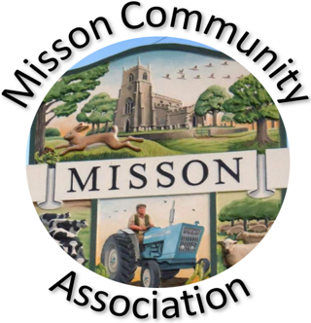
MISSON COMMUNITY ASSOCIATION

MINUTES OF AGM 19TH MARCH 2025

COMMITTEE MEMBERS PRESENT

Janis James (Chair & Trustee), Andrew Oldham, Michael Cooke, Spencer Robey (Trustee), Sue Scott, Sue Howard

OTHERS PRESENT

Reg Threlkeld, Wendy Threlkeld, Andrea Wilcox, Joan Challoner, Barbara Law, Jan Robey, Keith Howard, Susan Scott, Janis Butler, Michelle Thompson, Paul Thompson, Mandy Green.

- APOLOGIES FOR ABSENCE

Pat Swift

- MINUTES OF MEETING 20TH MARCH 2024

Agreed as a true record and signed.

3. PRESENTATION OF ANNUAL REPORT BY CHAIR

Janis J gave a resume of the happenings of the previous year. See attached report.

- PRESENTATION AND ADOPTION OF ACCOUNTS

Andrew O gave full report – see final year 2024 accounts attached. Thanks go once again to Pat Swift for arranging auditing.

- ELECTION OF MANAGEMENT COMMITTEE AND HONORARY OFFICERS

Spencer Robey, Sue Howard and James Brindley stood down and indicated a willingness to be re-elected.

Re-election of Spencer Robey proposed by Wendy Threlkeld, seconded by Sue Howard.
Re-election of Sue Howard proposed by Reg Threlkeld, seconded by Sue Scott
Re-election of James Brindley proposed by Janis James, seconded by Mandy Green

Appointment of Officers

Chair
Mandy Green proposed Janis James continue as Chair, seconded by Janis Butler and approved by all.

Treasurer
Spencer Robey proposed Andrew Oldham continue as Treasurer, seconded by Joan Challoner, approved by all.

PAGE 2 - MISSON COMMUNITY ASSOCIATION - MINUTES OF AGM – 19TH MARCH 2025 – CONTD.

Secretary
Janis James proposed Sue Howard continue as Secretary, seconded by Spencer Robey, approved by all.

- ANY OTHER BUSINESS

Village Clean Up
Janis J. said there is a village clean up on Saturday 12th April, falling within the BDC annual two week clear up. Organised by Reg and Wendy T., and WI will do lunch for the volunteers. Anoth clean up planned for 22nd November – tbc.

Mandy G. proposed a vote of thanks to the Committee for all their work over the past year.

The meeting closed with thanks to attendees, and an invitation to stay behind for cheese and wine.

