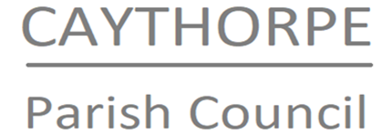

MINUTES OF EXTRAORDINARY CAYTHORPE PARISH COUNCIL MEETING
Monday 23rd June at 6.00pm.

Present: Cllrs Kerry (Chair), Freeman, Newbury, Ravenscroft
In Attendance: N Cope (clerk)

015/25 To receive and accept apologies.
Apologies received and noted from Cllr Pallister

016/25 To receive and note declarations of interest.
No declarations of interest declared

017/25 Finances
a. All documentation for the 24-25 AGAR were approved and signed. The Public Rights Notice dates were set for 26th June to 6th August.
b. Payments and receipts were noted and APPROVED: £30 Clerk training, £214 insurance quote, £45 internal auditor invoice, £1280 garden maintenance (reimbursed to Chair in lieu of Clerk’s access to bank account.) It was resolved to go ahead with the Zurich Insurance quote.

018/25 Set date for next meeting
Clerk to send a poll out for the next meeting.

019/25 Close
There being no further business the meeting was closed at 1830.

