Simonburn Parish Council Assets 31st March 2024
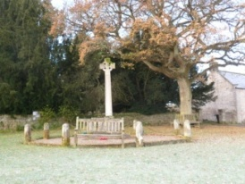 | War Memorial  30th May 1920  £1  Simonburn Village Hall Seat  £1
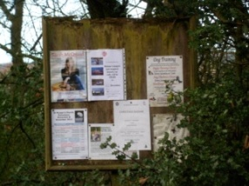 | Notice Board at Nunwick road end  £1
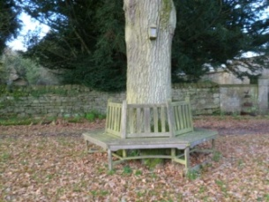 | Lancelot Guy Allgood 1944-1998  seat on Village green  1st December 1999  £360
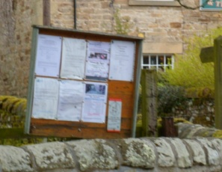 | Village Green Notice board  £1
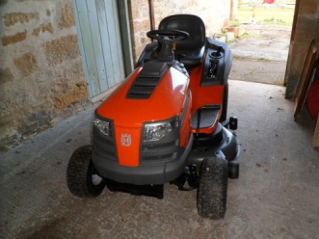 | Husquavanna Mower RCTH 194  Serial No. 021713D001756  Delivered 30th April 2013 £2500  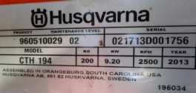
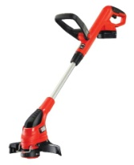 | Strimmer  10th May 2004  £45
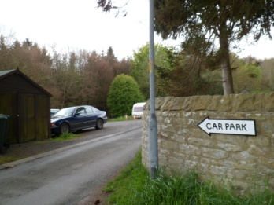 | Car Park Lease  £5
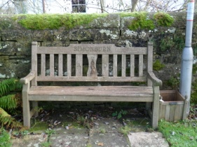 | Parish Seat and Litter Bin  9th September 1999  £350
Scanner | November 2016 £200
Jubilee Plaque | July 2022 £1
Defibrillator | Bought 2020 £2345
Simonburn Parish Council | Total value of assets £5810

