Beaumont Parish Hall Tree Planting in 2007

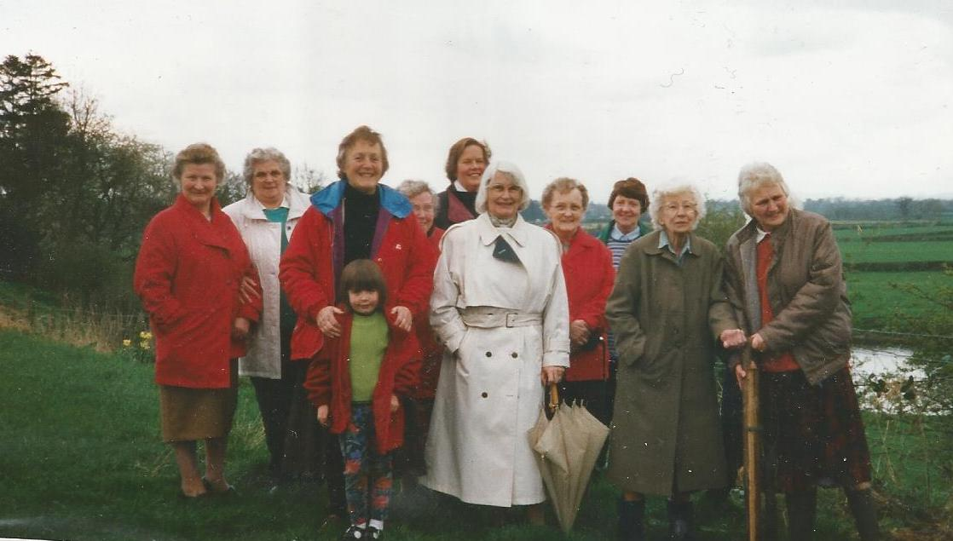

Margaret Roe 2nd from left), Margaret Parkinson, Sigrid Little, Miss Vickers, Sadie Bell, Shirley Graham, Mrs Stevenson, Stella Hodgson

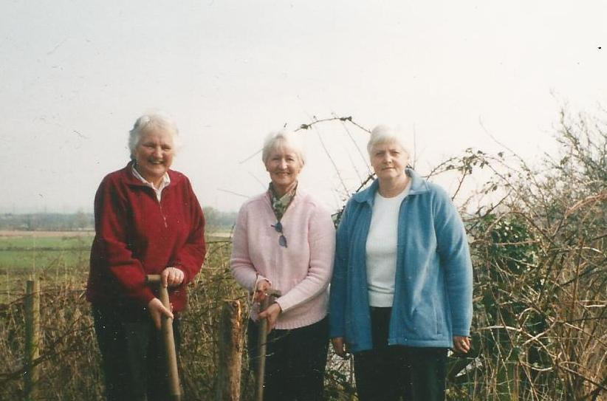

Stella Hodgson, Jenny Rayson, Margaret McKenna

