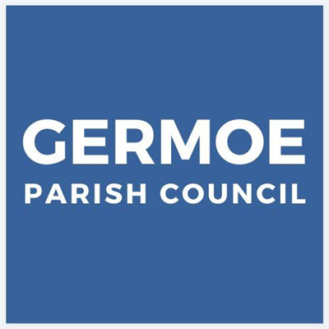

Neighbourhood Priority Statement (NPS) Steering Group
Terms of Reference
1. Purpose
The purpose of the Steering Group is to guide and oversee the development of a Neighbourhood Priority Statement (NPS) for Germoe Parish Council in accordance with relevant local and national planning guidance. The NPS will set out the key issues and priorities identified by the community to inform future planning and development policies and decisions.

2. Objectives
The Steering Group will:
- Coordinate the preparation and drafting of the NPS.
- Facilitate community engagement to ensure local priorities are understood and reflected.
- Gather and assess evidence to support the identified priorities.
- Liaise with relevant stakeholders, including the Local Planning Authority.
- Recommend a final draft of the NPS to the Parish Council for approval and submission.

3. Membership
- The Steering Group will be made up of a maximum of 12 members, including Parish Councillors and members of the community.
- The Parish Council will appoint the Chair and Vice-Chair of the Steering Group.
- Members will serve for the duration of the NPS preparation process or until the Group is dissolved.
- The Steering Group will be supported by the Clerk.

4. Responsibilities of Members
- Attend regular meetings and contribute constructively.
- Represent the views of the community and not individual interests.
- Participate in community consultation and engagement activities.
- Declare any conflicts of interest and act in accordance with the Parish Council's code of conduct.
5. Meetings
- Meetings will be held [monthly/as needed] and will be open to the public where appropriate.
- A quorum shall consist of at least one Parish Councillor and two other members.
- Notes will be taken and made publicly available.
- Where appropriate, separate meetings will also take place with Officers from Cornwall Council in an advisory capacity. Non-members may be invited to take part in joining working groups and contribute to defining and achieving the strategic objectives.
6. Reporting
- The Steering Group will report progress regularly to the Parish Council.
- The final NPS draft will be submitted to the Parish Council for formal approval.

7. Governance
- The Steering Group is an advisory body and has no decision-making powers beyond those delegated by the Parish Council.
- All decisions regarding the approval and submission of the NPS rest with the Parish Council.

8. Duration
- The Steering Group will be dissolved once the NPS has been approved by the Parish Council and submitted to the Local Planning Authority.

Adopted by Germoe Parish Council at the Extra-Ordinary Meeting of Germoe Parish Council held on Thursday 23rd July 2026 at 7:00pm, Balwest Methodist Schoolroom.

