Hadrian’s Wall
Carlisle to Bowness (and the aftermath)
Produced for the United Benefice of the Barony of Burgh
Description of the Wall
Hadrian’s Wall was constructed at the command of the Emperor Hadrian, after his visit in 121 AD to the northern most province of the Roman Empire. Its purpose was to mark and defend the border from the war-like tribes dwelling in what is now Scotland. The wall was to be manned by soldiers operating from a series of forts and fortifications set at regular intervals along the Wall from Wallsend in Northumbria across to Bowness-on-Solway. a distance of 73 miles. A system of defences was later extended along the coast of Cumbria to guard against raiders from Ireland.

Where can we see the Wall?

To those that walked the length of the Wall, or those who have visited the forts and museums along the way, this last stretch of 15 miles must come as an anti-climax or something of a puzzle. The question is often asked, “Where can we see the Wall?” Sadly, nowhere above ground although its course has been traced and written about for hundreds of years by scholars, archaeologists, and enthusiasts. New information is continually emerging. Recently a section of the Wall was uncovered and then recovered over between Beaumont and Burgh. Excavations have been carried out at the fort at Burgh-by-Sands (Aballava), Drumburgh (Congavata) and at Bowness (Maia), which was the second largest fort on the Wall and was intended to guard the approached across the Solway. Individual finds have been made along the course of the Wall. Some of which have been added to the extensive collection at Tullie House Museum in Carlisle. Inscribed stones have been inserted into later buildings; perhaps being parts of Roman alters of descriptions of troops.

The Romans leave

The Roman legions finally left Britain in 383 AD, as the Empire fell into decline, pressed by barbarian forces in other parts of the Empire. The Wall fell into decay, and the nature population was left to fend for itself, as did the few remaining farmer-soldiers.

After the Romans

Recent excavations in Carlisle (Lugovallium) have shown that vestiges of Roman urban amenities survived for a considerable time. The Venerable Bede writing in the 7th century describes a visit of St. Cuthbert to Carlisle when he apparently saw a Roman fountain in use. But on the Solway Plain life must have been harder. The inhabitants would have been glad to used the dressed stones of the decaying wall as building material. The Norman churches at Beaumont, Burgh, Kirkbampton and Bowness are all largely built of Roman stone.
Drumburgh Castle was enlarged in 1307 using stones from the Wall and was later enlarged again but Thomas, Lord Dacre, in the time of Henry VIII, as the headquarters of the Barony of Burgh. A Roman alter can be seen on the steps leading to the front door, with the arms of Thomas, Lord Dacre, above.

Border Warfare

For many centuries fighting continued between England and Scotland, either as costly military campaigns or on the smaller scale of cattle thieving or inherited feuds. Many border Ballads describe these murderous events.
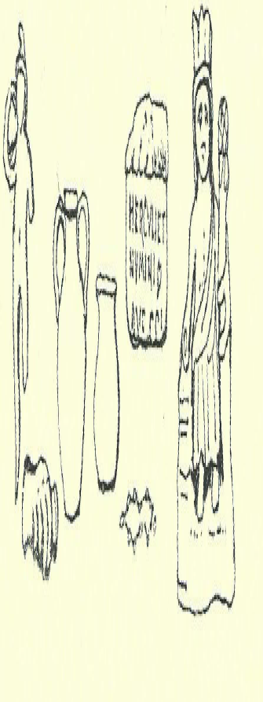
Burgh Church and Edward I

The tower of Burgh Church was a notable place of refuge for inhabitants wishing to escape raiders from across the Solway. The tower had no outside door and was safeguarded by an inner grille or yet.
In 1307 king Edward I, the Hammer of the Scots, after holding a parliament in Carlisle, set out on his third campaign against the Scots, but died on Burgh Marsh, where he is commemorated by an isolated, windswept monument. His body was carried back to Burgh Church where he lay in state.
The war-like activities between England and Scotland petered out by the Act of Union in 1707, to be briefly revived by the unsuccessful Jacobite rebellions of 1715 and 1745.

Canal and railway

In 1823 a canal was dug between Carlisle and Port Carlisle it was not a success, and a railway was built in its course. It was made redundant by Dr. Beeching in 1964.
Both these enterprises did great damage to the foundations of the Wall and to a corner of the fort at Burgh.

It is surely food for thought, that although the canal and railway today are almost forgotten, people from all over the world come in ever greater numbers to visit the remains of that staggering achievement, Hadrian’s Wall- a World Heritage Site.

