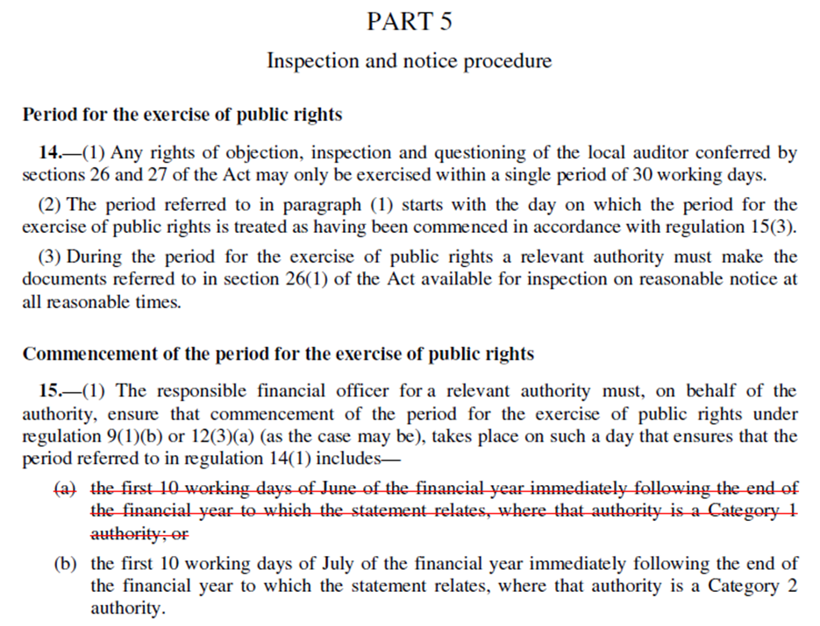

Local council name: ____________Greenhead Parish Council____________________

Notice of appointment of date for the exercise of public rights
Accounts for the year ended 31st March 2023
The Local Audit and Accountability Act 2014, and
The Accounts and Audit (England) Regulations 2015 (SI 234)
1. Date of announcement: __22/05/2023________________ (a) | (a) Insert date of placing of this notice on your website.
2. Any person interested has the right to inspect and make copies of the accounts to be audited and all books, deeds, contracts, bills, vouchers and receipts relating to them. For the year ended 31 March 2023 these documents will be available on reasonable notice on application to:
(b) _______Mrs Susan Saunders – RFO/Clerk________________  _____________________________________________________  ____________greenheadparish@gmail.com  01434 344470_________________________________________ | (b) Insert name, position and contact details of the Clerk or other person to whom any person may apply to inspect the accounts.
commencing on (c) _5th June 2023___________ | .
and ending on (d) 14th July 2023____________ | (c )And  (d)The inspection period must be 30 working days in total and commence no later than 3 July 2023.
3. Local Government Electors and their representatives also have:
- the opportunity to question the auditor about the accounts; and
- the right to make objections to the accounts or any item in them. Written notice of an objection must first be given to the auditor and a copy sent to the Authority (f).

The auditor can be contacted at the address in paragraph 4 below for this purpose during the inspection period at 2 above.
- The auditor complies with the provisions of the Local Audit and Accountability Act 2014, the Accounts and Audit (England) Regulations 2015 and the National Audit Office’ Code of Audit Practice. Your appointed auditor is:
Mazars LLP, The Corner, Bank Chambers, 26 Mosley Street, Newcastle upon Tyne, NE1 1DF
Email: local.councils@mazars.co.uk
5. This announcement is made by (e))______Mrs Susan Saunders RFO/Clerk________ | (e) Insert name and position of person placing the notice

Attachment 3.3
Councils’ Accounts: A Summary of Public Rights
The basic position
By law any interested person has the right to inspect a council’s/meeting’s accounts. If you are entitled and registered to vote in local council elections then you (or your representative) have additional rights to ask the appointed auditor questions about the council’s accounts or object to an item of account contained within them.
The right to inspect the accounts
When your council has finalised its accounts for the previous financial year it must advertise that they are available for people to inspect. Having given the council reasonable notice of your intentions, you then have 30 working days to look through the accounting statements in the Annual Return and any supporting documents. By arrangement, you will be able to inspect and make copies of the accounts and the relevant documents. You may have to pay a copying charge.
The right to ask the auditor questions about the accounts
You can only ask the appointed auditor questions about the accounts. The auditor does not have to answer questions about the council’s policies, finances, procedures or anything else not related to the accounts. Your questions must be about the accounts for the financial year just ended. The auditor does not have to say whether they think something the Council has done, or an item in its accounts, is lawful or reasonable.
The right to object to the accounts
If you think that the Council has spent money that it should not have, or that someone has caused a loss to the Council deliberately or by behaving irresponsibly, you can request the auditor to apply to the courts for a declaration that an item of account is contrary to law. You do this by sending a formal ‘notice of objection’ to the auditor at the address below. The notice must be in writing and copied to the council. In it, you must tell the auditor why you are objecting and what you want the auditor to do about it. The auditor must reach a decision on your objection. If you are not happy with that decision, you can appeal to the courts.
You may also object if you think that there is something in the accounts that the auditor should discuss with the Council or tell the public about in a ‘public interest report’. You must follow the same procedure as outlined in the previous paragraph. The auditor must then decide whether to take any action. The auditor does not have to, but usually will, give reasons for his/her decision and you cannot appeal to the courts. More information is available on the National Audit Office website (see contact details below).
You may not use this ‘right to object’ to make a personal complaint or claim against your council. You should take such complaints to your local Citizens’ Advice Bureau, local Law Centre or your solicitor. You may also be able to approach the Standards Committee of your local principal authority if you believe that a member of the council has broken the Code of Conduct for Members.

What else you can do
Instead of objecting, you can give the auditor information that is relevant to his/her responsibilities. For example, you can simply tell the auditor if you think that something is wrong with the accounts or about waste and inefficiency in the way the Council runs its services. You should make it clear that you are providing information rather than making a formal objection. You do not have to follow any set time limits or procedures. The auditor does not have to give you a detailed report of any subsequent investigation but will usually tell you the outcome.
A final word
Councils, and so local taxpayers, must meet the costs of dealing with questions and objections. In deciding whether to take your objection forward, one of a series of factors the auditor must take into account is the cost that will be involved. The auditor will only continue with the objection if it is in the public interest to do so. If you appeal to the courts, you might have to pay for the action yourself.

Who should you contact?
For more detailed guidance on electors’ rights and the special powers of auditors, copies of the publication Council Accounts – a guide to your rights are available by calling the National Audit Office on 020 7798 7000 or downloading from the website https://www.nao.org.uk/ | If you wish to contact your Council’s appointed external auditor please write to:  Cameron Waddell, Partner, Mazars LLP, local.councils@mazars.co.uk

