

CHARLTON PARISH COUNCIL
MINUTES OF THE ANNUAL COUNCIL MEETING HELD ON MONDAY 19th October
2026 at Charlton Church Foxcotte Room at 7.00pm

Present: Cllr Ward, Cllr Woods, Cllr Wilson, Cllr Rawlingson, Cllr Mockford

In attendance: E Attwood – Clerk 0 members of public

1. Apologies for Absence – Cllr Tasker & Cllr Summers

2. Declarations of Interest – None

3.Minutes - Resolved: The minutes of the Parish Council meeting held on 21st September 2026 were confirmed as a correct record and signed by the Chairman of the meeting. All members agreed.

4. Public participation – None

5. Clerk’s Report

- Interviews organised job offered subject to satisfactory references.
- E Mail sent to Highways Safety Officer requesting site meeting to discuss traffic survey results and Lane accessing Charlies Lake – No reply to date
- Traffic Survey results circulated.
- Resurfacing of Foxcotte Road all enquiries about access referred to contact details on postcard put through every letter box.
- 6 months attendance investigated – Any Cllr not attending a meeting during a period of six months is automatically disqualified.

6.1 County Cllr Donnelly/Borough Councillor Lashbrook – The last report was added to the website.
7. Lane accessing Charlies Lake and Bridge exit.
Councillors considered whether this item should remain on the agenda. Despite efforts by the Parish Council and Cllr Donnelly, Hampshire Highways has not engaged in arranging a site meeting. The Clerk used an email address provided by a traffic team member but was subsequently advised that it was incorrect. Cllr Ward will write to the leader of the County Council County, Councillor Nick Adams-King explaining the difficulties of trying to get a site visit arranged.

8. Policy –. Cllrs discussed the Financial Regulations in detail and suggested amendments will be made by Cllr Rawlingson. Resolved: It was agreed not to have a separate Finance group and that all decisions would be made by the whole council. The Clerk will upload documents on the website as PDFs.

9. Finance -
9.1The bank balance as of 31st September 2026 was as follows:

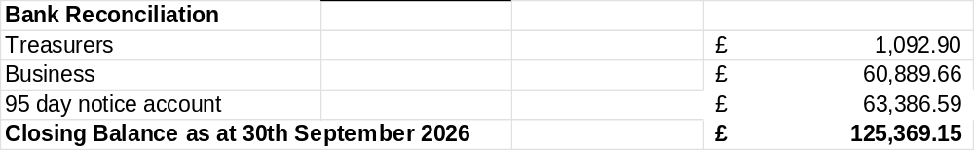
Resolved: Councillors approved the financial statement and payments for September 2026. The bank statements were circulated, and all Cllrs were given the opportunity to check the balance.

9.2 Approval of September payments:

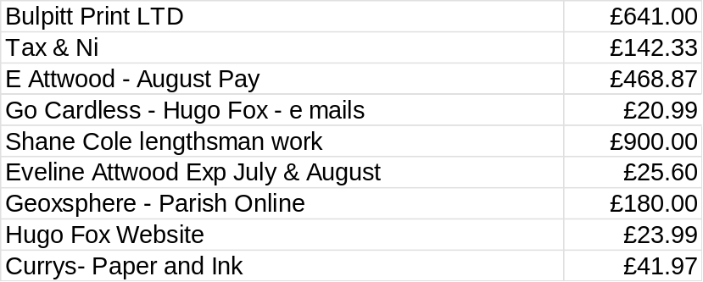
Approval of October payments to date

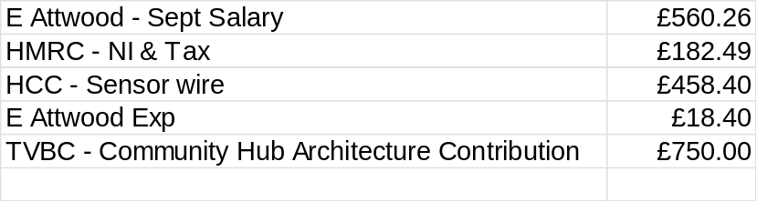
Resolved: Cllrs approved September & October 2026 payments to date.

9.3 To approve transferring additional money to 95-day account.
Resolved: Cllrs approved an additional £20,000 transferred to the 95-day account.

9.4 Budget 27/28
Councillors reviewed the draft budget and proposed amendments. The Clerk will make the changes and add the revised budget to next month’s agenda for further consideration.
An additional £20,000 will be set aside for the Community Hub. The lawn mower funds will be reallocated to the Neighbourhood Plan, increasing its total allocation to £5,000.

10. Planning – No updates to report

11. Tree at Charlton Waterside -. Cllr Rawlingson has contacted the contractor and Tesco to arrange access for the tree to be felled at the end of November and will continue liaising with the contractor.

12.Councillor Reports
12.1 Traffic Liaison – Cllr Wilson reported on the traffic sensor survey and its comparison with the volunteer count. A minor discrepancy arose because vehicles entering or leaving Home Gardens were not included. Highways recorded higher speeds than the SID, and weekday traffic was heavier than at weekends. Councillors also raised concerns about concealed driveways joining the road. Cllr Ward suggested relocating the SIDs, although some mounting brackets are rusted. The full results are provided in Appendix A.

12.2 Footpaths & Rights away – Nothing to report.
.
12.3 Charlton Village Community Association – Cllr Ward reported.
- AGM for the CVCA has been held on the 15^{th of} October, and the officer posts remain the same.
- 24th October Nokando will be organising a fund-raising event in the church.
- 24th October there will be a country file rambling aid of Children in Need– 3-mile walk.
- 28-29th November is the Christmas weekend; Sat 28th Church Christmas market, and tree lights switch on at Sunnyside.
- Website for the Village will be run by the CVCA with a link to the PC website.

12.4 Action Tracker – Cllrs were reminded to review and update. A link will be set out next month with the agenda for a full review.
12.5 Community Hub – The Parish Council is a member of the project. The project brief has been circulated, and £750 was approved towards the architect’s fees last month. Further information, including the concept design, is awaited.
13 Correspondence & Meetings. The following meeting were attended:
- Cllr Ward attended the HALC AGM and reported that the president RT Hon John Denham is stepping down.
- Cllr Woods has attended three resilience workshops and measures to be put in place should an emergency arise. Cllr Mockford volunteered to Join the Parish Emergency Group known as PEG.
- Cllrs Ward and Rawlingson will attend TVBC’S Planning Enforcement workshops ON 21st October.
- E mail from ramblers requesting support for another footpath by the Old Nursery to elevate walkers from walking on a busy road. Cllrs support in principle but have requested they attend November’s meeting to explore how they can proceed with this.

14. Items for next month –
- Approval of Clerk/invite to meeting
- Approval Change Bank accounts to Clerk as sig
- Approval to add additional Cllrs as signatures – dual authorisation.
- Approval of Investment policy
- Approval to book a training date for new clerk with HALC.
- Invite to Ramblers to discuss proposed footpath.
- Send out and review Action Tracker

15 To pass a resolution in accordance with the Public Bodies (Admission to Meetings) Act 1960 to exclude the public and press for discussion re staffing matters where publicity might be prejudicial to the special nature of the business.

The interviews have taken place, and it was recommended that the new Clerk be appointed subject to satisfactory references and a right to work in the UK check.

Resolved: Cllrs approved Leza Slater as the new Clerk, salary agreed as SCP 26. The new Clerk will be invited to the November meeting to meet Cllrs and sign her contract. Cllrs agreed to pay travel expenses. Handover is suggested for the week starting 7th December.
The handover will take place during the current Clerk’s working hours that week, followed by two weeks of remaining annual leave. The Clerk’s final salary for November and December must be processed during the handover so that her P45 can be issued and HMRC paid on time due to the need to change bank signatories which can take a little while for the bank to process. This will also provide payroll training.

16 Date of next meeting: The next meeting of the Parish Council will be held on Monday 16th November at 7pm in the Foxcotte room at St Thomas Church, Charlton.

Appendix A

Hatherden Road Traffic Survey
A traffic survey was carried out by HCC, from Thursday 17th September to Wednesday 23rd September 2026, at the request of Charlton Parish Council.
The purpose of the survey was:
· To determine the volume and speed of vehicles travelling into and out of Charlton Village via Hatherden Road
· To provide evidence for reducing, or at least not increasing, the number and speed of vehicles.
An additional benefit of the HCC survey is that it provided a check on the accuracy of the information produced by the Parish Council operated Speed Indicator Device (SID) located on Hatherden Road.
Volume Data,
Comparison of results of the HCC and SID findings for the week
Incoming Outgoing Total
HCC Survey 14,097 14,279 28,376
SID (camera) 13,442 12,534 25,974
Difference 655 1745 2,400
The HCC survey results appear to indicate that the SID is under recording the number of journeys.
In October 2014 a traffic survey was carried out on behalf of the Parish Council over a period of 9 days and the total number of vehicles on Hatherden Road was 4,295. The traffic in 2026 is over 7 times that of 2014. The problem will be exacerbated when the 135 new houses are built in the field behind Hatherden Road – the only access being from Hatherden Road.
On 17th September 2026 between 15:30 and 16:30 hrs a sight count of the number and type of vehicles travelling into and out of Charlton Village was carried out by local volunteers and Parish Councillors. The results of the sight count were compared with the HCC Survey and SID figures and were as follows:
Incoming Outgoing Total
HCC Survey 183 181 364
SID (camera) 183 161 344
Sight Count 186 183 369
Over the 1-hour period surveyed the SID outgoing figures appear to be under recorded. This may be because the SID does not count any vehicles that go into Home Farm Gardens, whereas the sight survey did.
The Parish Council / volunteer count identified 4 lorries incoming and 3 lorries outgoing during the period.
Speed Data
The HCC survey provided average speed information, and this was compared with the data produced by SID. The figures are derived from a daily average of all vehicles travelling over 35 mph.
No. > 35 mph Total %
HCC Survey 676 4054 16.7
SID (camera) 188 3710 5.1
There is a considerable difference in the two sets of results. One would expect that the HCC equipment is regularly calibrated, whereas the PC SID equipment has never been checked since its installation. The main benefit of the SID is that it may encourage some drivers to reduce their speed when they see that they are breaking the speed limit. Therefore, it is concerning that SID may not be warning all those doing so.

