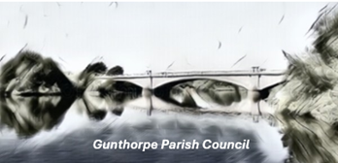
Annual Parish Meeting
Gunthorpe Village Hall on Wednesday 27th May 2026 at 7pm

Signed:
N Cope
Clerk to the Parish Council
11th May 2026
AGENDA

- Welcome from the Chair
- Discussion of Marston’s land at Gunthorpe riverside
- 100-year bridge celebration
- Village Hall and Play Park
- Update from Local Nature Reserve
- Open forum for questions, comments etc

