Beaumont Parish Hall – The New Hall

The existing Hall, a second-hand structure re-sited in Beaumont in 1947, was supposed to be a temporary structure, to be used until a new purpose-built brick hall could be constructed. However, by 2020 it has been in place over 70 years. The County Surveyor assessed the building and said it was no longer structurally stable and that it would be hard to obtain future funding to repair the building as it is of non-standard construction. The Hall Committee took the decision decided to try to replace the hall.

The first stage was a consultation of the Parish to find out what the parishioners wanted from their hall. This information was used to drawn up a list of the main requirements for a New Hall. This list was used to get local architects to quote for the tender to draw Concept Drawings of the New Hall. Concept drawings were obtained in March 2019.

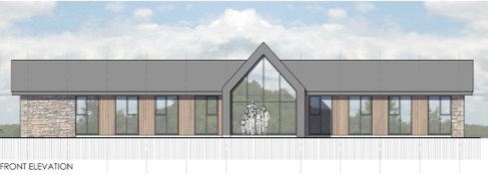

The existing hall rests directly on top of Hadrian’s Wall and after consultation with Historic England, and the Cumbria County Council Historic Environment Officer it was decided that the site of the New Hall should be moved to the centre of the hall field to avoid the additional complications of having to building around any existing archaeology. After this decision the concept drawings were exhibited to the Parish. And were approved by Carlisle City Council and Historic England.

The photographs below show the archaeological investigation which follow this step. No archaeology finds were found during the digging of the trenches.

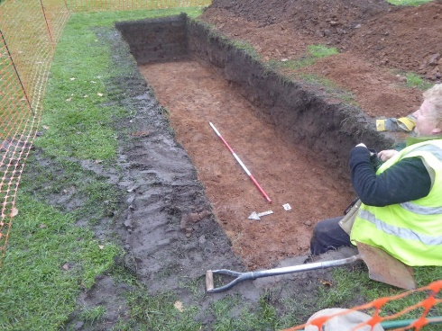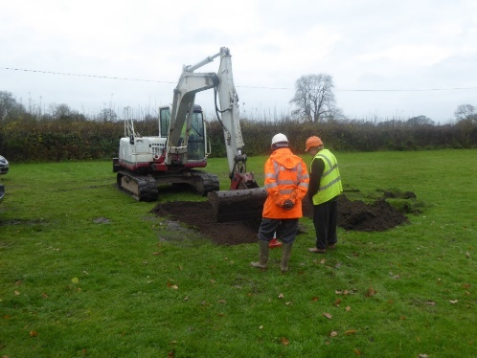

Unfortunately the cost of coverting the original designs were far too high so ther hall trustees had to devise a cheaper option of building a wooden hall very similar in size to the original..

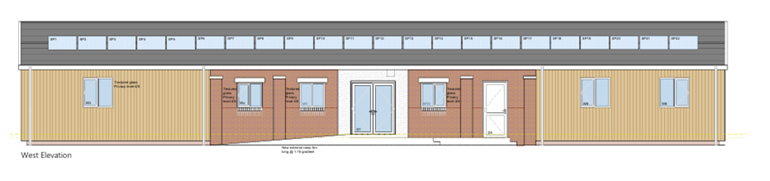

The elevation drawing above shows the much simpler concept. The building was to be squared off making a small meeting room next to the larger kitchen, a storage room and bar would be built at the far end of the hall and the stage removed to make a much larger space which would be able to be sectioned off to make two smaller rooms when required.

Frantic grant raising took place with pleas to the community to help both with demolishing and building the new hall, and to augment the depleted hall trustee numbers.
After much consultation the old hall was demolished in 2025.

Work commencing the rebuild of the new hall started in the Autumn of 2025.

