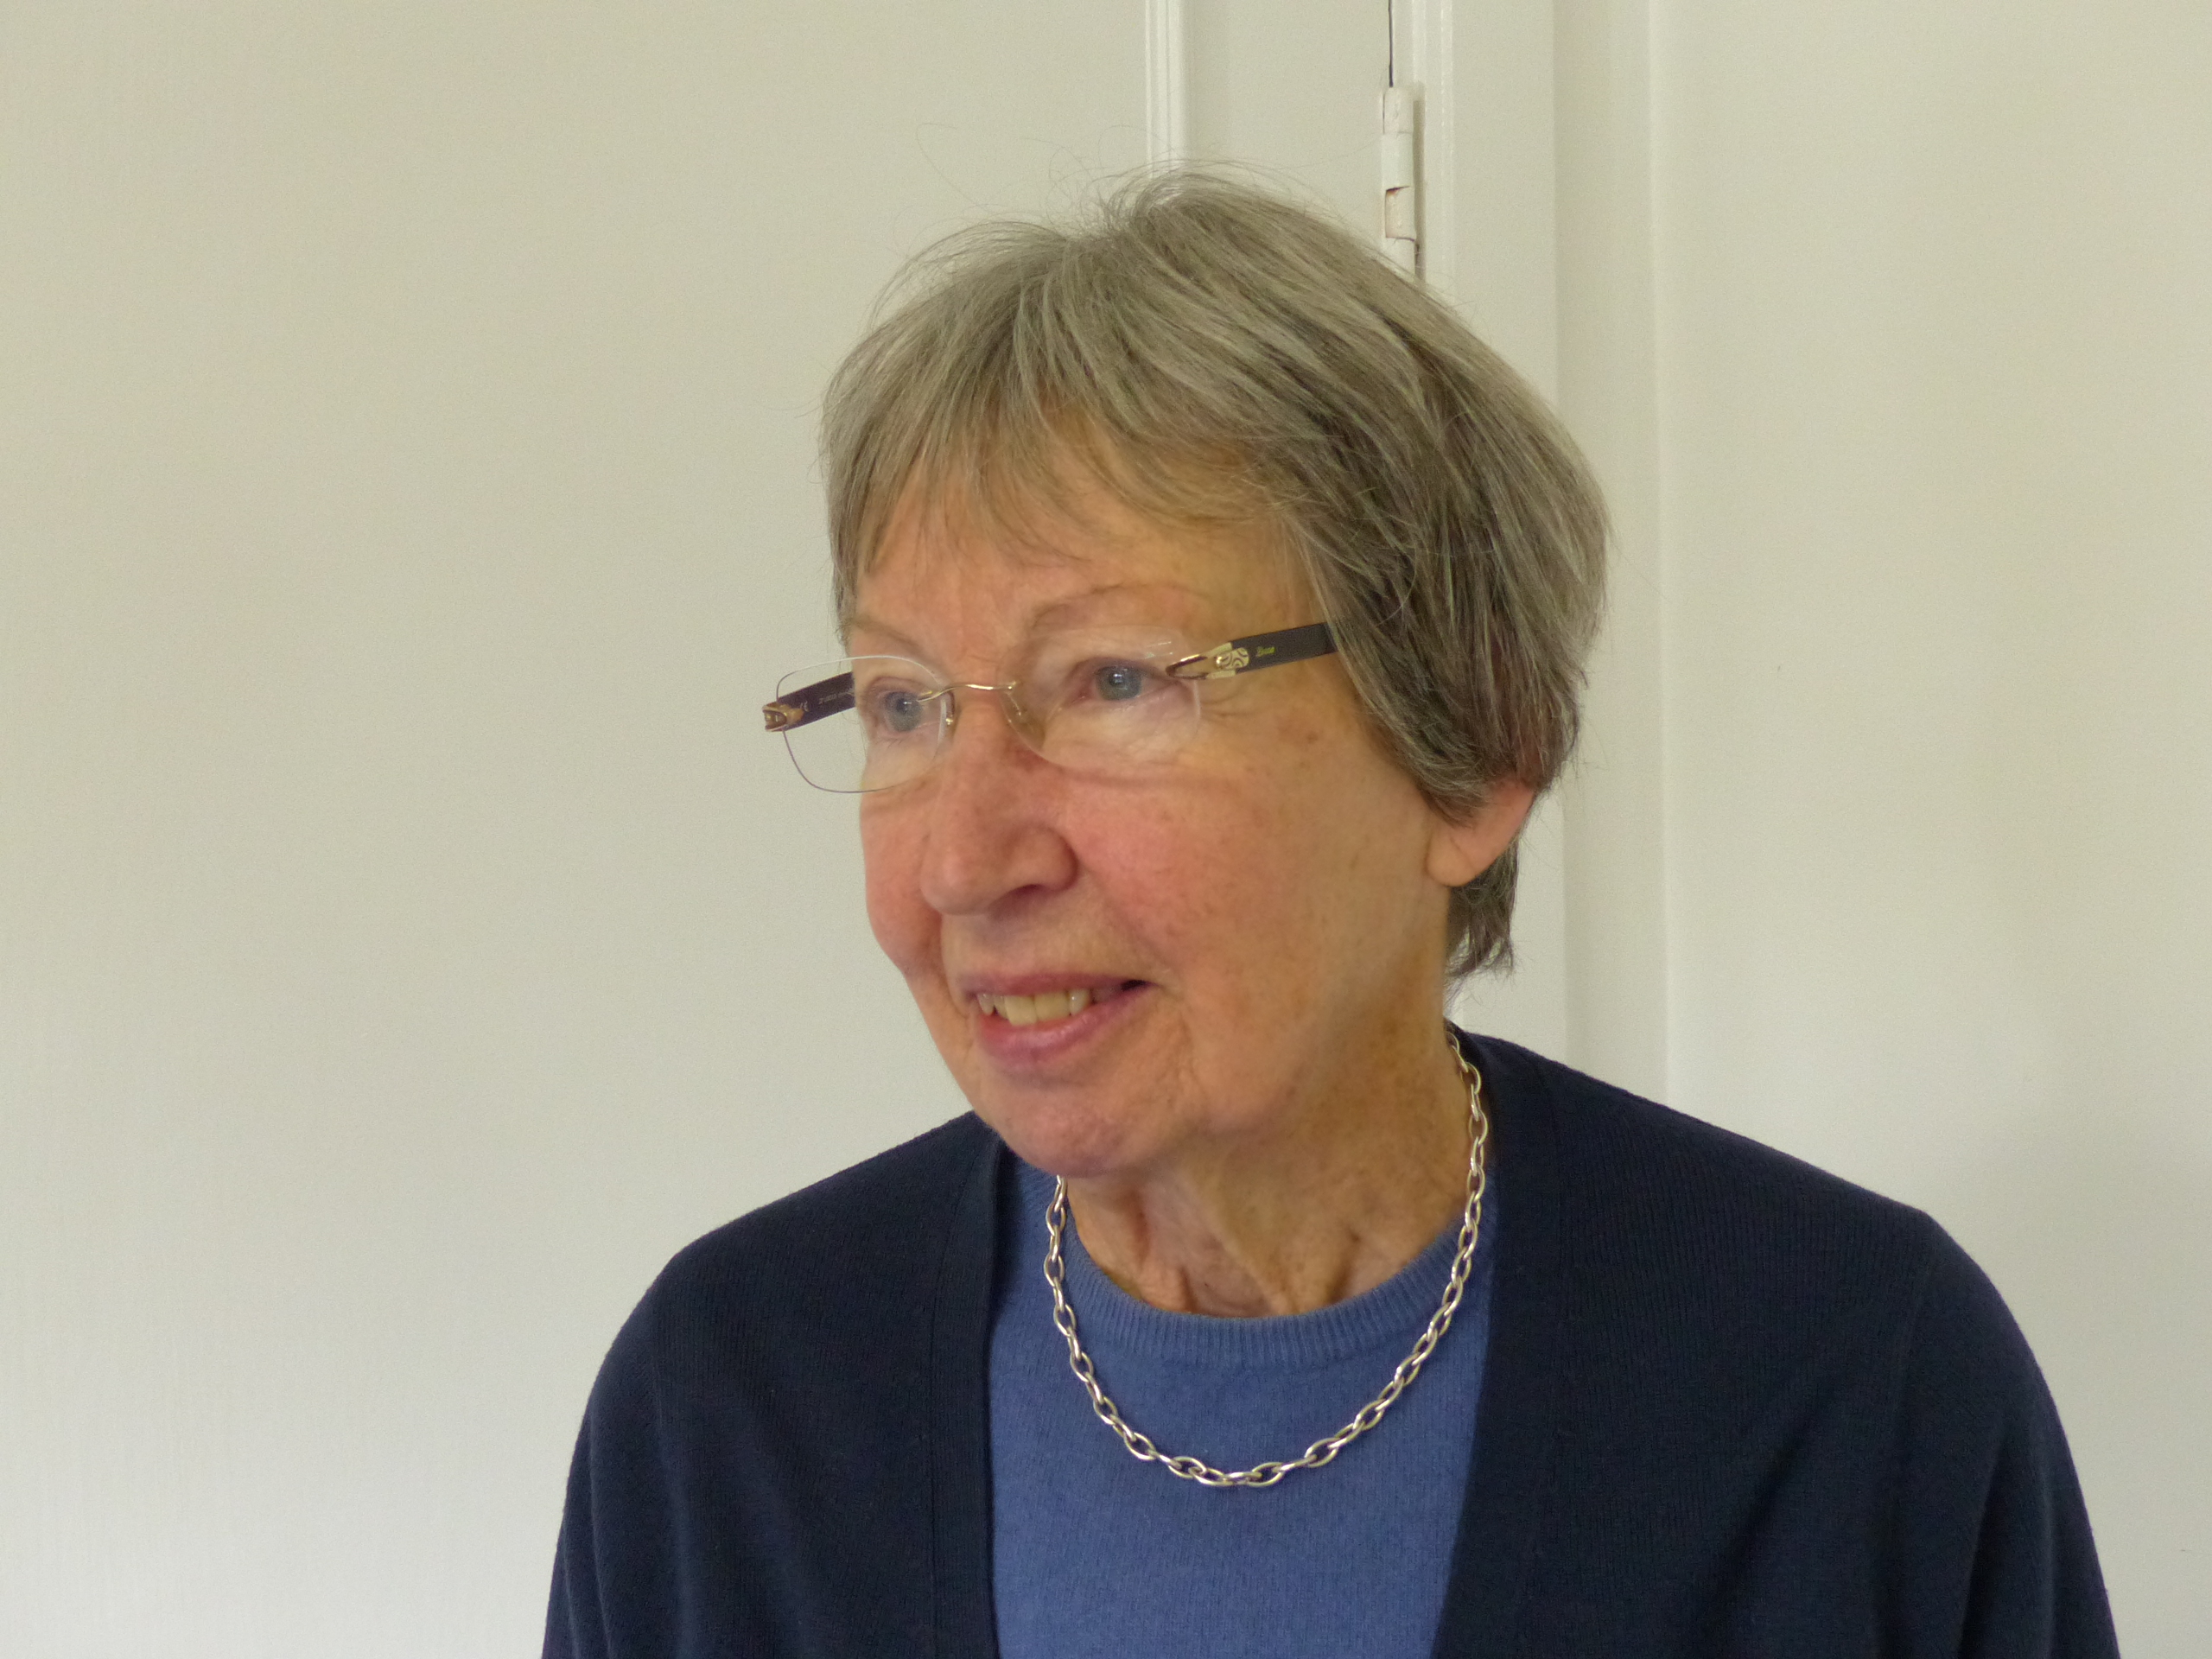

Venning Mary

Index number: MWOH002003

Recorded on: Tuesday 8 December 2015 by Anne Weaver and Roger Davis
Time commenced: 11.00 Duration: 25 minutes Location: Lullington , Pilgrims Close, Westhumble.
Mary’s parents initially rented their house, Lullington, in 1939 and Mary was born in 1940. Her earliest memories are of the air raid siren and that at night, as her father was deaf and her mother may not have heard, and because she was sleeping downstairs in the hall, she would run upstairs to alert her parents. They would either shelter in an the cloakroom or under the stairs or, if Mary was visiting friends, she would use an air raid shelter at a house in Adlers Lane. Mary tells us that her first school was in Pixham Lane and initially she walked there but later she was taken on the back of her mother’s bicycle. On leaving Pixham School she went to school at St Paul’s Dorking and then at the age of eight she went to school in Ashtead ( City of London Freeman’s School ). She has no recollection of school meals at her first two schools but she tells us that she enjoyed meals at the school in Ashtead and recollects about classes in domestic science. We are told that she still uses some of the recipe books from her school days as well as one from the Milk Marketing Board. At home about half the garden was used to grow vegetables and fruit trees, but Mary says that her Mother went into Dorking by bus about once a week to shop. Deliveries were made by the butcher, grocer and milkman. Food was stored in a larder, as they did not have a fridge. Mary relates that all the food preparation and cooking was carried out by her mother although she was keen to help, especially with the baking of cakes. As well as using fruits from the garden, damsons were bought at a greengrocer in Leatherhead and made into jam. Mary describes her mother as a good plain cook who would often prepare meat pies, brawn and would gut and cook fish. Often cheaper cuts of meat, such as brisket, were used. As her father was deaf he had a job that enabled him to work from home and although he was not involved in the preparation or cooking of food, he did have 3 cooked meals a day. Mary had lunch at school, which she enjoyed, and she tells us about her favourite puddings. She recalls that she helped her father with the gardening but that she found it tedious and did not like it. There was always a surplus of vegetables that needed to be stored. They also kept 12 hens who laid more eggs than they could consume. The surplus eggs were either stored in isinglass or posted weekly in a wooden padded box to her grandparents in Sheffield. Mary tells us that she enjoyed a Sunday roast, which was often a shoulder a lamb as beef was too expensive, especially during wartime. We then hear about the various deliveries made including heavy goods such as flour and tinned food from Kingham’s Grocers in Dorking, as well as deliveries from the baker and milkman. As far as Mary can recall birthdays did not merit a special meal but at Christmas and New Year they had turkey or ham. During they year her father would occasionally dispatch one of their chickens to eat. Sometimes meat was obtained from Mr Clifton, the farmer at Bradley’s Farm. She does not recall the family eating out in restaurants. On occasions they went with friends to Ranmore Common, taking a primus stove to make tea. Mary tells us that she cooks plain food like her mother and enjoys baking, usually having a cake in the freezer. Returning to her childhood days she tells us that Fish and Chips was a favourite meal. During her working life initially in London, Mary would take sandwiches with her for lunch. During a general conversation Mary shows us the various cooking and gardening books that she has kept from earlier days including her school cookbook and the cookbook that was supplied with her Mother’s Radiation Gas cooker. She recalls the story behind the building of her house and that during her childhood many of the houses in Pilgrims close were yet to be built and with fields stretching to the still incomplete Burney Road. There are tales of her mother learning to drive and finally we hear about a less than successful holiday taken on a farm in Devon including the difficulties cycling there and the lack of ice cream!

