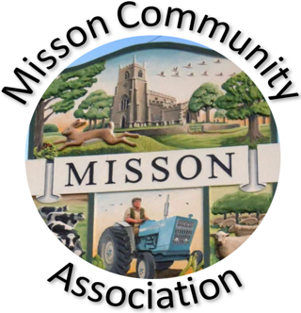
MISSON COMMUNITY ASSOCIATION

AGENDA

MEETING ON WEDNESDAY 18TH FEBRUARY 2026 AT 7.15 pm

- Apologies for absence

- Declarations of any new committee member interests outside MCA.

- Minutes of 21st January 2026.

- Non-agenda matters arising from minutes 21st January 2026.

- Treasurer’s report

- Building maintenance

- Current Events and Bookings

Race Night Friday 27th February 2026
MCA AGM – Wednesday 18th March
L&L “Tell it to the Bees” Saturday 25th April

- Proposed Events

Butterfly talk – March
Early morning bird walk – May
Bat walk
Garden Trail – June
Party on the Green – 18th July

- Working with other village groups

- Correspondence/Contact/Communication (Facebook, Posters, NL etc.)

- Any other business

Review of MCA Constitution
Back garden area – bulbs and planters
Storing and loaning wildlife books

- Date and time of next meeting – Wednesday 18th March at 7.15pm

