The Annual Parish Meeting of
Stretton Under Fosse
Will be held in the Village Hall
On Tuesday 9th May 2023 at 7.00pm

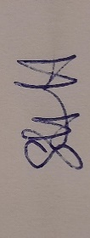
Sue Hartshorn Chair of the Parish Council
25th April 2023
Agenda
All members of the public are invited to attend

- Parish Council Chairman’s review of 2022-23

- To approve minutes of Annual Parish Meeting 2022

- Report from Tony Gillias (Rugby Borough Council)

- Report from Adrian Warwick (Warwickshire County Council)

- Any other matters raised

