Webbers

The story of a cottage

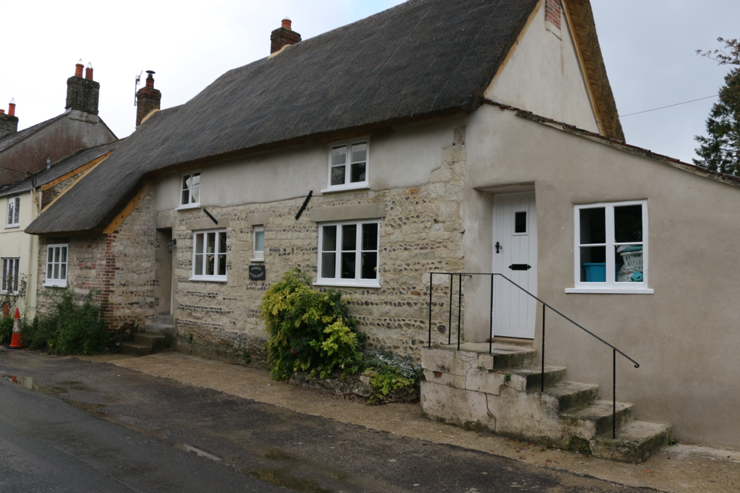
There have been Webbers in Sydling almost as long as records go back. In 1383 Johan “Webbe” rented a cottage from the Lords of the manor (Milton Abbey). In 1440 Thomas Webbe was renting a cottage from for 6s 8d per year. There is a meadow which was called Webber’s throughout the middle ages.
The very first tenant who we know for certain to have lived on the site of the cottage known as Webbers, was Johan (John) Webber, in the 1530s. He held the cottage by copyhold. A copyholder rented the cottage for life, and could nominate 2 lives to take on the rental from them when they died, on payment of a fee.
The Webbers and their descendants lived in the cottage for the next 370 years.
After John came William Webber, then John Webber, then his sons Thomas and William in 1591 then another Thomas, two Williams, Alice Webber, Dorcas Webber, A couple of Silas Webbers, Sarah, and lastly William Webber in 1769.
Of course, many Webbers married into other village families. In 1772 the copyhold passed to George Bridle, who had married Elizabeth Webber. The Bridles were here for the next century. They were an old Sydling family too, popping up in records as far back as the 1300s.
The tenants of the cottage also had grazing rights on the common land around the village, and rented plots of land from the lord of the manor, which they were allowed to cultivate or graze.
In 1764 Silas Webber had right of pasture for 1 horse, 13 cows, 1 heifer and 64 sheep, and he rented about 6 acres of arable land, in Churchfield, near Court Ashes and at Cow Lane Bank.
The rental book below is dated 1831, and shows the fields which George Bridle held with Webbers; the cottage, garden and orchard, 10 acres of pasture in the Combe, 10 acres of arable land in “Little Field”, (at the top of Dry Lane).

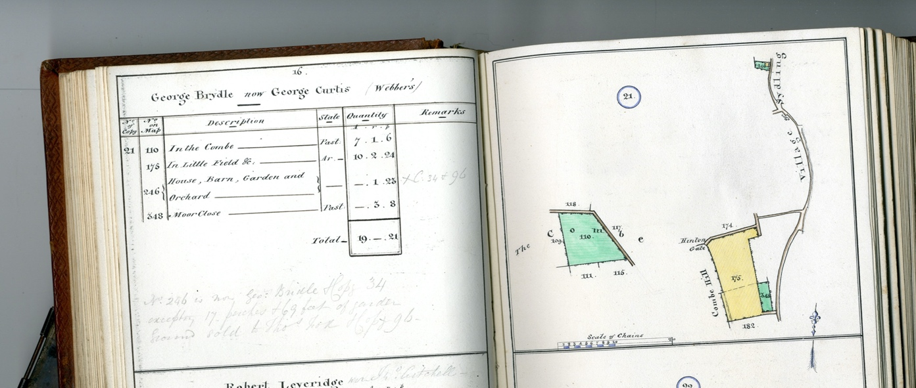

The Webbers seem to have been agricultural labourers, and have left little record of their lives apart from births and deaths in the parish records. It is tempting to think that all the major events of the centuries passed them by, as they toiled in the fields and lived their lives in the cottage. But this may be far from the truth. Who knows?
In 1832, only a year after the rental above was written,15 year old John Webber was buried in Sydling Churchyard. He had been employed by his master, a glazier, to help smugglers to carry away tubs from a vessel, and was shot dead by the coastguards.
The numbers of inhabitants of the cottage varied enormously over time. In 1841 there seem to be thirteen members of the Bridle family living together, aged from 79 to 4 years of age. By 1851, only two remained. In 1898 Tabitha Bridle had married and moved to Weymouth. When she died in 1908, leaving no-one named to inherit, the copyhold “fell in”. Winchester College took back ownership and rented Webbers to other tenants until they sold it, along with several other properties in the village, in 1956.
The 1956 sales details show that Webbers had mains electricity, but water was from a single tap outside the front of the cottage, and there was an “earth closet”. Life was still primitive!
Webbers, like many Sydling cottages, was built of banded chalk and flint. It is likely that the stone came either from the ruins of Cerne Abbey, or from the quarry on Giant Hill. The upper storey has chalk cob walls. The date it was built is uncertain. Historic England suggest that the cottage is 17th century, which would mean that it replaced an earlier cottage on the plot. It is thatched, with a catslide roof at one end. The lean-to extension was probably a later addition. Old photos show that this was once much taller.
By the 1970s, after standing for hundreds of years, the old roof timbers of Webbers finally gave way, the roof began to collapse, and had to be shored up by new timbers and supports. The upstairs of the cottage was no longer safe or usable, the stairs were removed, and for the next 40 years, only the ground floor was habitable. The cottage might have been nearing the end of its life.
But luckily, after extensive building works, in 2019 it was repaired and restored, and continues its long life as a family home. Hopefully it will still be standing in another 400 years!
Anne Brown

Winchester College Archives provided all the information above
Dorsetbuildingstone.org. Jo Thomas

