The development of the Pound or Pinfold at Kirkandrews on Eden p2
Photographs of picnic in May 2018

A picnic was organized on Bank Holiday Monday on 28th May 2018 to celebrate the opening of the Pound and a picnic area with benches and interpretation board. About 25 people attended the picnic afternoon
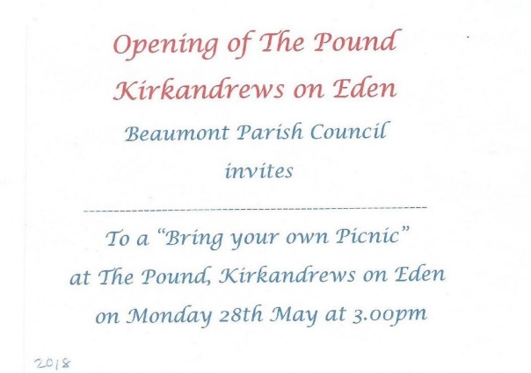
An open invitation to residents of the parish was included in the Parish Magazine and personalized invitations were issued to everyone involved in the project.

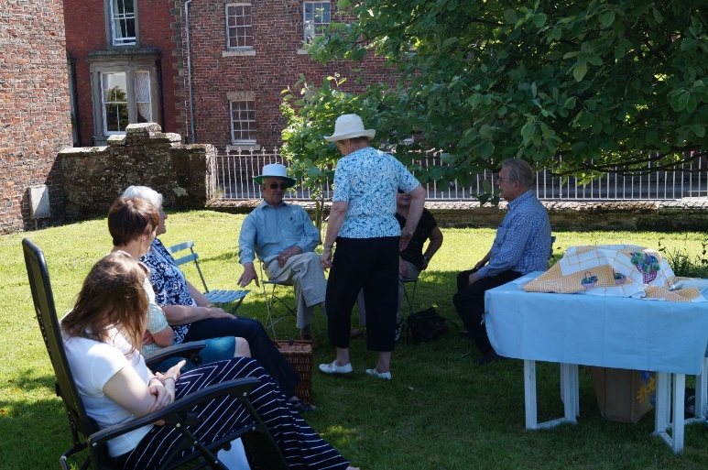
From left to right: Emily Roelich, Jean Wharton, Margaret McKenna, Harold Bowron, Trevor Allison, Kathleen Bowron (standing)
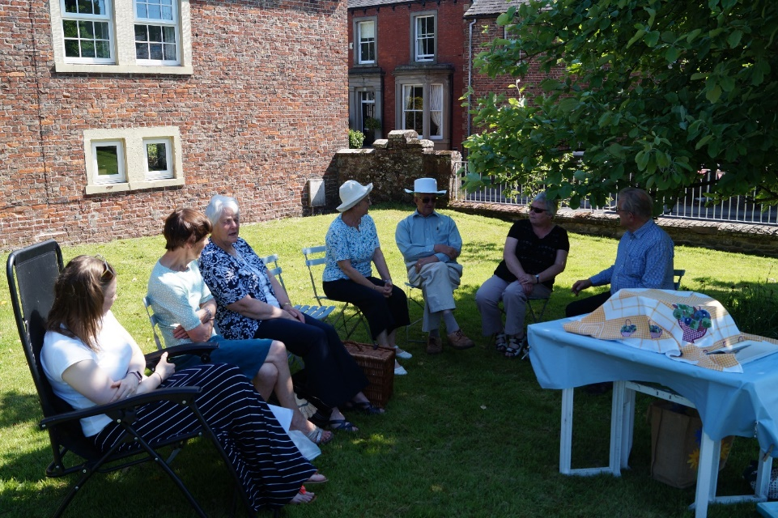
From left to right: Emily Roelich, Jean Wharton, Margaret McKenna, Kathleen Bowron, Harold Bowron, Linda Beattie, Trevor Allison.

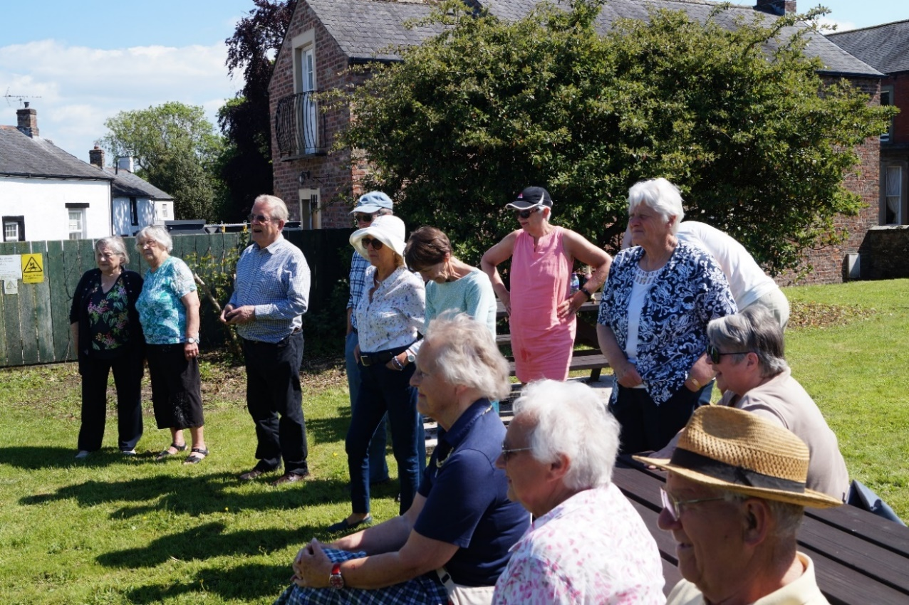
From left to right: Mary Fergusson, Alice Graham, Trevor Allison, Jim Johnson, Eve Johnson, Jean Wharton, Mrs. Bowen, Margaret McKenna. Seated: Margaret Parkinson, Stella and Alan Hodgson, Rona Salkeld,

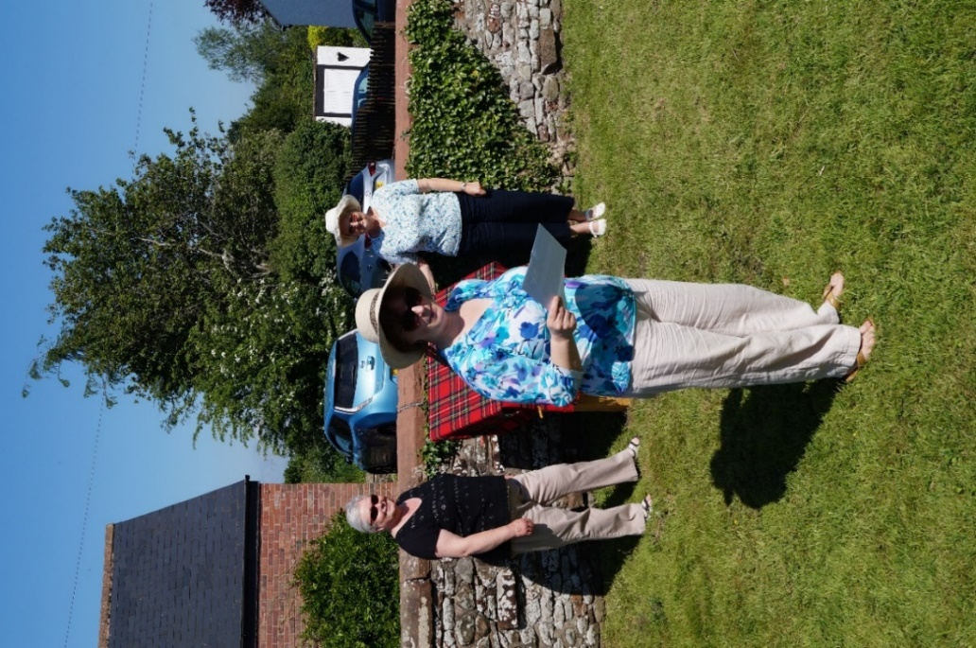
Panel hidden: Linda Beattie, Bryony Kirk, Kathleen Bowron.

Bryony gave a short speech about the history of the Pound and thanked all those who helped with the work to open the Pound as a picnic area, before the new interpretation board was revealed. The panel shows several scenes of sounds that would have been heard in the area.

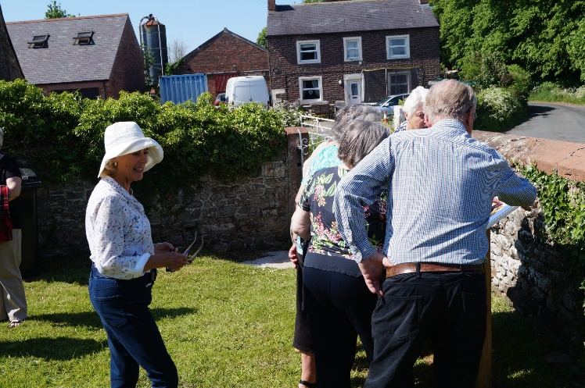
Even Johnson, looks on as others view the interpretation panel

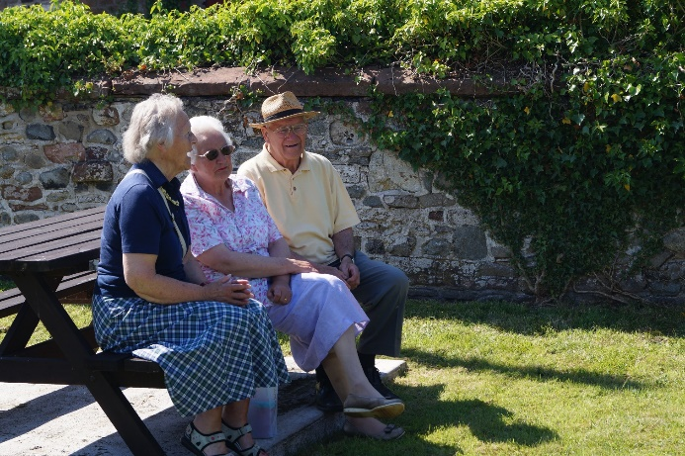
Margaret Parkinson, Stella Hodgson, Alan Hodgson

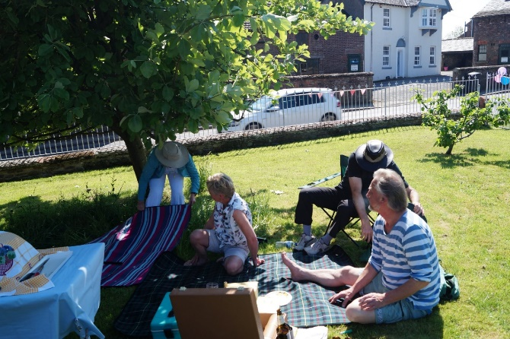
Margaret Milburn, Liz Morton, Chris Crabtree, Gordon Milburn
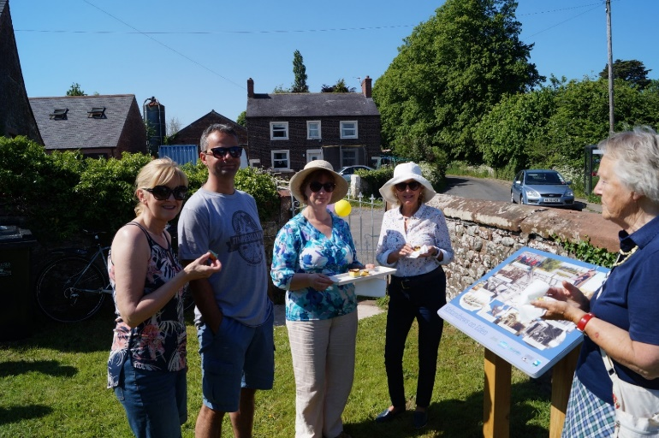
Liz and Stuart Williamson, Bryony Kirk, Eve Johnson, Margaret Parkinson

