Unit History: Labour Corps
The Labour Corps was raised in 1915 and disbanded in 1921, today thier roles are undertaken by the Royal Logistics Corps.
The Corps grew to some 389,900 men (more than 10% of the total size of the Army) by the Armistice. Of this total, around 175,000 were working in the United Kingdom and the rest in the theatres of war. The Corps was manned by officers and other ranks who had been medically rated below the "A1" condition needed for front line service. Many were returned wounded. Labour Corps units were often deployed for work within range of the enemy guns, sometimes for lengthy periods.
In April 1917, a number of Infantry Battalions were transferred to the Corps. The Labour Corps absorbed the 28 ASC Labour Companies between February and June 1917. Labour Corps Area Employment Companies were formed in 1917 for salvage work, absorbing the Divisional Salvage Companies. In the crises of March and April 1918 on the Western Front, Labour Corps Units were used as emergency infantry. It became the 18th -19th Labour Corps in May 1917.
The Corps always suffered from its treatment as something of a second class organization: for example, the men who died are commemorated under their original Regiment, with Labour Corps being secondary. Researching men of the Corps was made more difficult by this until the publication of the mammoth 'Soldiers died in the great war' collection where the Labour Corps was finally given it's own section in volume 80.
First Name:
F
Surname:
Vallis
Nationality:
British
Date of Death:
30/11/1918
Rank:
Private
Service Number:
215828
Service:
British Army
Regiment:
Labour Corps
Battalion:
439th Agricultural Company (Why is this important?)
Commemorated:
Britain

Memorial Register Great Britain and Ireland, Vol 2, WW1, Cemeteries and Churchyards in the County of Berkshire

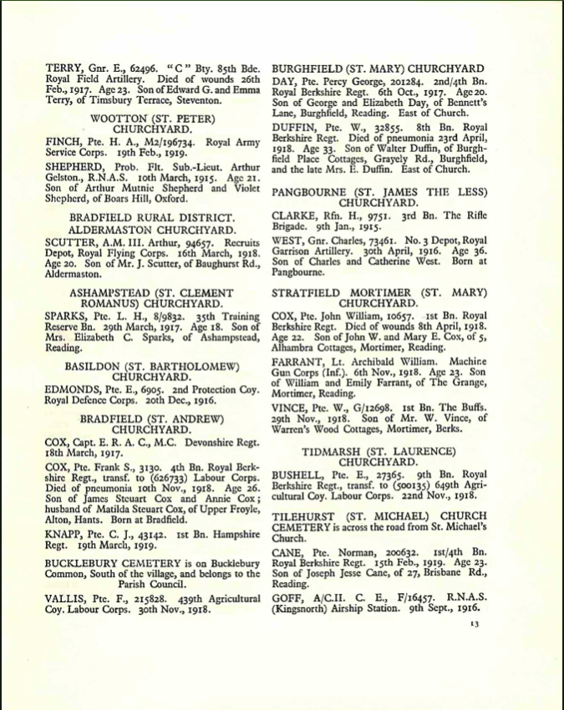

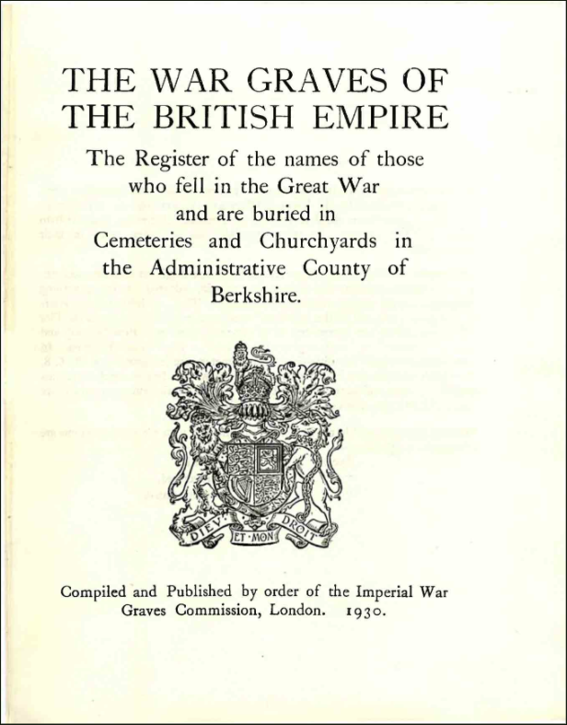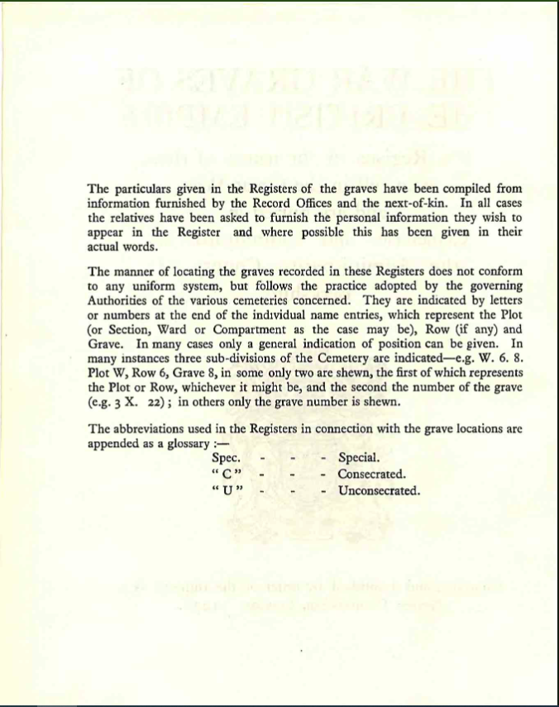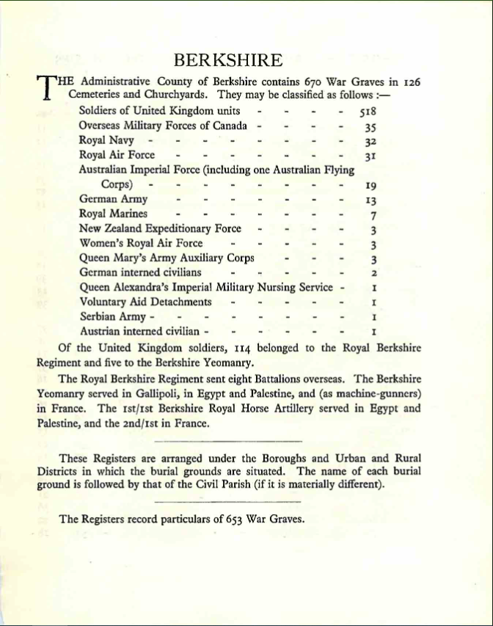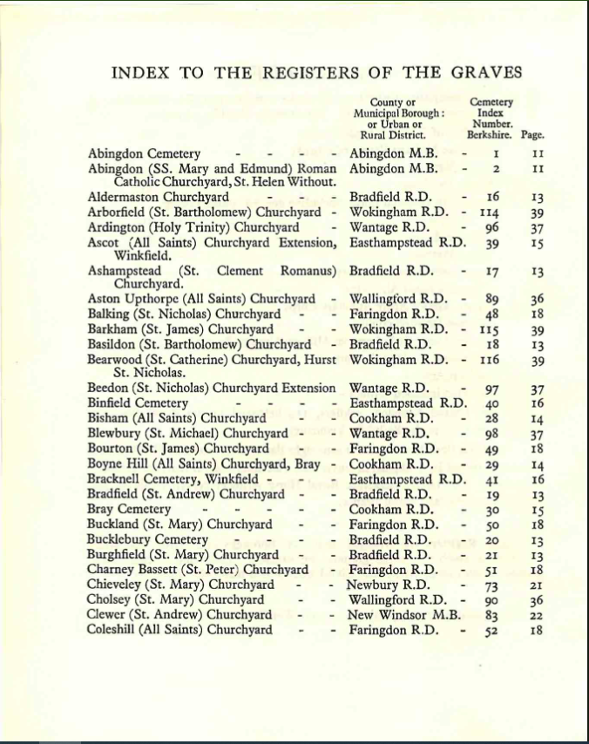British Army
Soldiers had a 'service record', sadly about 70% of WWI records were destroyed from the 1930’s onwards by various civil service audits of the bulk of the material, however the worst damage came from a direct hit on the Arnside (London) repository in an air raid on the 2nd day of the Blitz and the damage also caused in putting the raging fires out.
A service records the military career of the individual, it is made up of various different military forms. The types of forms will differ greatly, this goes hand in hand with the fact that many records will be handwritten and have annotations from the serviceman/woman themselves or a dependents enquiry, therefore whilst very interesting per se, the general legibility of some records is poor.
Service records are sometimes the only place where family details, age, birthplace and former occupations are recorded.

Collection WO363 'The Burnt records'-The National Archives
Many pre WWI records were destroyed intentionally by the war department when being placed into limited storage space in the 1930's, many more were destroyed in the Blitz of 1940. The bulk of these consist of discharge records of those leaving the army between 1914 and 1921, including those who died, sadly only between 20-30% of the total now survive and the originals are not accessible: there are microfiche copies of the surviving records although many are merely fragments of the originals, severely damaged by fire and water.

Pre WWI and up until 1920
Pre WWI and records up to 1920 are held at the National Archives in Kew, and are available to view there by appointment.
WWI Medal cards are also available to download, for a fee, from National Archives - Documents Online.
Please use our document expert service for any help you need in interpreting these. https://www.forces-war-records.co.uk/photo-expert
There are records other than WO363 within the national archive which are not presently available elsewhere:
- WO364 - commonly misnamed as 'the pension records' these contain a small part of what would have originally been in a service record for a number of persons.
- WO97 - Service records until 1914, many remain in their original format at TNA.
- WO96 - as per wo97 but for the militias that existed until 1908.
- PIN26- pensions records, a very small collection.
It is worth noting that if a soldier reenlisted and served therefore after 1921 his records would still be held by the MOD only (see below).
NOV. 11th, 1918
- Canadian forces capture Mons.
- Hostilities Suspended as Armistice concluded between Allies and Germany. - Armistice between Allies and Germany signed at 5a.m.; hostilities cease at 11a.m.
- At suspension of hostilities British troops had reached the line-Franco-Belgian frontier east of Avesnes, Jeumont, Givry, four miles east of Mons, Chievres, Lessines, Grammont.
- Allied forces on the Dwina defeat Bolshevists.
- New National Government formed in Estonia.
- British government officially recognises Latvian provisional government.

The Labour Corps of 1917-1918

Before the formation of the Labour Corps
The Army Service Corps Labour Companies
Among the earliest such units formed, the ASC Labour Companies originated to provide manpower to unload British ships and operate the docks in France. Two railway labour companies were also formed.
The Royal Engineers Labour Battalions
The RE raised 11 Battalions for labouring work.
Infantry Pioneer and Labour or Works Battalions
An early solution to the vast demand for labour was to create in each infantry Division a battalion that would be trained and capable of fighting as infantry, but that would normally be engaged on labouring work. They were given the name of Pioneers. They differed from normal infantry in that they would be composed of a mixture of men who were experienced with picks and shovels (i.e. miners, road men, etc) and some who had skilled trades (smiths, carpenters, joiners, bricklayers, masons, tinsmiths, engine drivers and fitters). A Pioneer battalion would also carry a range of technical stores that infantry would not. This type of battalion came into being with an Army Order in December 1914. In early 1916, a number of infantry battalions composed of men who were medically graded unfit for the fighting were formed for labouring work. They had only 2 officers per battalion. Twelve such battalions existed in June 1916.

The Labour Corps is formed

Army Order 85/17
The formation of the Labour Corps was authorised by a Royal Warrant issued as Army Order 85 published on 22 February 1917. The order specifically made the point that the raising of the Corps was to be a temporary measure but it would be regarded as a Corps for the purposes of the Army Act. Regimental pay would be the same as that of the infantry of the line.
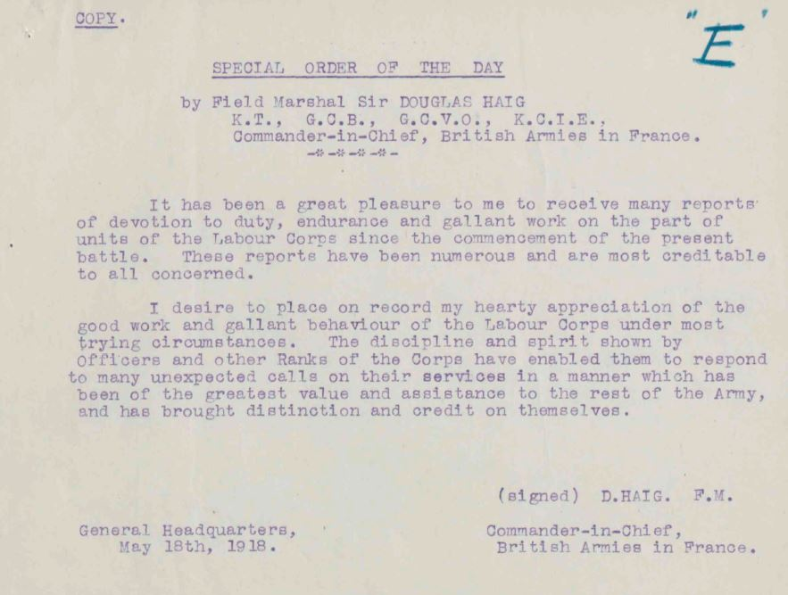From the war diary of Third Army Director of Labour (National Archives WO95/384). Sir Douglas Hiag praised the work of the Labour Corps during the German offensives of spring 1918.

Army Council Instruction 611
Army Council Instruction 611 of 13 April 1917 gave definition to the new Corps. Its purpose was to “obtain more fluidity in utilising the services of men in Infantry Labour and Works units, and to simplify administrative work.
The Corps would consist of a number of different types of units:
- a Labour Company;
- a Labour Group Headquarters;
- a Depot Labour Company;
- a Labour Battalion;
- a (Home Service) Labour Company.

Labour Companies
Army Council Instruction 611 stated that 203 Labour Companies would be formed from existing regimental Infantry Labour Battalions and Infantry Labour Companies. All Warrant Officers and NCOs serving in those units and who were required in the new structure would be transferred to the Labour Corps; all Privates would too. Those Warrant Officers and NCOs not required would be transferred elsewhere.
The original conversion of infantry units to the new companies, with the renumbering applied to the men, is laid out on this page: Labour Companies
An exception was the 1st to 4th Infantry Labour Companies of the Middlesex Regiment, which were not to be transferred to the Labour Corps. Instead, men of the 1st and 2nd ILC who were invalided home would be posted to the regiment’s 30th (Works) Battalion and those of the 3rd and 4th ILC to the 31st (Works) Battalion.

Labour Group Headquarters
These were to be formed overseas. Forty Group HQs would be formed in France and two in Salonika. They would be responsible for the discipline, administration and interior economy of the Labour Companies working with the district allotted to the Group Headquarters.
The original list of Labour Group HQs, with the renumbering applied to the men, is laid out on this page: Labour Group Headquarters

Depot Labour Companies
Army Council Instruction 611 stated that the eleven Depot Labour Companies were to be formed by the existing Depot Labour Companies in six of the the army commands at home. Their purpose was to provide drafts for Labour Companies serving overseas; to provide men locally for working parties as fatigues, as long as they could be quickly recalled if needed; to receive labour personnel returned from overseas and to deal with them according to their medical category: men of category “A” would be transferred to a Reserve Battalion of the infantry, B1, B2, C1 and C2 would be available for drafting overseas again, and B3 and C3 (i.e. fit only for home service) would be dealt with according to regulations in force at the time.
The first ten companies would be numbered 295 to 304 Depot Labour Companies and the last would be 320 (Home Service) Depot Labour Company.
The original list of Depot Labour Companies, with the renumbering applied to the men, is laid out on this page: Depot Labour Companies
Army Council Instruction 897 of 1917 changed the name of these units to Reserve Labour Company.

Labour Battalions
Army Council Instruction 611 stated that Labour Battalions would be formed from existing regimental Infantry Works Battalions. Their purpose was to provide working parties for military purposes as and when required and for civil work if they could be spared. They were for home service only.
The original list of Labour Battalions, with the renumbering applied to the men, is laid out on this page: Labour Battalions
An exception was the 30th and 31st (Works) Battalions of the Middlesex Regiment, which were not to be transferred to the Labour Corps.

Dress distinctions
Army Council Instruction 611 stated that men of the Labour Corps would wear the “Royal Arms” as a cap badge, with the following shoulder titles. It was recognised that it would be some time before these were all fully available and that in the meantime Men would continue to wear their pre-transfer insignia.
- Labour Companies, (Home Service) Labour Companies and Depot Labour Companies: the letters “LC” preceded by the number of their Company (e.g. “24LC”);
- Labour Group Headquarters: the letters “LC” with no numeric prefix;
- Labour Battalions: the letters “LB” preceded by the number of their Battalion (e.g. “4LB”).
(This instruction was soon cancelled by ACI 837 and all men would now wear just the “LC”.)
The man would also need a new identity disc bearing his Labour Corps details. Old discs were to be gathered in and defaced or destroyed.
The war diaryt of Third Army’s Director of Labour includes a memorandum in the spring of 1918 reporting that men (who had been medically downgraded after being wounded and then trasferred to the Labour Corps) wished to retain the cap badge of their original regiment. He suggested that only the LC shoulder title was required.

War diaries of Labour Corps units
Army Council Instruction 611 stated that units of the Labour Corps would not be required to maintain a war diary unless the Commander-in-Chief concerned authorised otherwise. This, and the fact that the nominal rolls and other documents were destroyed in the Arnside Street fire in 1940 makes researching a man of the Labour Corps difficult and producing a good analysis of his story a rather sketchy affair.

Army Council Instruction 837 of 23 May 1917
This ACI also defined four new types of units:
- a Divisional Employment Company;
- an Area Employment Company;
- a (Home Service) Employment Company; and
- a Depot Employment Company.
The first two of these types would be formed under orders of the Field Marshal Commander-in-Chief in France; the others under the home commands. A Labour Corps Base Depot would also be formed in France. Details are laid out on this page: The Divisional, Area or Home Service Employment Companies of the Labour Corps

Army Council Instruction 897 of 1917
This ACI also defined two new types of units:
- a Labour Centre;
- a (Home Service) Labour Company.
They were to be formed from the remaining personnel of Labour Battalions who were not posted to Employment Companies.

Labour Centres
One Labour Centre was raised for each of the home commands (Scottish, Northern, Western, Irish, Eastern, Aldershot, Southern and London District) and named, for example, as Scottish Command Labour Centre.
Its role was to provide drafts for overseas Labour Companies.
Men who were in Labour Battalions but at present attached to the Forage Companies of the Army Service Corps would be posted as follows: V Forage Company to Eastern Command Labour Centre; W and Z to Southern; X to Northern; Y to Western; R to Scottish; Q to London District.

(Home Service) Labour Companies
Army Council Instruction 897 stated that the 53 (Home Service) Labour Companies were to be formed by transfer and conversion of existing Infantry Works Companies.
The original list of (Home Service) Labour Companies, with the renumbering applied to the men, is laid out on this page: (Home Service) Labour Companies

Army Council Instruction 924 of 12 June 1917
This ACI authorised the transfer of existing Agricultural Companies to be transferred to the Labour Corps. Research carried out by historians John Starling and Ivor Lee suggests that the transferred men were numbered in the Labour Corps sequence in the block 23000 to 29000.The “company” did not exist as a formed body, for with the exception of its small headquarters unit the men either lived at home or were billeted near the farm or smallholding at which they were employed. A further set of companies was established in October 1917.

Army Council Instruction 985 of 20 June 1917
This ACI authorised the other ranks of the existing 1st to 11th RE Labour Battalions in France to transfer and became 700 to 710 Labour Companies of the Labour Corps respectively. Men affected by this transfer were renumbered in the Labour Corps range 289501 to 295100. 12th Labour Battalion in Salonika became 711 Labour Company of the Labour Corps and its men were renumbered in the range 348240 to 349500.
It also authorised the other ranks of the existing ASC Labour Companies to be transferred: ASC Labour Companies 1 – 3, 5 – 16, 18 – 20, 24 – 25, 27 – 28 and 31 – 32 became 712 t0 735 Labour Companies of the Labour Corps respectively. Men affected by this transfer were renumbered in the Labour Corps range 296701 to 310800.
…
The labour units became increasingly well-organised but despite adding large numbers of men from India, Egypt, China and elsewhere, there was never enough manpower to do all the labouring work required. In many cases the men of the infantry, artillery and other arms were forced to give up time to hard effort when perhaps training or rest might have been a more effective option.
According to the Official History: “..although some labour units were raised and eventually labourers from various parts of the Empire and China were brought to France, the numbers were never at any period sufficient for the demands of a great army operating in a friendly country”.
The Corps grew to some 389,900 men (more than 10% of the total size of the Army) by the Armistice. Of this total, around 175,000 were working in the United Kingdom and the rest in the theatres of war. In the crises of March and April 1918 on the Western Front, some Labour Corps units were used as emergency infantry.
Indian, Chinese, native South African, Egyptian and other overseas labour
With the shortage of manpower for labouring work continuing, Sir Douglas Haig requested an increase in the force of an additional 21,000 men. This demand was filled by importing men from China (where the British followed a French lead and signed an agreement with the Chinese for a supply of men), India, South Africa, Egypt and other places within the British Empire. Demand continued and by the wars end a total of approximately 300,000 such workers had been engaged, of which 193,500 were in France and Flanders. By the end of 1917 there were 50,000 Chinese workers in France, rising to 96,000 by August 1918 (with another 30,000 working for the French). 100,000 Egyptians were working in France and the Middle East, alongside 21,000 Indians and 20,000 South Africans, who were also in East Africa. They were kept on lines of communication and other work well behind the fighting line, and as a force were rather immobile due to the decisions to segregate them – many of these workers were black – and provide special camps. Indian labourers were more often used closer to the front lines, on fortification work. Many Indians were also used in Divisional Ammunition Column work, as drivers as well as in the manual tasks. The South African Native Labour Corps came to France early in 1917 and established a base at Arques-la-Bataille.
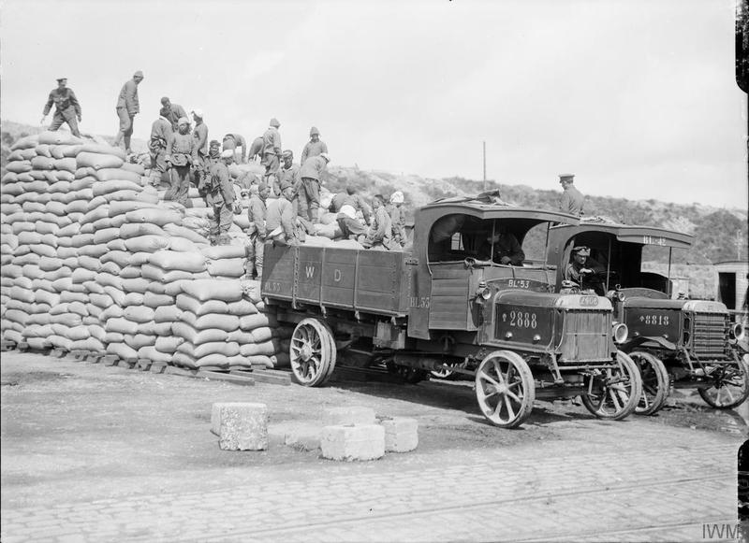Men of the Chinese Labour Corps stacking sacks of corn at Boulogne, 12 August 1917. Imperial war Museum image Q2701
Use of enemy prisoners of war
Until mid 1916, German prisoners were sent to England. From this time onward, prisoners were initially sent to Abbeville. Men with useful skills, notably forestry and engineering, were drafted into companies of about 100 men each, for use in POW Forestry Companies and ASC and RE workshops, respectively. 47 such POW labour companies were attached to the Labour Corps when it was formed.

Commemoration of men of the Labour Corps
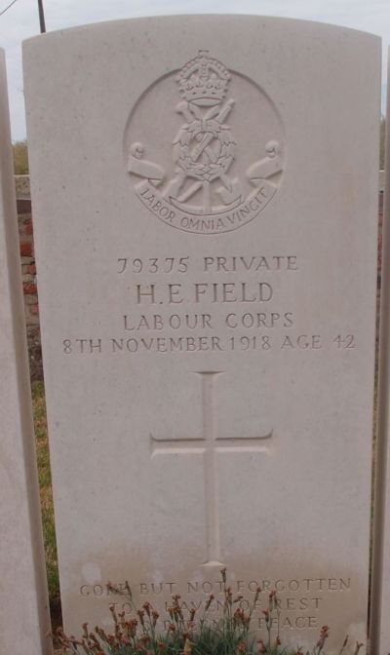The headstone of Pte 79375 Henry Edward Field of 133 Labour Company in Kezelberg Military Cemetery. Although he transferred into this unit from 25 Infantry Labour Company of the Queen’s (Royal West Surrey Regiment) he has Labour Corps insignia. One of the relatively few headstones of this design. Field died, of injuries sustained accidentally: his skull had been fractured in a train collision. He was brought in, already dead, to 3rd Australian Casualty Clearing Station.

Labour Companies of the Labour Corps
Original companies formed under Army Council Instruction 611 of 1917
Original regiment | Unit | Becomes Labour Company number | Men are renumbered from | to
Royal Scots | 19th (Labour) Battalion | 1 | 1 | 600
ditto | ditto | 2 | 601 | 1200
Scottish Rifles | 14th (Labour) Battalion | 3 | 1201 | 1800
ditto | ditto | 4 | 1801 | 2400
Black Watch | 12th (Labour) Battalion | 5 | 2401 | 3000
ditto | ditto | 6 | 3001 | 3600
Cameron Highlanders | 9th (Labour) Battalion | 7 | 3601 | 4200
ditto | ditto | 8 | 4201 | 4800
Royal Scots Fusiliers | 1st Infantry Labour Company | 9 | 4801 | 5400
ditto | 2nd Infantry Labour Company | 10 | 5401 | 6000
ditto | 3rd Infantry Labour Company | 11 | 6001 | 6600
Seaforth Highlanders | 1st Infantry Labour Company | 12 | 6601 | 7200
ditto | 2nd Infantry Labour Company | 13 | 7201 | 7800
ditto | 3rd Infantry Labour Company | 14 | 7801 | 8400
ditto | 4th Infantry Labour Company | 15 | 8401 | 9000
Lincolsnhire Regiment | 12th (Labour) Battalion | 16 | 9001 | 9600
ditto | diito | 17 | 9601 | 10200
West Yorkshire Regiment | 22nd (Labour) Battalion | 18 | 10201 | 10800
ditto | ditto | 19 | 10801 | 11400
Leicestershire Regiment | 13th (Labour) Battalion | 20 | 11401 | 12000
ditto | ditto | 21 | 12001 | 12600
Yorkshire Regiment | 16th (Labour) Battalion | 22 | 12601 | 13200
ditto | ditto | 23 | 13201 | 13800
West Riding Regiment | 12th (Labour) Battalion | 24 | 13801 | 14400
ditto | ditto | 25 | 14401 | 15000
South Staffordshire Regiment | 12th (Labour) Battalion | 26 | 15001 | 15600
ditto | ditto | 27 | 15601 | 16200
Sherwood Foresters | 20th (Labour) Battalion | 28 | 16201 | 16800
ditto | ditto | 29 | 16801 | 17400
York & Lancaster Regiment | 17th (Labour) Battalion | 30 | 17401 | 18000
ditto | ditto | 31 | 18001 | 18600
Durham Light Infantry | 1st Infantry Labour Company | 32 | 18601 | 19200
ditto | 2nd Infantry Labour Company | 33 | 19201 | 19800
ditto | 3rd Infantry Labour Company | 34 | 19801 | 20400
ditto | 4th Infantry Labour Company | 35 | 20401 | 21000
ditto | 5th Infantry Labour Company | 36 | 21001 | 21600
ditto | 6th Infantry Labour Company | 37 | 21601 | 22200
ditto | 7th Infantry Labour Company | 38 | 22201 | 22800
ditto | 8th Infantry Labour Company | 39 | 22801 | 23400
Lincolnshire Regiment | 1st Infantry Labour Company | 40 | 23401 | 24000
ditto | 2nd Infantry Labour Company | 41 | 24001 | 24600
ditto | 3rd Infantry Labour Company | 42 | 24601 | 25200
ditto | 4th Infantry Labour Company | 43 | 25201 | 25800
ditto | 5th Infantry Labour Company | 44 | 25801 | 26400
ditto | 6th Infantry Labour Company | 45 | 26401 | 27000
ditto | 7th Infantry Labour Company | 46 | 27001 | 27600
ditto | 8th Infantry Labour Company | 47 | 27601 | 28200
ditto | 9th Infantry Labour Company | 48 | 28201 | 28800
ditto | 10th Infantry Labour Company | 49 | 28801 | 29400
ditto | 11th Infantry Labour Company | 50 | 29401 | 30000
ditto | 12th Infantry Labour Company | 51 | 30001 | 30600
ditto | 13th Infantry Labour Company | 52 | 30601 | 31200
ditto | 14th Infantry Labour Company | 53 | 31201 | 31800
ditto | 15th Infantry Labour Company | 54 | 31801 | 32400
ditto | 16th Infantry Labour Company | 55 | 32401 | 33000
Cheshire Regiment | 18th (Labour) Battalion | 56 | 33001 | 33600
ditto | ditto | 57 | 33601 | 34200
Cheshire Regiment | 19th (Labour) Battalion | 58 | 34201 | 34800
ditto | ditto | 59 | 34801 | 35400
Cheshire Regiment | 20th (Labour) Battalion | 60 | 35401 | 36000
ditto | ditto | 61 | 36001 | 36600
Cheshire Regiment | 21st (Labour) Battalion | 62 | 36601 | 37200
ditto | ditto | 63 | 37201 | 37800
Cheshire Regiment | 22nd (Labour) Battalion | 64 | 37801 | 38400
ditto | ditto | 65 | 38401 | 39000
Liverpool Regiment | 1st Infantry Labour Company | 66 | 39001 | 39600
ditto | 2nd Infantry Labour Company | 67 | 39601 | 40200
ditto | 3rd Infantry Labour Company | 68 | 40201 | 40800
ditto | 4th Infantry Labour Company | 69 | 40801 | 41400
ditto | 5th Infantry Labour Company | 70 | 41401 | 42000
ditto | 6th Infantry Labour Company | 71 | 42001 | 42600
ditto | 7th Infantry Labour Company | 72 | 42601 | 43200
ditto | 8th Infantry Labour Company | 73 | 43201 | 43800
ditto | 9th Infantry Labour Company | 74 | 43801 | 44400
ditto | 10th Infantry Labour Company | 75 | 44401 | 45000
ditto | 11th Infantry Labour Company | 76 | 45001 | 45600
ditto | 12th Infantry Labour Company | 77 | 45601 | 46200
ditto | 13th Infantry Labour Company | 78 | 46201 | 46800
ditto | 14th Infantry Labour Company | 79 | 46801 | 47400
ditto | 15th Infantry Labour Company | 80 | 47401 | 48000
ditto | 16th Infantry Labour Company | 81 | 48001 | 48600
ditto | 17th Infantry Labour Company | 82 | 48601 | 49200
ditto | 18th Infantry Labour Company | 83 | 49201 | 49800
ditto | 19th Infantry Labour Company | 84 | 49801 | 50400
ditto | 20th Infantry Labour Company | 85 | 50401 | 51000
ditto | 21st Infantry Labour Company | 86 | 51001 | 51600
ditto | 22nd Infantry Labour Company | 87 | 51601 | 52200
ditto | 23rd Infantry Labour Company | 88 | 52201 | 52800
ditto | 24th Infantry Labour Company | 89 | 52801 | 53400
ditto | 25th Infantry Labour Company | 90 | 53401 | 54000
ditto | 26th Infantry Labour Company | 91 | 54001 | 54600
ditto | 27th Infantry Labour Company | 92 | 54601 | 55200
Queen's (Royal West Surrey) | 13th (Labour) Battalion | 93 | 55201 | 55800
ditto | ditto | 94 | 55801 | 56400
Queen's (Royal West Surrey) | 14th (Labour) Battalion | 95 | 56401 | 57000
ditto | ditto | 96 | 57001 | 57600
Queen's (Royal West Surrey) | 15th (Labour) Battalion | 97 | 57601 | 58200
ditto | ditto | 98 | 58201 | 58800
Royal Fusiliers | 33rd (Labour) Battalion | 99 | 58801 | 59400
ditto | ditto | 100 | 59401 | 60000
Royal Fusiliers | 34th (Labour) Battalion | 101 | 60001 | 60600
ditto | ditto | 102 | 60601 | 61200
Royal Fusiliers | 35th (Labour) Battalion | 103 | 61201 | 61800
ditto | ditto | 104 | 61801 | 62400
Royal Fusiliers | 36th (Labour) Battalion | 105 | 62401 | 63000
ditto | ditto | 106 | 63001 | 63600
Royal Fusiliers | 37th (Labour) Battalion | 107 | 63601 | 64200
ditto | ditto | 108 | 64201 | 64800
Queen's (Royal West Surrey) | 1st Infantry Labour Company | 109 | 64801 | 65400
ditto | 2nd Infantry Labour Company | 110 | 65401 | 66000
ditto | 3rd Infantry Labour Company | 111 | 66001 | 66600
ditto | 4th Infantry Labour Company | 112 | 66601 | 67200
ditto | 5th Infantry Labour Company | 113 | 67201 | 67800
ditto | 6th Infantry Labour Company | 114 | 67801 | 68400
ditto | 7th Infantry Labour Company | 115 | 68401 | 69000
ditto | 8th Infantry Labour Company | 116 | 69001 | 69600
ditto | 9th Infantry Labour Company | 117 | 69601 | 70200
ditto | 10th Infantry Labour Company | 118 | 70201 | 70800
ditto | 11th Infantry Labour Company | 119 | 70801 | 71400
ditto | 12th Infantry Labour Company | 120 | 71401 | 72000
ditto | 13th Infantry Labour Company | 121 | 72001 | 72600
ditto | 14th Infantry Labour Company | 122 | 72601 | 73200
ditto | 15th Infantry Labour Company | 123 | 73201 | 73800
ditto | 16th Infantry Labour Company | 124 | 73801 | 74400
ditto | 17th Infantry Labour Company | 125 | 74401 | 75000
ditto | 18th Infantry Labour Company | 126 | 75001 | 75600
ditto | 19th Infantry Labour Company | 127 | 75601 | 76200
ditto | 20th Infantry Labour Company | 128 | 76201 | 76800
ditto | 21st Infantry Labour Company | 129 | 76801 | 77400
ditto | 22nd Infantry Labour Company | 130 | 77401 | 78000
ditto | 23rd Infantry Labour Company | 131 | 78001 | 78600
ditto | 24th Infantry Labour Company | 132 | 78601 | 79200
ditto | 25th Infantry Labour Company | 133 | 79201 | 79800
ditto | 26th Infantry Labour Company | 134 | 79801 | 80400
ditto | 27th Infantry Labour Company | 135 | 80401 | 81000
ditto | 28th Infantry Labour Company | 136 | 81001 | 81600
ditto | 29th Infantry Labour Company | 137 | 81601 | 82200
ditto | 30th Infantry Labour Company | 138 | 82201 | 82800
Northamptonshire Regiment | 1st Infantry Labour Company | 139 | 82801 | 83400
ditto | 2nd Infantry Labour Company | 140 | 83401 | 84000
ditto | 3rd Infantry Labour Company | 141 | 84001 | 84600
ditto | 4th Infantry Labour Company | 142 | 84601 | 85200
ditto | 5th Infantry Labour Company | 143 | 85201 | 85800
ditto | 6th Infantry Labour Company | 144 | 85801 | 86400
ditto | 7th Infantry Labour Company | 145 | 86401 | 87000
ditto | 8th Infantry Labour Company | 146 | 87001 | 87600
ditto | 9th Infantry Labour Company | 147 | 87601 | 88200
ditto | 10th Infantry Labour Company | 148 | 88201 | 88800
ditto | 11th Infantry Labour Company | 149 | 88801 | 89400
ditto | 12th Infantry Labour Company | 150 | 89401 | 90000
ditto | 13th Infantry Labour Company | 151 | 90001 | 90600
Devonshire Regiment | 12th (Labour) Battalion | 152 | 90601 | 91200
ditto | ditto | 153 | 91201 | 91800
Devonshire Regiment | 14th (Labour) Battalion | 154 | 91801 | 92400
ditto | ditto | 155 | 92401 | 93000
Duke of Cornwall's Light Infantry | 12th (Labour) Battalion | 156 | 93001 | 93600
ditto | ditto | 157 | 93601 | 94200
Royal Berkshire Regiment | 10th (Labour) Battalion | 158 | 94201 | 94800
ditto | ditto | 159 | 94801 | 95400
Royal Berkshire Regiment | 11th (Labour) Battalion | 160 | 95401 | 96000
ditto | ditto | 161 | 96001 | 96600
Royal Berkshire Regiment | 12th (Labour) Battalion | 162 | 96601 | 97200
ditto | ditto | 163 | 97201 | 97800
Royal Berkshire Regiment | 13th (Labour) Battalion | 164 | 97801 | 98400
ditto | ditto | 165 | 98401 | 99000
Devonshire Regiment | 1st Infantry Labour Company | 166 | 99001 | 99600
ditto | 2nd Infantry Labour Company | 167 | 99601 | 100200
ditto | 3rd Infantry Labour Company | 168 | 100201 | 100800
ditto | 4th Infantry Labour Company | 169 | 100801 | 101400
ditto | 5th Infantry Labour Company | 170 | 101401 | 102000
ditto | 6th Infantry Labour Company | 171 | 102001 | 102600
ditto | 7th Infantry Labour Company | 172 | 102601 | 103200
ditto | 8th Infantry Labour Company | 173 | 103201 | 103800
ditto | 9th Infantry Labour Company | 174 | 103801 | 104400
ditto | 10th Infantry Labour Company | 175 | 104401 | 105000
ditto | 11th Infantry Labour Company | 176 | 105001 | 105600
ditto | 12th Infantry Labour Company | 177 | 105601 | 106200
Hampshire Regiment | 1st Infantry Labour Company | 178 | 106201 | 106800
ditto | 2nd Infantry Labour Company | 179 | 106801 | 107400
ditto | 3rd Infantry Labour Company | 180 | 107401 | 108000
ditto | 4th Infantry Labour Company | 181 | 108001 | 108600
Royal Irish Regiment | 1st Infantry Labour Company | 182 | 108601 | 109200
ditto | 2nd Infantry Labour Company | 183 | 109201 | 109800
Companies numbered 194 to 200 (in which men would be numbered in blocks of 600 per company, from 109801 to 120000) were allocated to the Commander in Chief of British Armies in France for future use. Similarly, Companies numbered 201 to 203 (in which men would be numbered in blocks of 600 per company, from 120001 to 121800) were allocated to the Commander in Chief of the British Salonika Force.

Links
Labour Corps
The composition of a Labour Corps Company

Labour Corps (British Army)
From Wikipedia, the free encyclopedia
Jump to navigationJump to search
The Labour Corps was a British Army unit formed in 1917 for manual and skilled labour on the Western Front and Salonika during the First World War. In previous centuries the British Army had fulfilled this role through the Royal Pioneer Corps (1762-1763), the Corps of Pioneers (1795-1800) and the Army Works Corps (1855-c.1856). Though it disbanded in 1921, it is often seen as the predecessor to the Royal Pioneer Corps of the Second World War.^{[1]}

History[edit]
Earlier in the war the Army Service Corps had formed labour companies to work docks and railways and unload ships and the Royal Engineers had formed eleven labour battalions for manual work. From December 1914 onwards each infantry division had also been provided with a Pioneer Battalion, with full infantry training but usually used in manual and skilled work and thus consisting of those with experience in those areas. From early 1916 onwards conscripted men with health too poor for fighting were also assigned to these battalions, twelve of which had been formed by June that year.^{[2]}
On 22 February 1917 an Army Order formed the Labour Corps, turning the pre-existing Infantry Labour Companies and Infantry Labour Battalions into 203 Labour Companies. The Corps as formed also included Depot Labour Companies (renamed Reserve Labour Companies later in 1917) back in the United Kingdom as well as seven Labour Battalions converted from the Works or Infantry Works battalions of the King's (Liverpool Regiment), the Devonshire Regiment, the Royal Scots Fusiliers, the Middlesex Regiment and the Durham Light Infantry.^{[3]} All these would be commanded by forty-two Labour Group Headquarters. Later in 1917 eight Labour Centres were added to the Corps, one for each of the eight home commands, as were the existing Infantry Works Companies (renamed Home Service Labour Companies) and Agricultural Companies.^{[2]}
In 1916, Colonel Richard S. H. Moody raised, from the Devonshire Regiment, and took to France,^{[4]} as Commander, a battalion of the Labour Corps, which he commanded from 1917^{[5]} to 1918, after which he retired from active service.^{[6]} By November 1918 the Corps numbered around 389,900 men.^{[2]}

References[edit]
  - ^ "Royal Pioneer Corps". regiments.org. Archived from the original on 2008-01-13. Retrieved 6 December 2020.
  - ^ Jump up to:ª ^{b} ^{c} "The Labour Corps 1917-1918". The Long, Long Trail.
  - ^ "Labour Battalions of the Labour Corps". The Long, Long Trail.
  - ^ "Obituary of Colonel Richard S. H. Moody, Windsor Paper, July 1930, 'Newspaper cuttings concerning St. George's Chapel and Military Knights of Windsor', Reference No.:SGC M.1042, College of St. George, Windsor Castle". Dean and Canons of Windsor. 1930.
  - ^ "No. 30183". The London Gazette (Supplement). 13 July 1917. p. 7080.
  - ^ "No. 30839". The London Gazette (Supplement). 9 August 1918. p. 9443.

Agricultural companies were not so much recruited as formed from soldiers no longer fit enough for front line combat duties, in much the same way as some labour battalions were. Their task was to work the land as there were major labour shortages due to the war and food production was vital. Farmers were charged for the use of personnel from them. Some of the men were trained in tractor driving which many of the older farmers were unable or unwilling to learn. Murray MACLEAN's book 'Farming and Forestry on the Western Front 1915- 1919' published in 2004 is exceptionally good - it has 124 splendid photograhs covering farming and forestry on the Home Front and the Western Front.
You will find Chapter 2 most informative in terms of British Army Farming Operations 1915-19.
By October 1917 ammunition at the rate of 56,000 tons per week was being shipped to the Western Front - the second highest weekly tonnage being forage at 35,970 tons per week. (Hay,straw and oats for the feeding of army horses and mules)
All the other Theatres of War away from the Western Front also required supplying and its little wonder that the Army busied itself with food production following the fall of Baghdad in 1917 in the fertile lands in Mespotamia once they had driven the Turks out of the immediate vicinity.

One of the problem with the Agricultural Companies is that each had a HQ that was its administrative centre although men could work on farms not only in that area but could be miles away.
Although not your area I have even come across one man who Agricultural Company's HQ was in Kent but he worked on a farm near his home in Norfolk.
Anyway if you want to send me a list of the towns that you are interested in I'll send you a list of the companies based in them.
When they were organised on a regimental basis then there would be a possibility as men from a particular regiment were more likely to come from the same area. However when they became part of the labour corps I guess it would be more told to go where you are most needed

Thanks Ivor - the ones I have do partially correlate with above:
443rd Agricultural Company, Labour Corps
447th Agricultural Company, Labour Corps
449th Agricultural Company, Labour Corps (3)
532nd Agricultural Company, Labour Corps
620th Agricultural Company, Labour Corps
626th Agricultural Company, Labour Corps
Three men in the 449th!
The HQs for the Companies were located as below
443 - Dorchester
447 - Devizes
449 - Taunton
532 - Preston and then Wrexham
620 - Aldershot and then Warwick
626 - Taunton
Interesting to see two Companies were not local to your area - that doesn't necessarily mean the man was employed in their areas.
In the graveyard of my parish church in Worcestershire, there's the CWGC grave of a member of an Agricultural Co. of the Labour Corps. I'm writing a memorial to the lads of the village who died in the two World Wars and the Falklands and, as this chap wasn't a local lad - being born and bred in Norfolk - he isn't really part of my subject matter . Even so, I've naturally tried to find out more but with little success, other than from census material from the Overstrand/Cromer area of Norfolk (where he was born and lived at least until 1911) and from Ivor, bless him! The soldier's name is Henry Robert Comer; he died, age 35, on 29th August, 1918; his Labour Corps number was 431206 and he was serving at the time of his death in the 424th Agricultural Company (H.Q. in Worcester). Yet his headstone doesn't mention any of that service detail (I found some of it in 'Soldiers Died', the rest from Ivor). It only refers to his original regiment, the Royal Norfolk Regiment (in which his number was 6762), which seems to be a bit of a slap in the face for his final unit! Naturally his service records didn't survive Hitler's bombs!
It also seems quite sad that he wasn't taken home to Norfolk for burial, as would have been normal. Maybe his family couldn't afford or weren't able for some other reason to bring him home. It's also sad that it's so hard to get any kind of detail about people in the Agricultural Companies; even someone who was actually working on farms in this area. However, it seems that the Agricultural Companies didn't do much in the way of record-keeping and that little survives of whatever they did keep. So Henry Robert might be fairly typical of the lads who were transferred into the Agricultural Companies - for whatever reason. At least his grave is in a lovely corner of a lovely corner of the Heart of England. - but I haven't figured out how to add a photo!
It is correct that Agricultural Companies were largely made up of those who were no longer fit for front line duties however there was another group . When the war office raised the level for conscription from 45 to 50 the those new men could opt to join an Agriculture Company.

AGRICULTURAL COMPANIES OF THE LABOUR CORPS
This community remembers those who served in an agricultural labour company during the First World War. These men were generally unfit for front line service (either due to wounds or from the beginning of their army service). Some had previous farming experience, others were sent to work on the farms with very limited prior knowledge of farming.

Kingston upon Hull War Memorial 1914 - 1918
The story of Hull in World War 1
- At Home

- At Sea

- WW1

- Our Losses

- Memorials

- Regiments

- Battles

- Galleries

- Map

- Directory Searches

Ashley, George
BORN STAFFORD 1888. SON OF THE LATE WILLIAM ASHBY, AND SARAH ELLEN HODGSON, OF 45 BAKER STREET, KIRKSTALL ROAD, LEEDS. A PLOUGHMAN AND FARM WAGGONER. HE ENLISTED IN HULL, ON 22/09/1916, AGED 28 YEARS AND 6 MONTHS. JOINED AS PRIVATE, AS 49214, 13TH DEVONSHIRE REGIMENT AND 170TH LABOUR CORPS.. DESCRIBED AS 5 FOOT, 7 INCHES TALL, 140 LBS WEIGHT, 38 INCH CHEST AND OF ‘GOOD’ PHYSIQUE. ARRIVED IN FRANCE, ON 21/09/1916. RETURNED TO ENGLAND ON 16/06/1917. MARRIED MARY WHITEWICK, AT OVERTON, BASINGSTOKE, HAMPSHIRE, ON 20/07/1917. HIS WIFE MARY LIVED AT THIS HULL ADDRESS (ARMY RECORDS). POSTED TO THE ‘R’ COMPANY, 439TH AGRICULTURAL LABOUR CORPS, IN READING, ON 30/09/1917. HE DIED OF FLU AT CAMBRIDGE HOSPITAL, ON 06/11/1918. AGED 30.
BURIED AT FOVANT (ST. GEORGE) CHURCHYARD, WILTSHIRE, UK
HE NEVER SAW HIS DAUGHTER, SARAH ELLEN ASHLEY, BORN ON 24/11/1918, WHO THEN DIED ON 26/01/1919. A DOUBLE LOSS FOR HIS WIDOW, MARY. SHE BECAME MARY JAMES AND MOVED TO BAMPTON, OXFORD. HIS ARMY RECORDS STATE THAT HE WAS BROTHER TO WILLIAM, ARTHUR AND AMY ASHLEY, BUT HE DID NOT KNOW THEIR WHEREABOUTS. ANOTHER SISTER, MARY HAD MARRIED AND MOVED TO CANADA, TO AN UNKNOWN ADDRESS.
GEORGE ASHLY HAD SERVED IN THE ARMY FOR 2 YEARS AND 47 DAYS. HE RECEIVED THE BRITISH WAR AND VICTORY MEDALS. HOWVER, THERE IS NO CWGC RECORD OF GEORGE ASHLEY’S DEATH?

First name:
GEORGE
Regiment:
Labour Corps 617th Agricultural Company
Military Number:
101460 49214
Rank:
Private
Date Died
06/11/1918
Place died:
FOVANT (ST. GEORGE) CHURCHYARD, WILTSHIRE, UK
Age:
30
There are few records of their service, most men who were posted into the Corps were in a lower medical category (B(i)) or (ii) and unfit for active service. Often this was a consequence of wounds on active service. 435 Agricultural Company was disbanded at Danbury in Essex on 17.7.1919 and men transferred to other Companies. In November 1918 they were at Chignall St James. it appears that administratively men were posted into the Company from Warley in the West Midlands.

The 437th Agricultural Company was created in autumn 1917 and Located in Maidstone.
An Agricultural Company strength consisted of; CO a Major or Captain, 2 Sub Alterns 2 NCOs and 250 other ranks, although most were well under strength.
POWs were attached to the Agricultural Companies with the men primarily acting as guards.

This information comes from:

'No Labour, No Battle - Military Labour During the First World War' John Starling and Ivor Lee

There are several pages in the book that give more detail of activities of the Agricultural companies.
Again this is from 'No Labour No Battle'. Up to 1916 all POWs were moved to Britain and employed largely in agriculture. In 1916 it was decided to retain POWs in France for non military work such as road and railway maintenance and construction. 5 companies were set up in August 1916, by 1917 there were 47 and by autumn 1918 there were nearly 400. Unfortunately these companies must have been numbered separately from the rest of the LC companies as the only two referenced in the book are the 50th and 285th, the number 50 had already been used for an Infantry Labour company formed from the 11th Lincolns and 285 was an AE company. There is plenty of information about how the POW companies were formed and used in the book, for example initially each company had 425 POWs commanded by a Captain or Major, with 1 officer, 4 sergeants, 8 corporals and 40 ORs. 4 additional officers were added in April 1917. After the armistice they were employed in battlefield clearance, including German ordnance.

