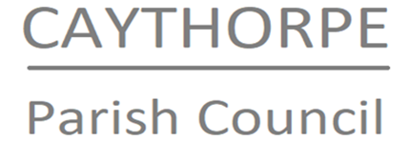

Councillors are hereby summoned to attend the meeting of Caythorpe Parish Council which will take place in the Caythorpe War Memorial Hall on Monday 21st July 2025 at 7.30pm
Signed:
N Cope
Clerk to the Parish Council
14th July 2025

AGENDA

To receive and note public participation (Max. 10 Minutes)

020/25 To receive and accept apologies.
021/25 To receive and note declarations of interest.
022/25 To accept the Minutes from the last Parish Council meeting on 12th May and Extraordinary Council meeting on 23rd June.
023/25 Time allocated for District County Councillor Roger Jackson
024/25 Village maintenance and Highways
025/25 To receive monthly defibrillator report
026/25 Clerk pay
To discuss increase in hourly rate for Clerk
027/25 Planning (final decisions are made by NSDC Planning Department)
Applications: None at the time of writing the agenda
Decisions: None at the time of writing the agenda
028/25 Finances
a. To approve Payments and note receipts: To approve Clerk pay for May, June & July. Gratuity cost £27 (reimbursement to Cllr Freeman). To note payment of £250 donation from Community Development Fund and £100 donation from West Bridgford Lodge of Masons towards Caythorpe Fun day.
b. To approve the Bank reconciliation providing Clerk has access to the accounts by the date of meeting
029/25 Website
Discuss the move to council-owned domain for website and council-owned email addresses
030/25 Traffic problems
a. Inappropriate parking outside cricket club
b. Speeding – possibility of community speed watch, traffic calming measures
031/25 Correspondence
a. Newark & Sherwood call for development sites (emailed to Cllrs on 26/6)
b. Email about flood resilience grant (emailed on 26/6).
032/25 Trustee responsibilities
Discussion and clarification of responsibilities and arrangements for meetings as Trustees of Memorial Hall
033/25 Co-option policy for councillors
034/25 Items for future agenda
035/25 Dates of future meetings
036/25 Private and Confidential
In accordance with Public Bodies (admission to meetings) Act 1960 section 1(2), the Council exclude the public and press from the meeting by reason of the confidential nature of the business to be transacted.
037/25 Close

