HAVE YOUR SAY – EXTENSION OF PUBLIC FOOTPATH AND INSTALLATION OF DOUBLE YELLOW LINES AND WHITE LINE IN THE VILLAGE

Following concerns raised by residents, Detling Parish Council and Kent County Council’s (KCC) Highway Improvements Team have been reviewing pavement safety and road safety concerns in the village. Concerns raised include the lack of a continuous safe footpath throughout the village and road safety concerns due to parking on bends, vehicles crossing into oncoming traffic, and poor sight lines at junctions and access points in The Street where there are dropped kerbs, leading to safety risks for residents, pedestrians and road users.

Traffic Regulation Orders are required to implement new road markings and therefore DPC is considering the implications of displaced parking when making these recommendations, in an attempt to ensure safety for all residents and road users, at least cost.

We have identified that a footpath extension outside the Public House would improve pedestrian safety, allowing safe passage to the village shop and the whole village. Dropped kerbs could be provided for private vehicle access to the pub.

Double white lines as shown on the map on the bends by the Pub and the top of Hockers Lane, these are proposed to reduce the risk of vehicles straying into oncoming traffic, which has been raised as a safety concern at both locations and has resulted in accidents.

Double yellow lines are a statutory requirement where there are double white lines, and DPC are also attempting to reinstate the double yellow lines which existed previously existed but for which there is no current Traffic Regulation Order, outside Tudor Gate. The proposed double yellow lines on the West Side of the street to the Church are planned to prevent displaced parking from blocking The Street. The use of double yellow lines and single white lines is to afford maximum visibility and sight lines to improve safety for all.

We are therefore considering installing double yellow, white and single white lines on the sections of the following roads, as shown on the map as shown.

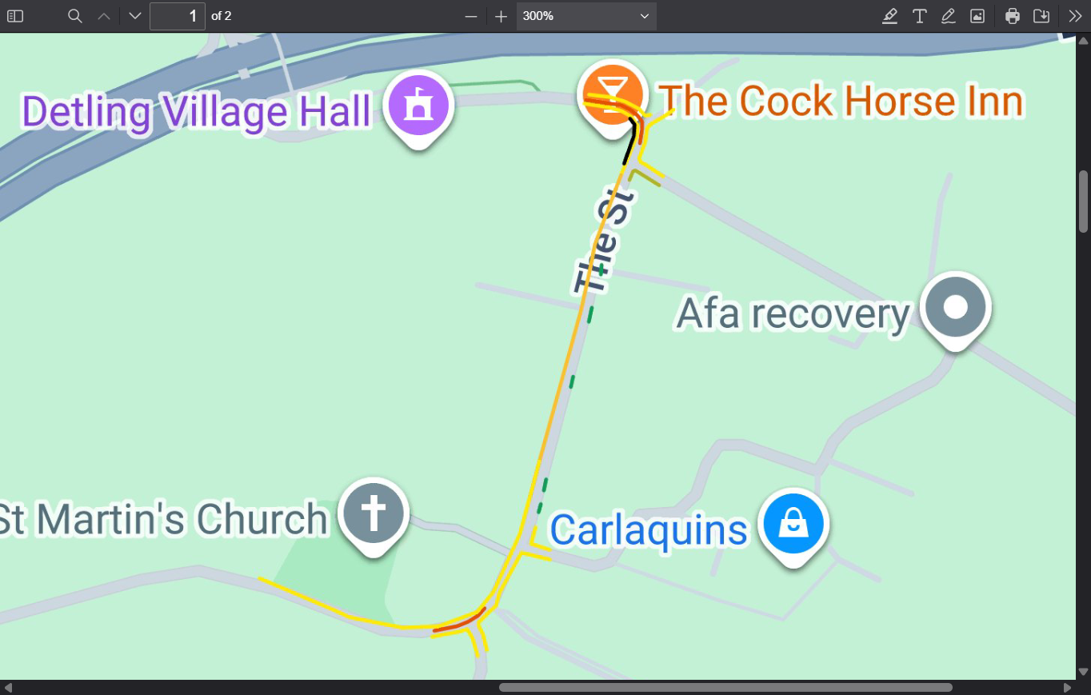

Key:
Black line - proposed footpath extension outside the pub
Red lines - double white lines to improve safety on bends
Yellow lines - proposed double yellow lines to prevent parking and displaced parking
Green lines - proposed single white lines at dropped kerb access to properties

YOUR VIEWS MATTER

Ahead of any statutory consultation, we are seeking local opinion and have provided the attached questionnaire for you to tell us what you think.

The feedback from this pre-consultation engagement will be considered by Detling Parish Council and help inform if and how the scheme proceeds.
QUESTIONNAIRE

Q1. Are you responding as…?
Please select the option from the list below that most closely represents how you will be responding to this questionnaire. Please select one option.

A resident of the Parish / a resident from elsewhere / on behalf of a friend or relative / on behalf of an organisation, business, or group or other (please specify)

Q1a. If you are responding on behalf of an organisation, please tell us the name of your organisation.
Please do not reveal your whole postcode. If you are responding on behalf of an organisation, please use your organisation’s postcode. If you are responding on behalf of someone else, please use their postcode. We use this to help us to analyse our data. It will not be used to identify who you are.

Q3. Do you agree with the proposals for a continuous footpath as shown on the attached plan? Yes/No/Partly/ Don't know (please select one option only)
Please tell us the reason for your answer to Q3. Please do not include any personal information that could identify you or anyone else in your answer.

Q4 Do you agree with the proposed double white lines as shown on the plan?
Yes/No/Partly/ Don't know (please select one option only)
Please tell us the reason for your answer to Q4. Please do not include any personal information that could identify you or anyone else in your answer.

Q5 Do you agree with the proposed double yellow lines on the attached plan?
Yes/No/Partly/ Don't know (please select one option only)
Please tell us the reason for your answer to Q5. Please do not include any personal information that could identify you or anyone else in your answer.

Q6 If there is anything else you would like to tell us about these proposals, please tell us in the box below Please do not include any personal information that could identify you or anyone else in your answer.

You can email your responses to consultation@detlingparishcouncil.org.uk by attaching your completed questionnaire or answering all questions in the text or simply fill it in and post it to Clerk at 14 Trapfield Close, Bearsted, Maidstone, ME14 4HT.

If you need any help taking part, or have any questions, please contact us by email (address provided above) or telephone us on 07952734352.

PLEASE GET YOUR RESPONSE TO US BY 30 DECEMBER 2026.

Privacy: Detling Parish Council collects and processes personal information in order to provide a range of public services. Detling Parish Council respects the privacy of individuals and endeavours to ensure personal information is collected fairly, lawfully, and in compliance with the United Kingdom General Data Protection Regulation and Data Protection Act 2018.

