Miss Margaret Vickers 90th Birthday Celebration

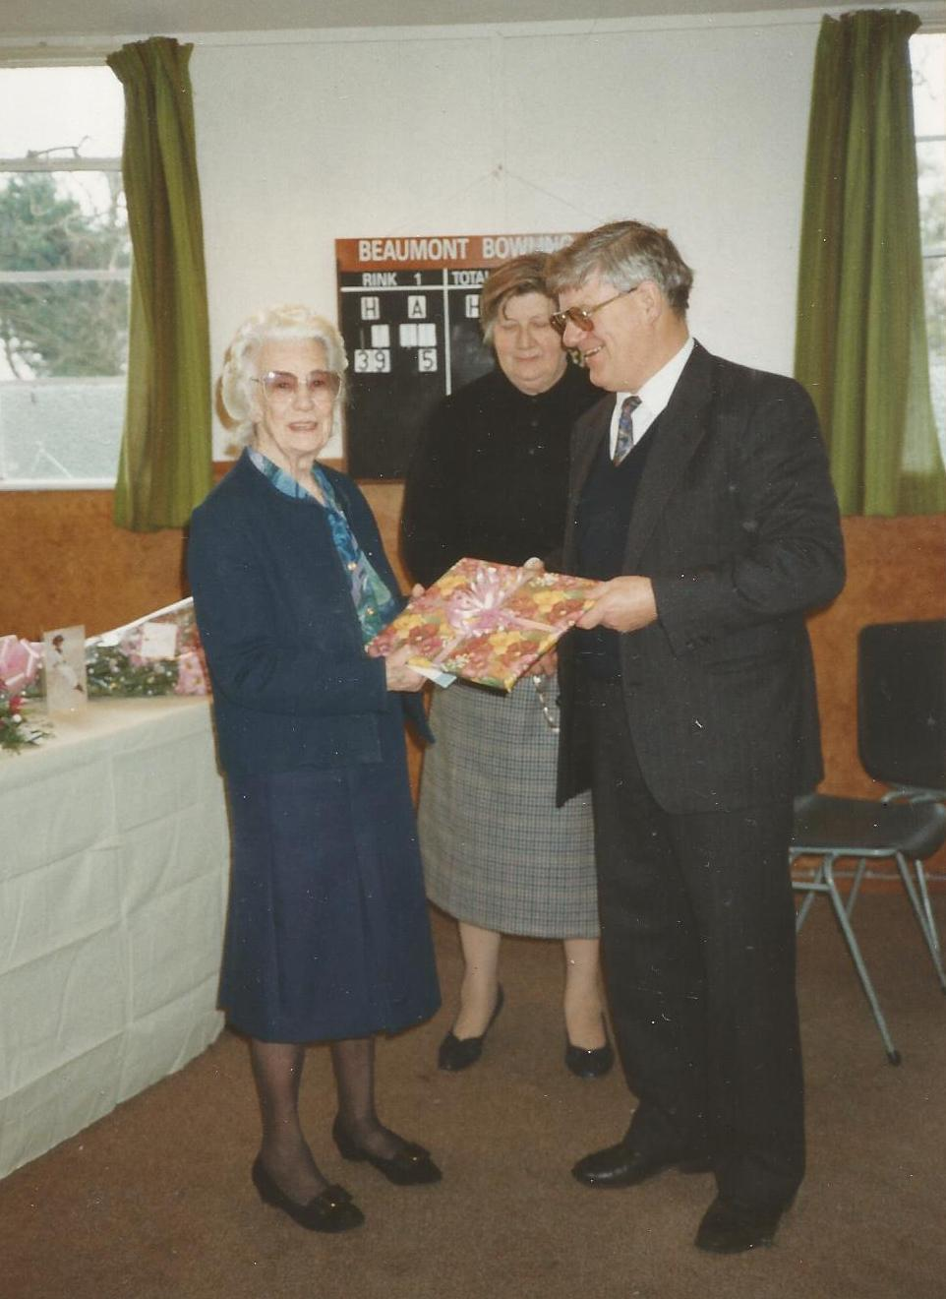
Alan Hodgson presents Miss Vickers with a gift from the Parish

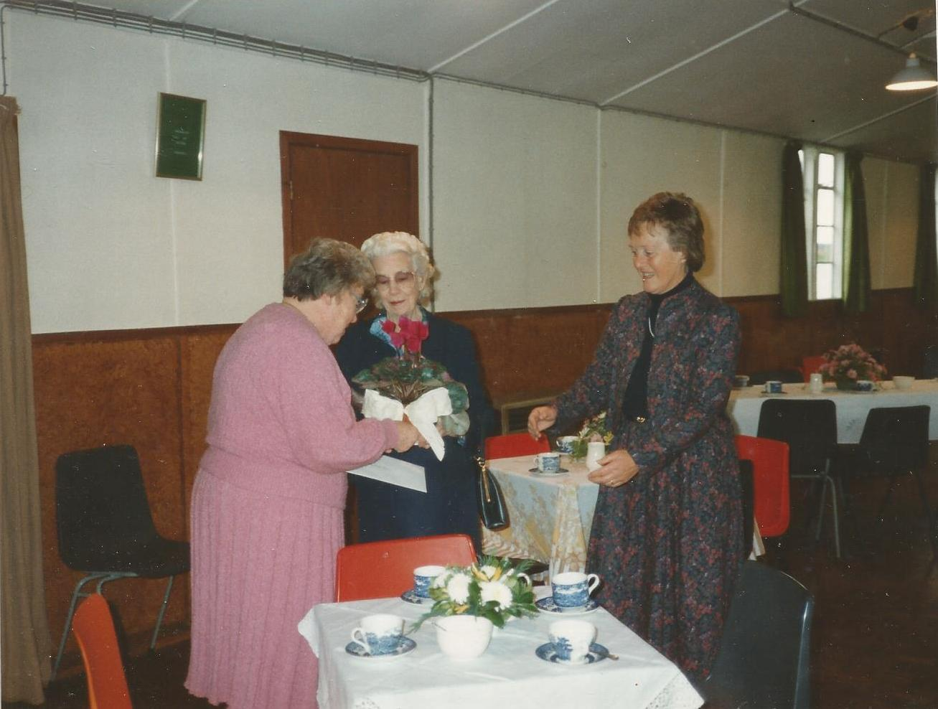

Cathy Stephenson Presents Miss Vickers with a plant

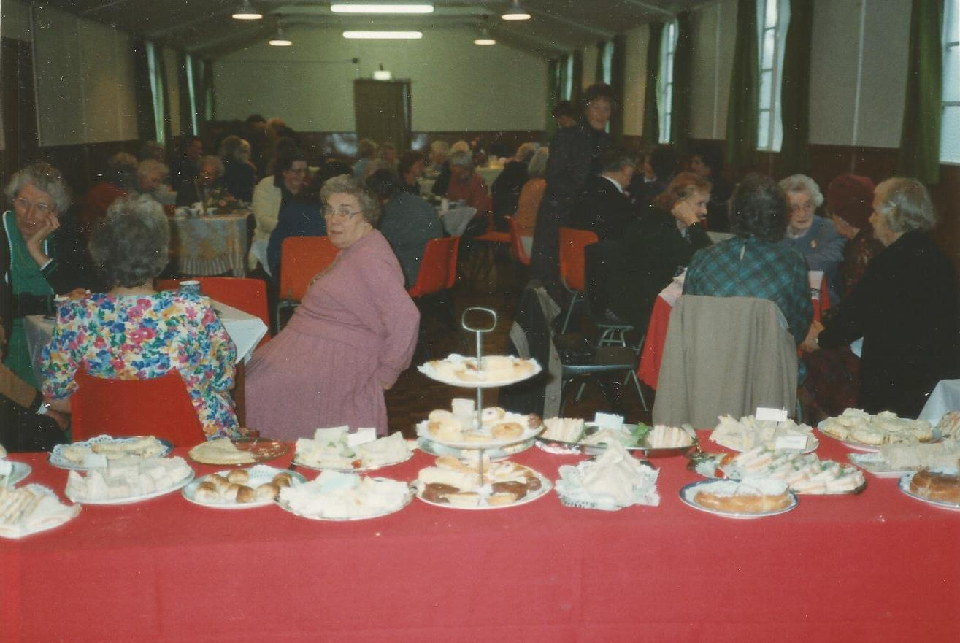
Friends at the Tea Party
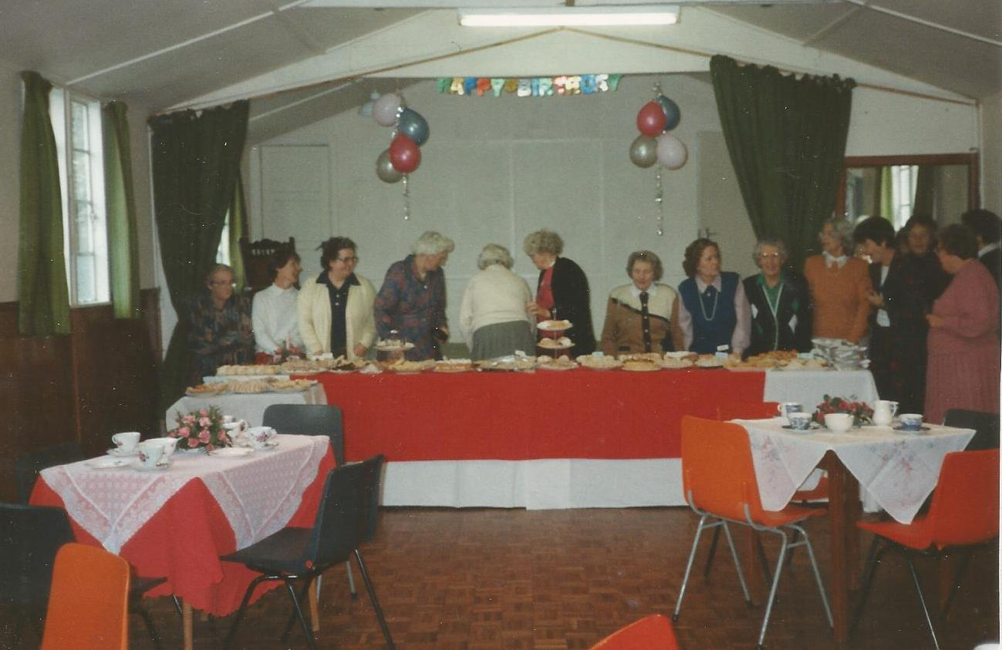
Kirkandrews on Eden WI preparing Tea for Miss Vickers’ 90th birthday party
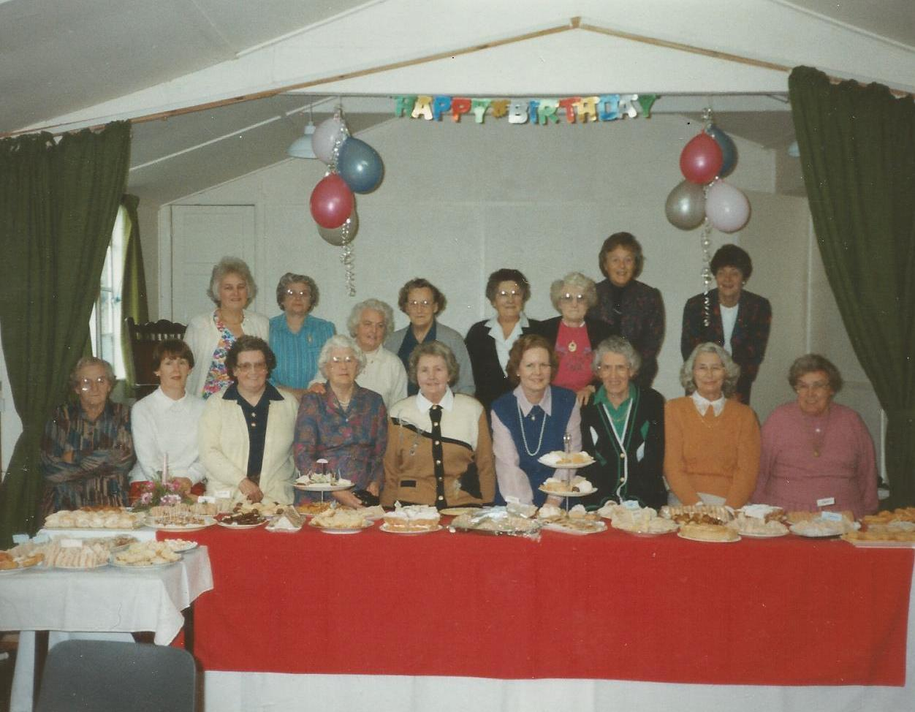
WI members at Miss Vickers 90th birthday
Front row: Mary Care, Jean Wharton, Dot Dickenson, Hilda Henderson, Eileen Docker, Sigrid Little, Ethel Beattie, Thelma Burgess, Cathy Stephenson
Back row: Stella Hodgson, Margaret Roe, Dora Mitchell, Sadie Bell, Alice Graham, Dot Reay, Margaret Parkinson, Betty Frost
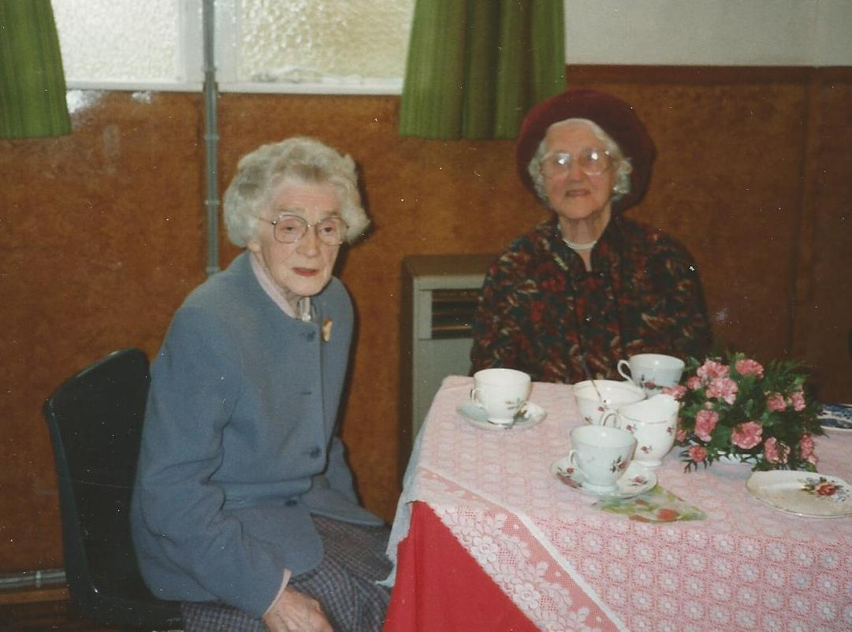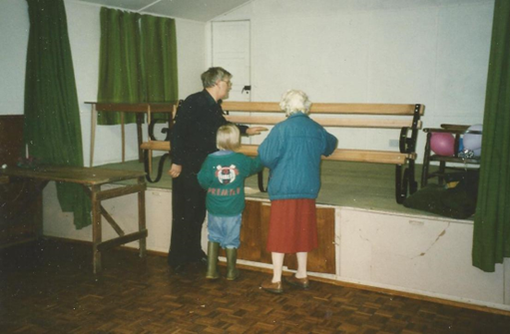
Mrs Stroy and Agnes Mallinson Inspection of the bench
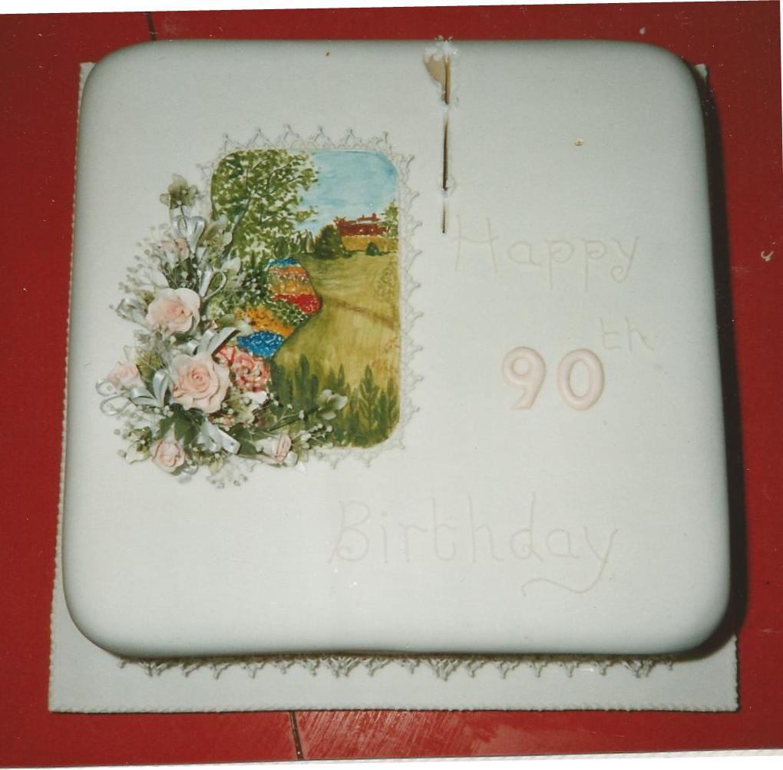

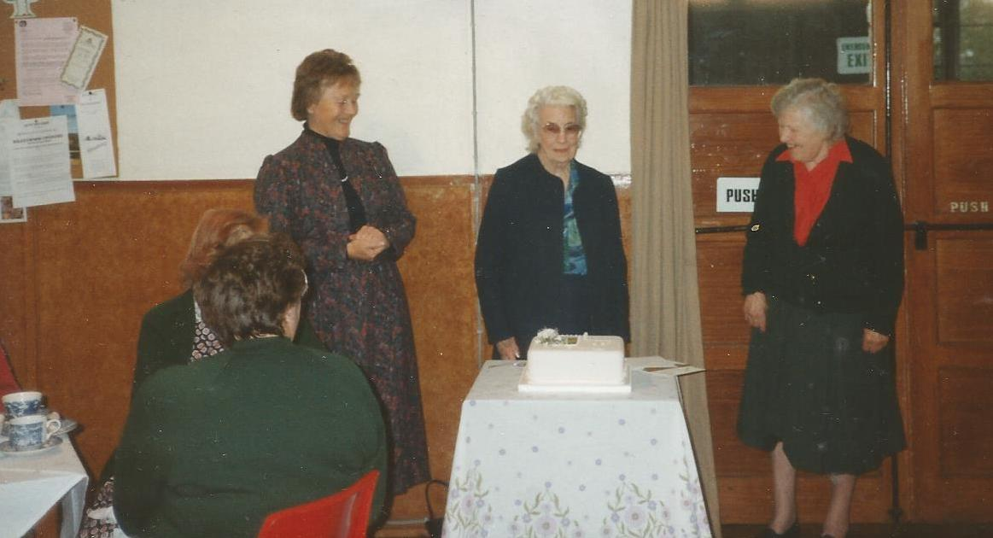
Left to right: Margaret Parkinson, Margaret Vickers, Miss Burgess
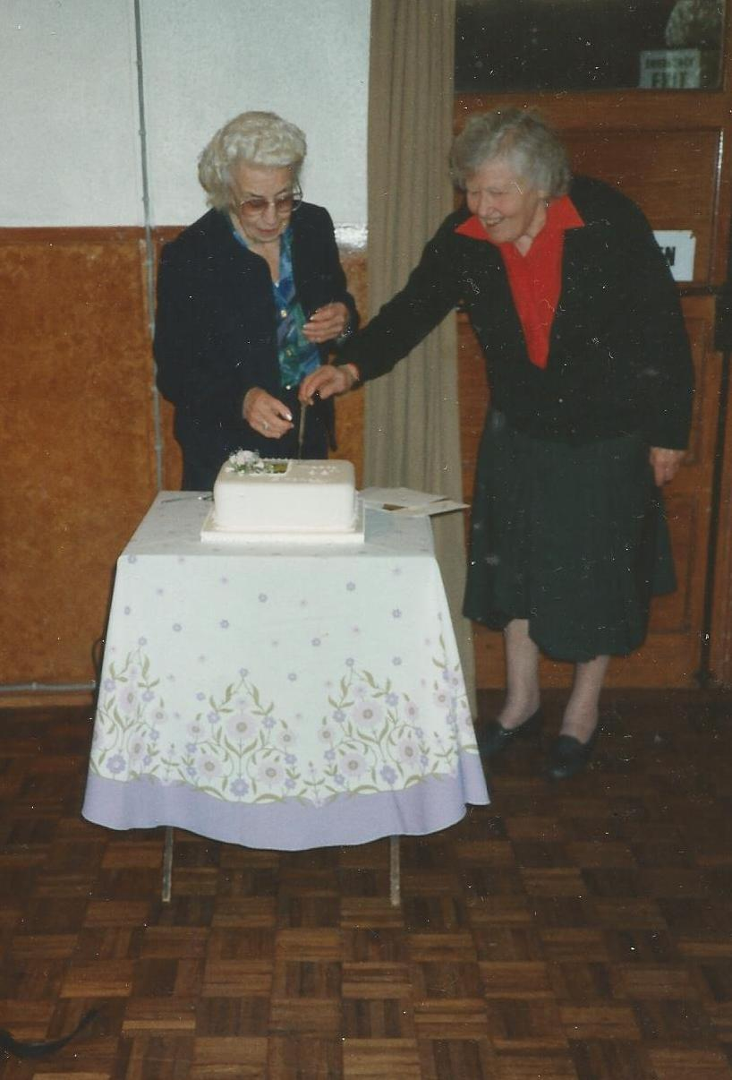
Miss Vickers with the help of Miss Burgess cutting her 90th birthday Cake

