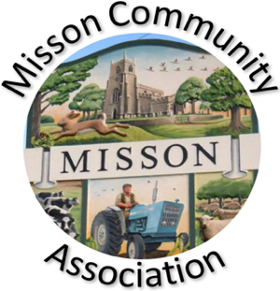
MISSON COMMUNITY ASSOCIATION

AGENDA

MEETING ON WEDNESDAY 15TH APRIL 2026 AT 7.15 pm

- Apologies for absence

- Declarations of any new committee member interests outside MCA.

- Minutes of 18th February 2026.

- Non-agenda matters arising from minutes 18th February 2026.

- Treasurer’s report

- Building maintenance

- Current Events and Bookings

Saturday 18th April – Village clean up
Saturday 25th April – Live & Local “Tell It To The Bees”
Saturday 9th May – Early morning bird walk
Sunday 31st May – Harworth Brass Band and picnic
Thursday 16th June – talk on Brodsworth gardens
27th and 28th June – Garden Trail
27th and 28th June - Art Weekend
Saturday 25th July - Party on The Green
5th and 6th September - Village Show & Scarecrow Trail weekend

- Proposed Events

Bat walk – Autumn
70s/80s Disco – Autumn
Spooky Stories - Autumn

- Working with other village groups

- Correspondence/Contact/Communication (Facebook, Posters, NL etc.)

- Any other business

Defibrillator
New MCA committee member and email/website responsibility
Review of MCA Constitution
Back garden area – bulbs and planters

- Date and time of next meeting – Wednesday 18th March at 7.15pm

