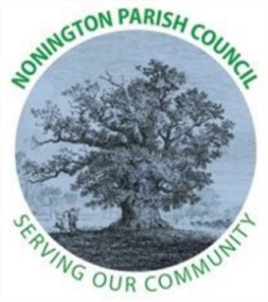
NONINGTON PARISH

ANNUAL ASSEMBLY OF THE PARISH
TO BE HELD ON 6th May 2026 at 7.45pm
Nonington Village Hall

AGENDA

- APOLOGIES FOR ABSENCE

- WELCOME AND INTRODUCTION

- CHAIRMAN’S REPORT FOR THE COUNCIL YEAR 2025/26

- REPORTS FROM CLUBS & ASSOCIATIONS

- REPORTS FROM POLICE & COUNCILLORS

- PUBLIC FORUM: The chairman will invite any members of the Public in attendance to ask questions or make statements

- CLOSE

Please join us for a glass of wine and some nibbles after the meeting

