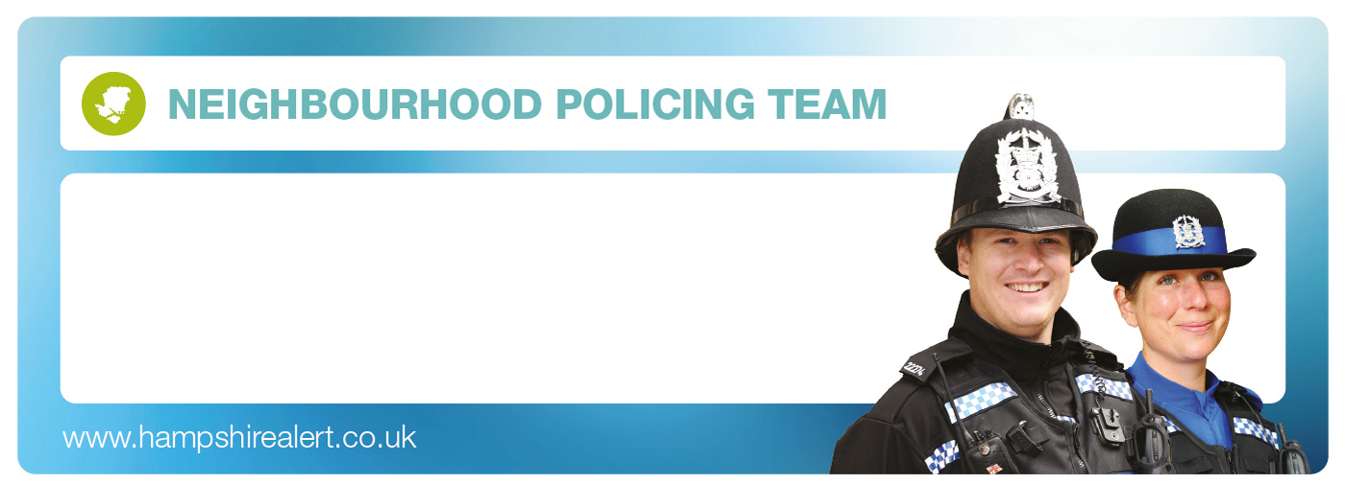

NORTHERN
NEW FOREST HEART
Monthly Beat Report –
November 2017

Hello and welcome to November’s Beat Report for the Northern New Forest Heart area. I am
PCSO 14495 Richard Williams, one of the Beat Officers for this area, and I am based at Lyndhurst Police Station with my colleague PC 20127 Steven Norris.

Beat Surgeries

Please come and meet us, in December we will be at -
Bramshaw Village Shop on Tuesday 5th December at 8am.
Bartley Post Office on Tuesday 5th December at 9am.
Lyndhurst Parish Council Shop on Friday 8th December at 11am.
Minstead Village Shop on Saturday 9th December at 10am.
St Michael and All Angels Church in Lyndhurst on Sunday 10th December at 10.00am.
Lyndhurst Baptist Church on Sunday 10th December at 11.30am
The Tip, Leaf and Bean café in the Lyndhurst Visitor’s Centre on Sunday 24th December at 10am.
Colbury Parish Church on Deer Leap Lane on Sunday 24th December at 11.00am.

Burglaries

In November there was only one residential burglary and the targeted house, which was in Emery Down, was again entered during the day when there was no one at home. There have been another 6 non-residential burglaries in Ashurst this month, with expensive bicycles and garden tools stolen from sheds, garages and other out buildings. There were also non-residential burglaries at the Lyndhurst golf club, and at properties in Bramshaw and Fritham.

Christmas poses many opportunities for criminals, especially because of the gifts we collect either for ourselves or to give to our family and friends. The following advice is again common sense but I think it’s worth revisiting

- Don’t leave Christmas presents in view of a window.
- If you are buying or receiving valuable gifts such as bikes, mobiles or electrical items register them for free at www.immobilise.com By doing so you will assist the police in returning your property should it be lost or stolen.
- Dispose of present packaging carefully as empty boxes left outside advertise the goods that you have inside.
- Refrain from keeping large amounts of cash at home.
- A secure home will reduce the chance of a burglary. Make sure windows and doors are locked every time you leave the house. Avoid leaving tools and ladders lying around that could help a thief get into your home.
- When you go out at night make it appear that someone is home. Draw the curtains and leave a light on. You could always put a lamp or radio on a timer switch. CCTV is an excellent deterrent and is now much more affordable.
- Never allow people into your home unless you are expecting them or have made arrangements with them or their company beforehand.

The BURGLARY BUS will also be visiting LYNDHURST and ASHURST on Wednesday 6th December. On board will be lots of advice on how to make you and your property as secure as possible in the build up to Christmas and beyond. The Burglary Bus will be on Wood Road by the CO OP in Ashurst at 5pm for an hour and then in the main car park in Lyndhurst from 6.30pm, also for an hour.

Theft From Motor Vehicle

The sunny weather has seen an increase in the number of thefts from parked cars. 14 have been broken into this month with Fritham, Highland Water and Knightwood Oak the car parks targeted in the New Forest, but vehicles parked on roads in Ashurst, Bartley and Lyndhurst have also had valuables stolen from them. Again make sure that nothing is left on display when you leave your vehicle anywhere. Two of the reports made to Police this month in the New Forest read like this “someone has broken the driver-side rear window and stolen my wallet from my bag and my wife’s handbag that was left underneath some coats” and “someone has stolen my handbag from underneath the front passenger seat of my vehicle whilst it was parked in a New Forest car park”. Thieves will only break into vehicles if they can see something on display.

Other Incidents of notes:

A motorbike has been stolen from outside a house in Bramshaw and there have been two unusual incidents of fly tipping in the New Forest where the remains of equipment used to grow cannabis and some cannabis stalks and stems have been dumped in the Janesmoor Pond and Ocknell Park car parks. Again if you ever see anyone dumping anything anywhere then please let us know, especially if you have managed to write down the registration number of the vehicle involved. One visitor to the Lyndhurst area did exactly that when they saw someone dumping some rubbish in a car park, and the offender is now being dealt with by New Forest District Council. And number plates have been stolen from a car parked overnight at a hotel in Ower.

So far this month 9 drivers have been caught speeding in Bramshaw and Lyndhurst, and in Colbury a man was arrested for being drunk in charge of a vehicle.

During November, the Speed Watch team in Minstead monitored 140 vehicles travelling in and around the village and 67 of them, so nearly 48%, were exceeding the 30 mph speed limit. Of those 67, 18 vehicles were travelling at 35mph or more and have received warning letters from the Police. Meanwhile the Speed Watch team in Lyndhurst surveyed 1657 vehicles in November and of those 808, nearly 49% were travelling over the 30 mph speed limit. 115 of those vehicles have received warning letters from the Police for recording speeds of 35 mph or more.
I’m delighted to say that the Copythorne Speed watch team is up and running again and is about to start surveying the roads in and around the village. In the New Year I am looking to start up Speed Watch schemes in Ashurst and Netley Marsh, so if you live in either of those areas then please let me know if you’d like to join as a volunteer.

There has been a lot in the press recently about the increase in the number of accidents and animal deaths on the roads across the New Forest, and this month a new initiative has been launched which is asking drivers to add just 3 minutes to each of their journeys to prevent the deaths of New Forest animals. It’s worth thinking about it isn’t it. Simply going that little bit slower will make your journey much safer for you and the other users of the New Forest.
I’ve also been asked to mention that this month has seen an increase in the number of complaints made about people stopping on Forest roads to feed the animals. Not only are we asked not to feed any of the animals that roam free on the Forest but by doing so we are also attracting them to the roadside where they are more likely to be hit by passing vehicles.

At this time of year more and more of us are using the internet to buy our Christmas presents, which of course means that we are putting ourselves at risk of fraud. So the organisation ACTION FRAUD has put together an excellent leaflet that highlights the most common festive season scams. By following the link below you can see that leaflet and it is definitely worth a read. Just hold down the Ctrl button on your computer keyboard and click on the link

https://www.actionfraud.police.uk/sites/default/files/12%20Frauds%20of%20Christmas%20Leaflet_0.pdf

Thank you again for all the calls made to the Police in November about the suspicious people and vehicles you have seen in the Northern New Forest. You can call 101 or if you prefer you can call PC NORRIS or myself PCSO WILLIAMS directly. If there is no answer then that means we are on a rest day, so either leave us a message or send us an email. And remember if you are telling us about a vehicle, the most useful information you can give us is the registration number. You are our eyes and ears in your community and we value any information you can give us that will help us keep the places where you live safe.

Finally PC Steven Norris and myself would like to wish you all a very Merry Christmas and a peaceful, happy and crime free 2018.

steven.norris@hampshire.pnn.police.uk
07554 775477
richard.williams@hampshire.pnn.police.uk
07554 775469
