This Business Continuity Plan is a strategy for ensuring that the parish council can respond to incidents and business disruptions in the event of unforeseen or unplanned staff absences.
In the case of the parish council there is only one member of staff, the Clerk. This plan outlines what procedures should be implemented should the Clerk not be able to perform his/her contractual duties.
The plan will be maintained by WHITCHURCH RURAL Parish Council. The plan will be reviewed and updated regularly. Any changes to documents will be added to the hard and online copies.
Councillors and the clerk are responsible for communicating any major changes.
This plan has been designed using a 3x3 risk matrix.

Likelihood of Impact
 | Unlikely | Risk from occurrence is improbable
 | Likely | Risk from occurrence is possible
 | Highly Likely | Risk from occurrence is probable

Severity of Impact
 | Minor | Consequences can be absorbed by normal management
 | Major | Consequences of impact can be resolved with extra actions
 | Critical | Consequences could cause significant impact

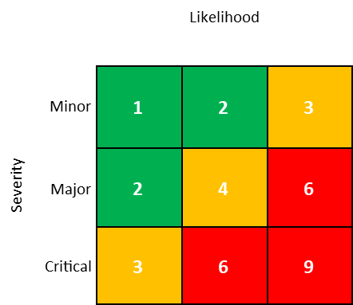

Risk Rating
 | 1 – 2 | Minimal impact to continuity
 | 3 – 4 | Moderate impact with some effect on normal operations
 | 6 - 9 | Potential to cause significant impact/loss

