The kneelers at St Mary’s Church, Beaumont

The canvas work kneelers in this church were made to celebrate the 700th anniversary of the appointment of the first recorded Rector in 1296.

We wanted to commemorate a rector from each century, and also make some reference to the lay patrons, who were lords of the Barony of Burgh, as well as something of the historical setting of the time.

***

1296 Sir Elias De Thirwell

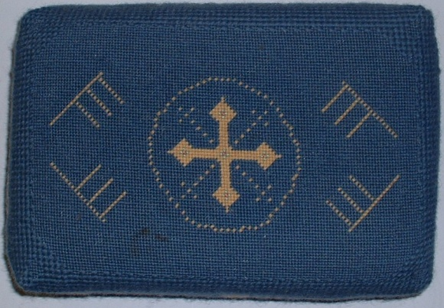
There is a central cross surrounded by the Hebrew letter E, for Elijah, and a Celtic strap work design on one end to symbolise the early church.

1339 Rich Bronne

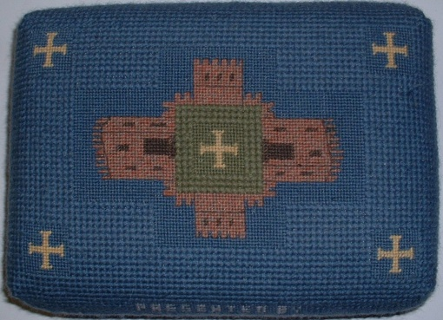
He was presented by Matilda De Brun, the Lady of Beaumont, who is said to have lived in the small castle of the De Brun family cited on the green near the church. Emblems from the coat of arms of the De Brun’s are incorporated in the kneeler.

1490 Robert Chapman

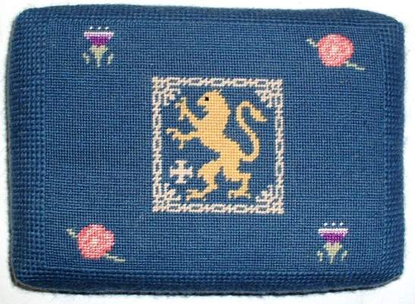
This depicts the warfare between England and Scotland. The Lord of the Barony, was Thomas Lord Darce, Knight of the Garter, who played a prominent part on the Battle of Flodden.

1560 Thomas Thompson
1562 Henry Haselhead

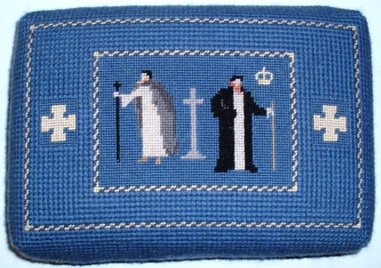

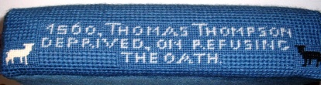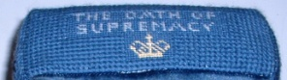

This depicts the conflict of conscience during the Reformation, when Thomas Thompson was deprived of the living on his refusal to acknowledge Elizabeth I under the Act of Supremacy

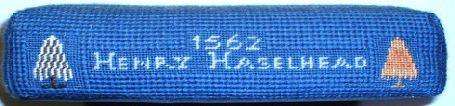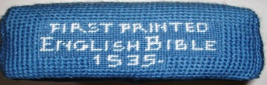

Henry Haselhead was appointed in his stead. The Bible in the English language was first printed and came within the reach of everyone.

1663 Patricius Hume

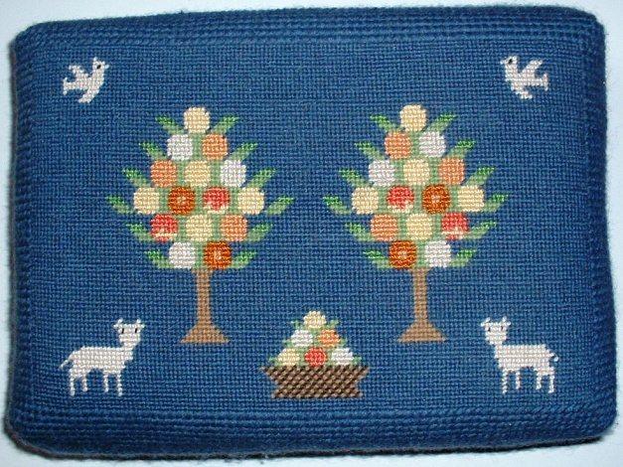
After the uneasy time of the Commonwealth under Oliver Cromwell, the Anglican services were restored. The apple trees and the lambs symbolise the “First Fruits”, which were the tithes due to the Rector from his parishioners. The Barony came to the Howard family by decent and later came into the possession of the Earls of Lonsdale.

1703 Gabriel Trant

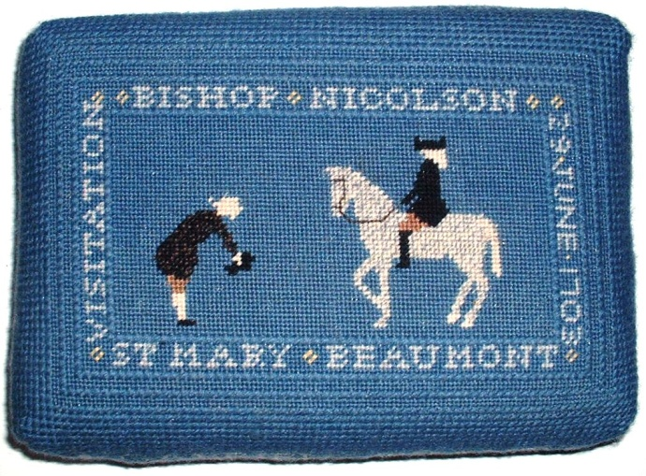

He was a young Frenchman, who had taught at the school at Lowther belonging to the earl of Lonsdale. Here he is greeting Bishop Nicholson on his visitation to the Parish.

1846 William Benn, M.A.

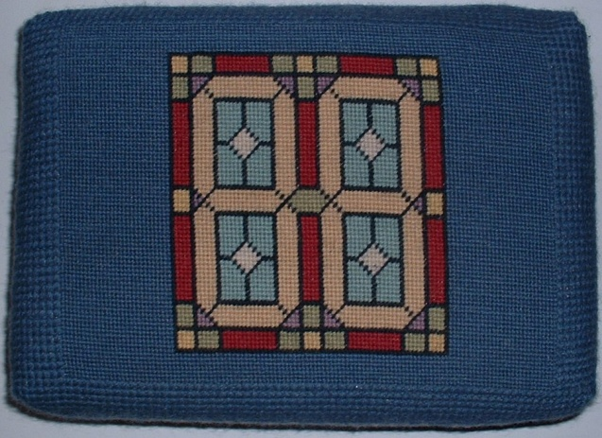
He bought the rectory at Kirkandrews at a cost of £800.The kneeler shows the design of a small stained glass window at the rectory.

1965 Deryck Garland, M.A.
1990 David King, B.A.

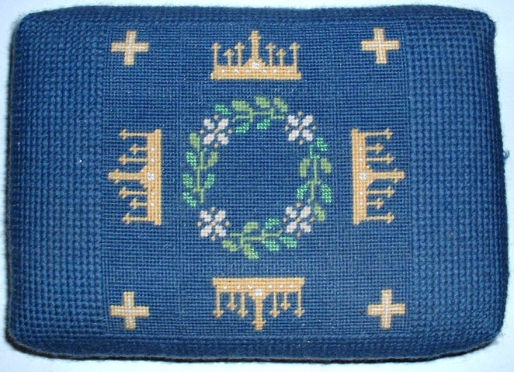
The garland of leaves and flowers is am emblem for this Rector, who drew up the list of Rectors of the past which has inspired this project. David King, our Rector today, is depicted by four crowns as a reminder of his name, and by four crosses to symbolise the four churches of the united benefice.

***

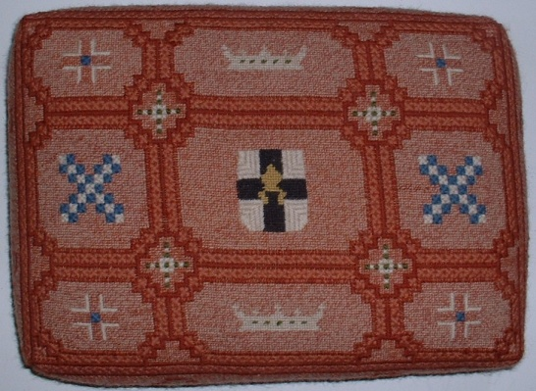
In addition to these eight kneelers, a larger kneeler was made for the Bishops chair in the chancel. It shows the arms of the diocese, the Bishops mitre and St. Andrew’s cross.

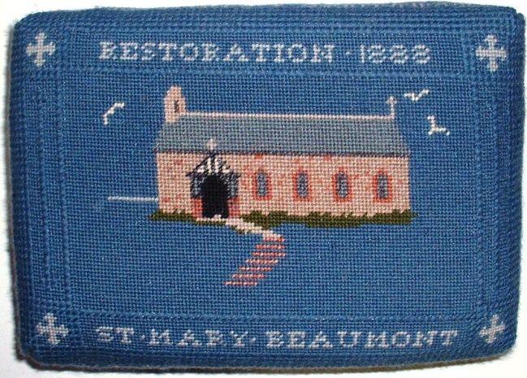
The restoration of the church in 1888 is depicted by a kneeler in the choir stalls, and lists ball the men who were responsible for the work and restoration.

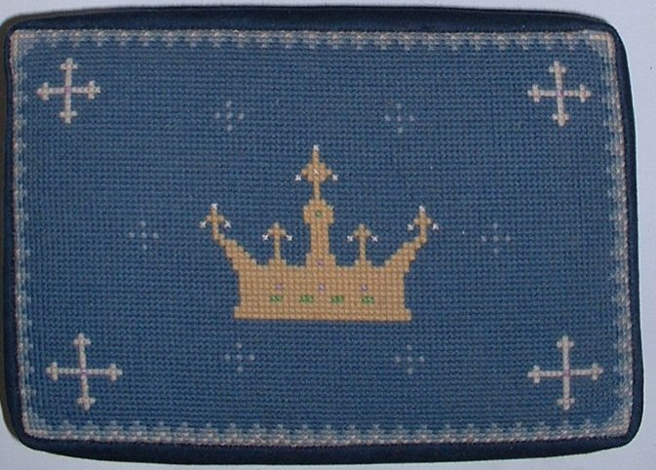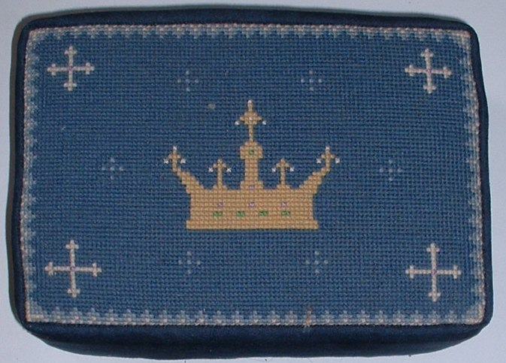

Two wedding kneelers in the choir stalls show elaborate medieval crowns, for St. Mary.

Two cushions on the bench by the font refer to the Celtic traditions of the early church, and to the natural world around us.

24th August 1999.

