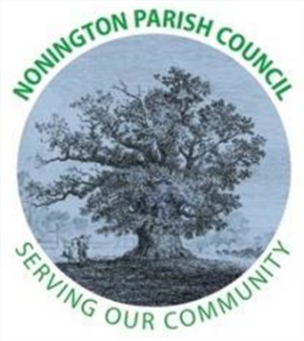

NONINGTON PARISH COUNCIL
Email: noningtonparishclerk@outlook.com Website: www.noningtonpc.org.uk

TO: ALL MEMBERS OF NONINGTON PARISH COUNCIL
Councillors are hereby summoned to attend an Ordinary Meeting of the Council to be held on
Wednesday 1st October 2025 at 7.00pm in Nonington Village Hall

A G E N D A

- Chairman’s Welcome and Apologies for absence

- Declarations of Interest

- Confirmation of the Minutes of the Meeting held 3rd September 2025

- Review of Previous Action Points

- Public Forum

- Finance

Balance as of 29th September 2025
Current Account: £ 6,152.52 (opening) £ 6,140.53 (29/09/2025)
Savings Account: £ 18,431.96

Payments 01/09/25 29/09/2025 (£11.99)
Hugo Fox £11.99 (website)

- Planning
- Replacement trees and fines for planning violation
- planning permission 25/00431 for "Erection of 2 radio aerials" to allow alterations to the aerial arrangement Location: 14 Park View Rise, Nonington, CT15 4JS,

- Highways and Footpaths

- Playground, Field and Pond

- Items for discussion not on the Agenda

- Date of the next meeting: Wednesday 5th November 2025

