Kirkandrews Railway Station
In 1819 a port was constructed at Port Carlisle and in 1821, the Carlisle Navigation Canal was built to take goods to Carlisle. The canal was closed in 1853 and much of it was in-filled by the Port Carlisle Railway Company who constructed a railway that started passenger services in 1854, discontinuing two years later when the Carlisle & Silloth Bay Railway & Dock Company's (C&SBRDC) new railway to Silloth opened, utilising the Port Carlisle Branch as far as Drumburgh.
The station on the Port Carlisle Railway branch and later the Silloth branch was built in 1854. The station served the village and the rural district.
On the Port Carlisle Railway Company line the order of stations were Carlisle, Kirkandrews, Burgh-by-Sands, Drumburgh, Glasson and terminating at Port Carlisle. The line was built to carry freight and passengers from Carlisle to the Liverpool steamer service which departed from Port Carlisle. Once the new Carlisle and Silloth Bay Dock Company took over the line the Liverpool steamer relocated its departure from the more reliable Silloth docks.
A cheap alternative, a horse-drawn service was provided in 1856 between Drumburgh and Port Carlisle for a number of years using four Dandy Cars.
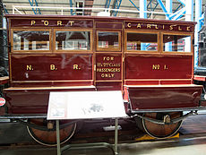
Photograph of one of the four horse-drawn 'Dandy cars' built by the North British Railway. The Dandy car was originally preserved at Carlisle, before being moved to the National Railway Museum at York.

In 1914 steam power was used and to try and avoid closure a steam railmotor called 'Flower of Yarrow' was built and this service to Port Carlisle railway station lasted until the branch was closed in 1932. Freight services had been withdrawn in 1899.
On the Carlisle & Silloth Bay Railway and Dock Company line the order of stations were Carlisle, Kirkandrews, Burgh-by-Sands, Drumburgh, Kirkbride, Abbey Junction, Abbey Town, Blackdyke Halt and Silloth.
The North British Railway leased the line from 1862; it was absorbed by them in 1880, and then taken over by the London and Eastern Railway in 1923.
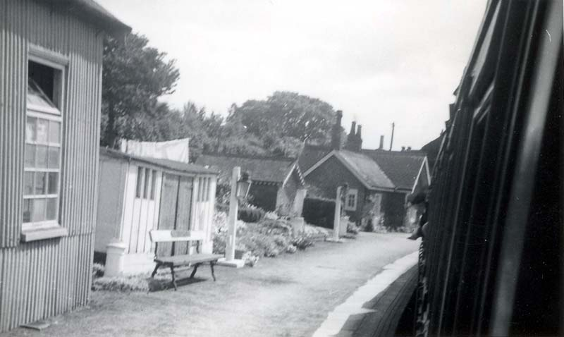
Photograph of the station buildings as seen from the window of a train in the station. Photograph taken June 1964.

The station sat close to the village in the cut of the old canal; it had a single platform, and a shelter. The branch ran close to the course of Hadrian’s Wall. A substantial station building was present. A large seed warehouse was located at the station. In common with other stations on the line, it had its name picked out in sea shells on a raised area opposite the station building.

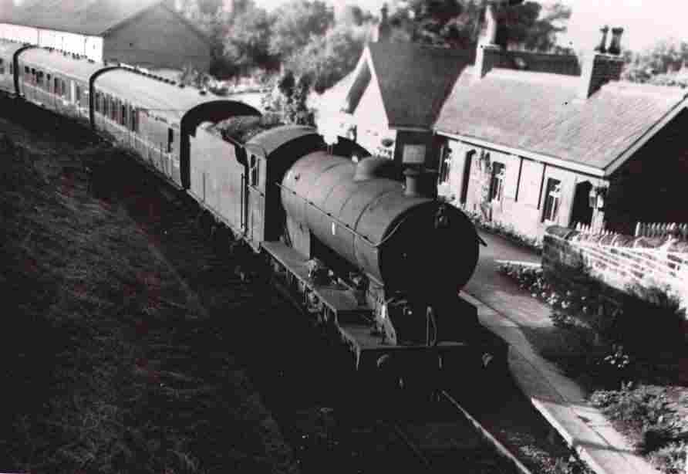
Photo of a train passing through the station. c 1950’s
Kirkandrews station closed on 7 September 1964 when the line to Silloth closed as part of the Beeching cuts.
The station building survives as a private dwelling.

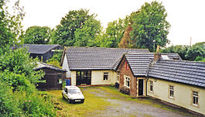
Photograph of Kirkandrews former Railway Station now a residential property, 2002

