FINMERE PARISH COUNCIL

Draft Minutes of Annual Parish Meeting held on 5th May 2026

in Finmere Village Hall

Present:- Councillors, Mike Kerford-Byrnes (MKB) (Chairman), Katherine Grimston (KG) (Vice Chair), Stephen Trice (ST), Joanne Brooks (JB), Marcia Clydesdale (MC) and Clerk and RFO Sharron Chalcraft (SC)
In attendance District Councillor Barry Wood (BW), District Councillor Grace Conway-Murray (GCM), Paul Elcoat (PE) (Wappenham Parish Footpath Warden) and 14 members of the public
1. Apologies Apologies were received from District Cllr Nigel Simpson, Cllr Mike Kirby, Phillip and Carol Rushforth, Clare Law – Head of School, Illa Moss – Village Hall and Playing Fields Committee Chair, Paul Nash – Poors Plot Chair, John How – Football Club, Michael Geelan – Finmere Cricket Club and Sports Club Chair and Barbara Cunningham – Church Warden.

2. MINUTES
The minutes of the meeting of 13th of May 2025 were circulated and approved.

3. CHAIRMAN’S REPORT
(TO FOLLOW)

4. FINANCIAL REPORT
Income this year was lower than last year, down by £2.5k, even though the precept had been increased. This was due to a lower VAT refund due to lower capital expenditure last year, lower capital income as no logs were sold and much lower donations from the Sports Club and Village Hall Committee. No grants were administered. The PC is again below the threshold when exemption from external audit can be applied for. The internal audit has been carried out, as required by law.
Expenditure was much higher than last year, some £7.5k. This was due to much higher capital expenditure and therefore much higher VAT payments. Tax also increased this year as I paid tax for the whole year. There was a drop in general administration but a large increase in running costs. A detailed explanation is given below.

Income:
The precept increased by £700 this year.
The VAT refund is lower this year at £369.73 reflecting less spending last year.
Bank interest was also slightly lower due to interest rate changes.
The annual grass cutting payment from OCC remained the same.
The Sports Club paid a grass cutting payment increased in line with inflation.
Capital income was only £1.00 as there was no timber to sell.
There was no donation from the Sports Club this year.
The Sports Club paid for the share of the PC insurance premium which covers the pavilion.
There were no refunds this year.
There was a much smaller donation from the Village Halll and Playing Fields Committee, towards the costs incurred by the PC for the spinney.
There was a clothing bin receipt this year, this will be the final income from the scheme as the bin has been removed, apparently these bins are no longer worth the maintenance of the scheme.
There was a payment on account for the purchase of a salt bin from residents on whose behalf the PC had ordered the bin.

Outgoings:
Running costs were very much higher this year. This was due to spending on the spinney trees (£1800), which had been expected. There was also the relaying of slabs in Chinalls Close (£600), the mending of the fence at the village hall car park (£300) and the mower service (£800).
General Administration was lower this year. There was no cost for a survey this year, other costs remained similar, with a small rise in insurance costs and the cost of the new .gov.uk emails.
Salary costs actually went down slightly despite an increase in hours and pay, as I paid more tax on that pay.
S137 expenditure was very similar to last year. The memorial wreath was covered by S137 this year. There was also a contribution to VE Day 80 (£500), £165 to the pop-up-pub initiative, £700 to the cricket club to help with new sight screen costs, and the usual contributions to organisations which help residents of Finmere.
S144 expenditure this year was £0 as the wreath was recategorized as S137 expenditure.
HA S96 Grass Cutting was a little higher this year, with a new contractor having started and a more normal length of growing season.
Capital expenditure was higher this year. This was largely due to the purchase of two new VAS signs which are to be fitted at the entrances to the village at Sandpit Hill and Fulwell Rd (£4.6k). There was also the purchase of a tablet for the RFO for new internet banking requirements (£82), some Christmas light replacements (£65), as well as speed signs to fit to the old VAS post on the Old Banbury Rd (£75), posts to erect the new dog bins (£60) and a new Silent Soldier, after the original was damaged by vandalism (£175).
HMRC This was higher this year due to the continued freezing of thresholds and my receipt of a full years pension.
VAT This was much higher this year, due to increased capital expenditure. This money has already been reclaimed as part of the year end/internal audit procedure.
The expenditure over income balance for the year is £4,008.15. This is entirely explained by the purchase of the new VAS signs, along with general increases in prices. The PC will certainly need to think hard in January about capital expenditure for next year as we need to balance things in the future.
The PC has reserves of £4,500 for the eventual replacement of the mower. There is also the £500 granted to Tuesday Teas kept in reserve for when this is needed, and the funds raised for leisure equipment plus any interest paid in are also kept in reserve.
This means that the PC had actual uncommitted balances of £15.1k, which is slightly less than one year’s precept. The latest audit advice suggests a reserve of no more than twice the precept, so we are well within limits and may be actually too low, if unforeseen expenses arise.
The precept for the 2026/27 financial year was kept at £15,300. This was due to the hope of funding for some of the future work on the spinney and old play area and a recognition of the financial conditions prevailing at the moment.
This is perhaps a good time to remind everyone that the monthly financial report, given at the PC meeting and detailed in the minutes, is available to view online, the draft minutes are now published within a month of the meeting on the website. Anyone wishing to apply for S137 monies can contact the Clerk or approach any of the Councillors who can explain the criteria for eligibility.

5. REPORT OF COUNTY COUNCILLOR
No report was delivered by the County Councillor this year.

6. REPORT OF DISTRICT COUNCILLOR MR BARRY WOOD
Cllr Barry Wood delivered this year’s report. I am standing down as a councillor after 21 years of service; and have greatly appreciated the wisdom of MKB and the help of the whole PC on many issues over those years. To the incoming councillors, being on the PC can be a thankless task, but you will not regret it. It has been a pleasure to represent Finmere and the other villages in my remit over the years. I am pleased to say that there has not been too much change over that time. The school is a great benefit to Finmere and its preservation has been very welcome.
CDC is in a time of change. Within the next 12 months the new Unitary Authorities will be in place. There are currently three plans on the table – one large council for the whole of Oxfordshire – three small councils covering the City/Cherwell and West/ South and Vale – or 2 medium councils covering North and West with the City. Given the direction of travel in areas already decided it is likely that the 3 small councils plan will be chosen.
The local plan is in flux at the moment, with new rules on location of development coming in to place. In the past the local plan had focused on placing the main developments in Banbury, Bicester and at Heyford Park. With the new rules this may change.
At this point JB asked about the future relationships that are likely between the new Unitary Authorities and parish councils. I am hopeful that there will be a similar relationship to the current one with CDC, with the District culture prevailing in these new authorities. They are going to be responsible for social care, SEND provision and Highways. Hopefully the atmosphere will not be too political, reflecting the current District Councils.

7. PARISH FOOTPATH WARDEN INFORMATION
Paul Elcoat, Parish Footpath Warden for Wappenham, gave an overview of his post and duties. Wappenham is a similar village to Finmere, with some 250 residents and a large network of footpaths, some dating back to Roman times. Being a dog walker and enjoying walking Paul was an unofficial walker of local paths for some years before joining the Wappenham PC as a councillor. At this point he became an official Parish Footpath Warden and needs to walk all the local paths at some point each year. Rather than becoming associated with the Ramblers Association, which previous Finmere wardens have found to be rather burdensome, Paul simply reports any problems to West Northants Council via fix-my-street. Realising that some of the paths are hardly walked by anyone Paul began organising community walks to introduce more people to the network. There is now a monthly community walk, enjoyed by 10 – 15 people and several dogs.
If anyone would be interested in taking on a voluntary Path Warden role please contact either the clerk or any councillor for information. Paul is happy to help anyone with advice on reporting problems/organising community walks.

8. PLAY AREA INSPECTION DUTIES
As part of their insurance provision requirements the PC has certain duties which it must fulfil, or which must be fulfilled by volunteers or paid contractors.
In respect of the play area, it is required that there is an annual professional inspection and report. This is organised by the Village Hall and Playing Field Committee and paid for by the PC. Both the Committee and the PC discuss and implement the recommendations of the annual report.
However, in addition, there must be a weekly inspection of the play area. This is not a thorough and exhausting physical check of all equipment, rather it is a sensible review of the condition of the play area as a whole.
If there is any broken glass on the ground, if there is any obviously damaged or vandalised equipment, if there is any evidence of loose posts, frayed cables etc then the person checking the play area reports those things to myself, either by email or phone. I can then inform the PC and the Committee and action can be taken.
This inspection has, for some time, been undertaken by a volunteer. But unfortunately, that volunteer has been unable to continue and for some months now one of the PC Cllrs has been carrying it out. The Cllr is happy to continue these weekly inspections for another month or two but will be unable to carry on indefinitely.
As you will all be aware the new PC taking post after the election will be much reduced in number, at least for a while. Therefore, the PC would like to set up a rota of volunteers who can carry out this inspection. Perhaps someone whose children use the play area regularly, or anyone who visits the field in the course of their week, walking a dog or something similar. A rota would mean less pressure on an individual to get this done. There is no set day for the inspection, simply one must take place within the 7 day interval.
Unfortunately, if no volunteer or rota of volunteers is forthcoming, the PC will have to close the play area to the public as there will be no insurance cover for users. It is profoundly hoped that this eventuality can be avoided.
Please contact me either by phone, email or through the website if you would be interested in being included on a rota.

9. THE CURRENT LANDFILL SITUATION
Doctor Fenny, whose company bought the landfill a few years ago, had improved things at the landfill and had been much more involved with the village. The main aim of his company was to make money from the electricity produced by the landfill gas which can be flared off or used for electricity generation. This also helped to reduce the odour problems on the site. The price for this electricity has been dropping however, and the company went into voluntary liquidation last December. The licence has been handed to the EA by the liquidators. The EA are currently monitoring the site and looking for the original owner to obtain compensation if possible. OCC are trying to arrange a liaison meeting but with no cooperation from the liquidators this is proving difficult. Ways to report odour, and the site to check for the latest info on this matter are detailed on the PC website.

10. REPORTS OF VILLAGE ORGANISATIONS
Church – Michelle Myers, who is soon to be a Church Warden, gave a brief report on behalf of the Church. This was because Barbara Cunningham, current Church Warden, had suffered a fall and was unable to attend.

There will be interviews for a new Rector next week. A potential candidate has already been shown around the Shelswell parishes. A new treasurer has been appointed, and it is sadly clear that finances are not what they should be and the Church will struggle to keep its head above water. The only way ahead at the moment is to reduce the amount paid to the Diocese in the Parish contribution. This cannot continue for long.

The Church has managed to replace the damaged part of the window but there is a need to replace the gate to the churchyard, and a recent report has confirmed that a safer ladder to access the bells will be needed, along with some repairs to the roof. Whatever fundraising events are possible are being carried out.

School – Mrs Clare Law (Headteacher) sent the following report:
Thank you for inviting me to submit a report for the Parish Council records.

We currently have 42 children on role, with there being 8 children in preschool. The school grew rapidly last year, however at the start of this school year we lost some families whose circumstances changed, and we had a large year 6 cohort leave us and a smaller reception cohort join, which lead to the smaller numbers this year. Through talking to parents, the small classes and the outside spaces are still what attracts them to Finmere.

The staff at Finmere remain stable with the same teachers and support staff remaining with us this year. I continue my maths work across the multi academy trust. At the end of last year Mrs Bibi successfully interviewed and is also now working across the trust as Phonics lead. We are very proud of all the expertise our children have access to in such as small school.

We continue our relationship with the church and have enjoyed visiting the church for our Harvest and Remembrance services and at the end of last year, our leavers service. We were sad to lose Reverend Alice but have continued our relationship with the church through the spacemakers’s initiative and have continued the monthly ‘Open the Book’ assembly with help from volunteers in the local community.

We have continued to strengthen our links within the Warriner MAT team. They have successfully supported us through various audits and have been working with myself and staff to continue to develop the knowledge and skills of the children and staff. This year, the main focus has been looking at adaptive teaching and how we can ensure our classroom are the best they possible can be so all our children can access a high level of learning.

Our Curriculum continues to be well received by the staff and children. This year the children have been studying a range of subjects from Victorians to Space in upper key stage 2, Ancient Egyptians and Mountains, Rivers and oceans in lower key stage 2 and places of the world in early years as well as Antarctica and the Great Fire of London in key stage 1. All the children continue to talk so enthusiastically about their learning, it is a joy to listen to. We have continued to provide weekly forest school sessions for our youngest pupils in Willow class and again have been able to visit the Warriner Farm

Our parents’ association (FoFSA) continues to work incredibly hard to raise funds to enhance the resources for the children. They ran a successful summer Fayre with the village last year and this raised over £7000 for the school. As well as outdoor equipment, including a sand pit and water walls for Willow, they have bought reading books for each class and have supported with trips where the bus cost would mean we couldn’t go. Once again, they paid for the annual theatre trip at Christmas.

Finmere school has continued to develop links within the local community. As always, we enjoy being part of the switching on of the Christmas lights in the village. In October we ran our “happy harvest tea” and invited the older members of the local community into school for tea and cake. The older children acted as waiters and all the children performed the songs and poems we had sung at the church during our harvest festival. It was lovely to see the children being so confident and the opportunity for the community to come and see our school.

We continue to share many of our school events with parents and the wider community through our Facebook page, Instagram and school newsletter. I encourage you to have a look and see all the exciting achievements and the learning that takes place at Finmere school. I continue to be immensely proud of all the staff and pupils and what has been achieved during the last year, everyone has worked so hard to make Finmere a thriving village school.

FoFSA – The activities of FoFSA were covered in the school report.

Poors Plot Charity – The following report was read out for the Poors Plot charity:
The members of the Poor’s plot management comprise of Anita Bilbo (secretary), Paul
Nash (chair), Phillip Rushforth (treasurer), Joanne Brooks and Andrea Cochrane.

The history of the Poor’s Plot has been detailed at past APMs, so we will not bore all by repeating it. Suffice to say that the 400 year old village charity derives its income from a 12 acre field to the west of the village, plus fees charged to Finmere allotment holders.

For those interested, there is an excellent history of the ‘poor’s plot’ written by Anita
Bilbo, available on the website www.myfinmere.com/poorsplot.

Poor’s plot Income & Expenditure - The Poor’s Plot constitution states that any
income is used for ‘….. the sole benefit of the residents or ‘needy’ of the village of
Finmere’.

The Poor’s Plot incurs annual costs relating to public liability insurance for the allotments, otherwise there are no regular operating costs.other than metered water charges for the allotments.

Outlook – A number of allotments plots remain available and anyone interested in a
plot should either make contact with the Secretary or visit the Poor’s Plot page on the
village hall website.

The committee continue to discuss options for the application of Poor’s Plot funds and
welcome any viable suggestions that Finmere residents may wish to make in this
respect. Contact can be made with the Poor’s Plot through the Secretary, or via links on
the website www.myfinmere.com/poorsplot.

Village Hall and Playing Fields Committee – the following report was read out for the Village Hall and Playing Fields Committee.
Finmere Village Hall and Playing Fields continue to operate as a registered charity - Charity registration number: 1168895

Trustees are : Illa Moss – Chair, Phillip Rushforth - Finance and Bookings secretary, Paul Nash – Secretary, Pat White, Steve Trice
The management committee consists of the above, plus Trevor Jones.
Type of governing document: Constitution (2016)

Activities report for 2025/26:
Principle activities are in pursuit of objectives as defined in the charity constitution. The hall continues to be used on a regular basis by a variety of organisations and also enjoys a healthy bookings calendar. Bookings enquiries may be placed through the website www.myfinmere.com

The Playing fields continue to require maintenance and the trustees’ thanks go to
Alan & Trevor Jones who spend many hours throughout the year looking after the playing
field.

Funding strategy and reserves policy
The hall management strategy is to maintain the revenue budget on a self-financing basis i.e., lettings. As part of this policy and with the assistance of a local grant, an array of solar panels linked to an energy storage system have now been installed. The solar panels are proving very effective in reducing electricity costs.

Volunteer contributions, Grants and Fundraising
The trustees thank the hall management committee for their work during the year. The trustees thank the Finance and Bookings secretary for diligence in applying for grants as they become available and managing the positive bank balance. As a result the hall continues to have sufficient funds and reserves for day-to-day expenses and continues to consider a variety of possible improvements.

The Village Hall Management Committee continues to operate under an informal and
temporary authority from the Parish Council.

Future plans The core activity of the hall and playing fields management is the delivery of a sustainable, safe and high-quality community building for the use and benefit of the village.

Football Club – The following report was read out for the football club.
The Football Club continues to maintain a sporting presence in the Village, we only run with one team currently and play in the middle division (Intermediate Division) of three in the North Bucks League. We were promoted two seasons ago and currently sit just above the relegation zone in 9th position out of 11. We still have our last game of the season this Saturday away in Milton Keynes, playing Grid City. We are very much the minnows of the League, but do enjoy playing the underdog when hosting teams with superior facilities and a much larger catchment area.
We are now Sponsored by Cain car valets and have a new red kit for this season.
We celebrated our 40th continuous season last summer with a friendly football at the field with Current players playing alongside the old boys, with five players who played in the original season still getting their boots on to have a run around!
Many thanks must to Trevor Jones for cutting the pitch and maintaining an excellent pitch in what is definitely one of the more ‘visually pleasing pitch locations”. Rabbits have continued to be problem that would good if it wasn’t there.. Many thanks also to the Cricket Club, sharing the costs of the pavilion and grass cutting only really just makes it viable for us.
Not having changing rooms with showers is something we should really resolve and could be a barrier to further league progression at some point in the future.
We do run low on players and are always looking out for new players, the demographic of villages has changed over the years and would like to have a greater representation from the village, but still do have a number of players with generational connections to Finmere and surrounding villages.
Running a Village Football club is a very tenuous operation and it wouldn’t take much for it to fall over. We do stumble a bit from season to season, but hope that we do contribute to the life of the village and that we are still here to celebrate “Finmere at 50 in 2035”!
Cricket Club – The following report was read out for the Cricket Club.
Despite having been relegated from the Premier Division in our very first season, due to a technicality, the club been re-instated for 2026.
We live to fight another day!
A new committee has taken over the reins this season with the aim of overseeing Finmere CC’ development into one of the foremost village clubs in the area. Membership is flourishing due to a close season marketing campaign across all the local villages and, following some professional coaching during pre-season nets, we now have our strongest batting line-up for some time. We are also participating in the ECB-sponsored All Stars and Dynamos programmes again this June which is a launching pad for youngsters in the village who want to participate in cricket.
Club finances are in good shape due to another successful fundraiser last November.
Finally, and due to the financial support of the PC and The Firkin pop-up, we are now the proud owner of two new sight screens.
Finmere Quarry – No report was received this year.

Yew Tree Motor Works – No report was received this year.

Village Hall Users – No reports were received this year.

11. ITEMS OF INTEREST
Thank you - A vote of thanks for MKB and his long service as Chair of the PC was proposed and met with applause.

MKB thanked those attending on behalf of the PC. The main meeting closed at 20.50.

The PC then considered Item 12, with those members of the public who wished to, remaining.

12. INTERNAL AUDIT REPORT AND COMPLETION OF EXTERNAL AUDIT 2025/26
The PC considered the internal audit report. The PC qualifies for an exemption application as income and expenditure were both under £25k. The AGAR sheets were checked and signed.

Resolved (i) To accept the internal audit report, proposed MKB, seconded JB, carried unanimously. (ii) To make newsletters and District Cllr reports available on the website in future. (iii) SC is to suggest a training framework for the new PC councillors. (iv) SC will attempt to consolidate agenda items as much as possible; and will encourage the shortening of meeting times in future. (v) The PC will submit an exemption application, proposed MKB, seconded KG, carried unanimously.

The meeting closed at 21.20

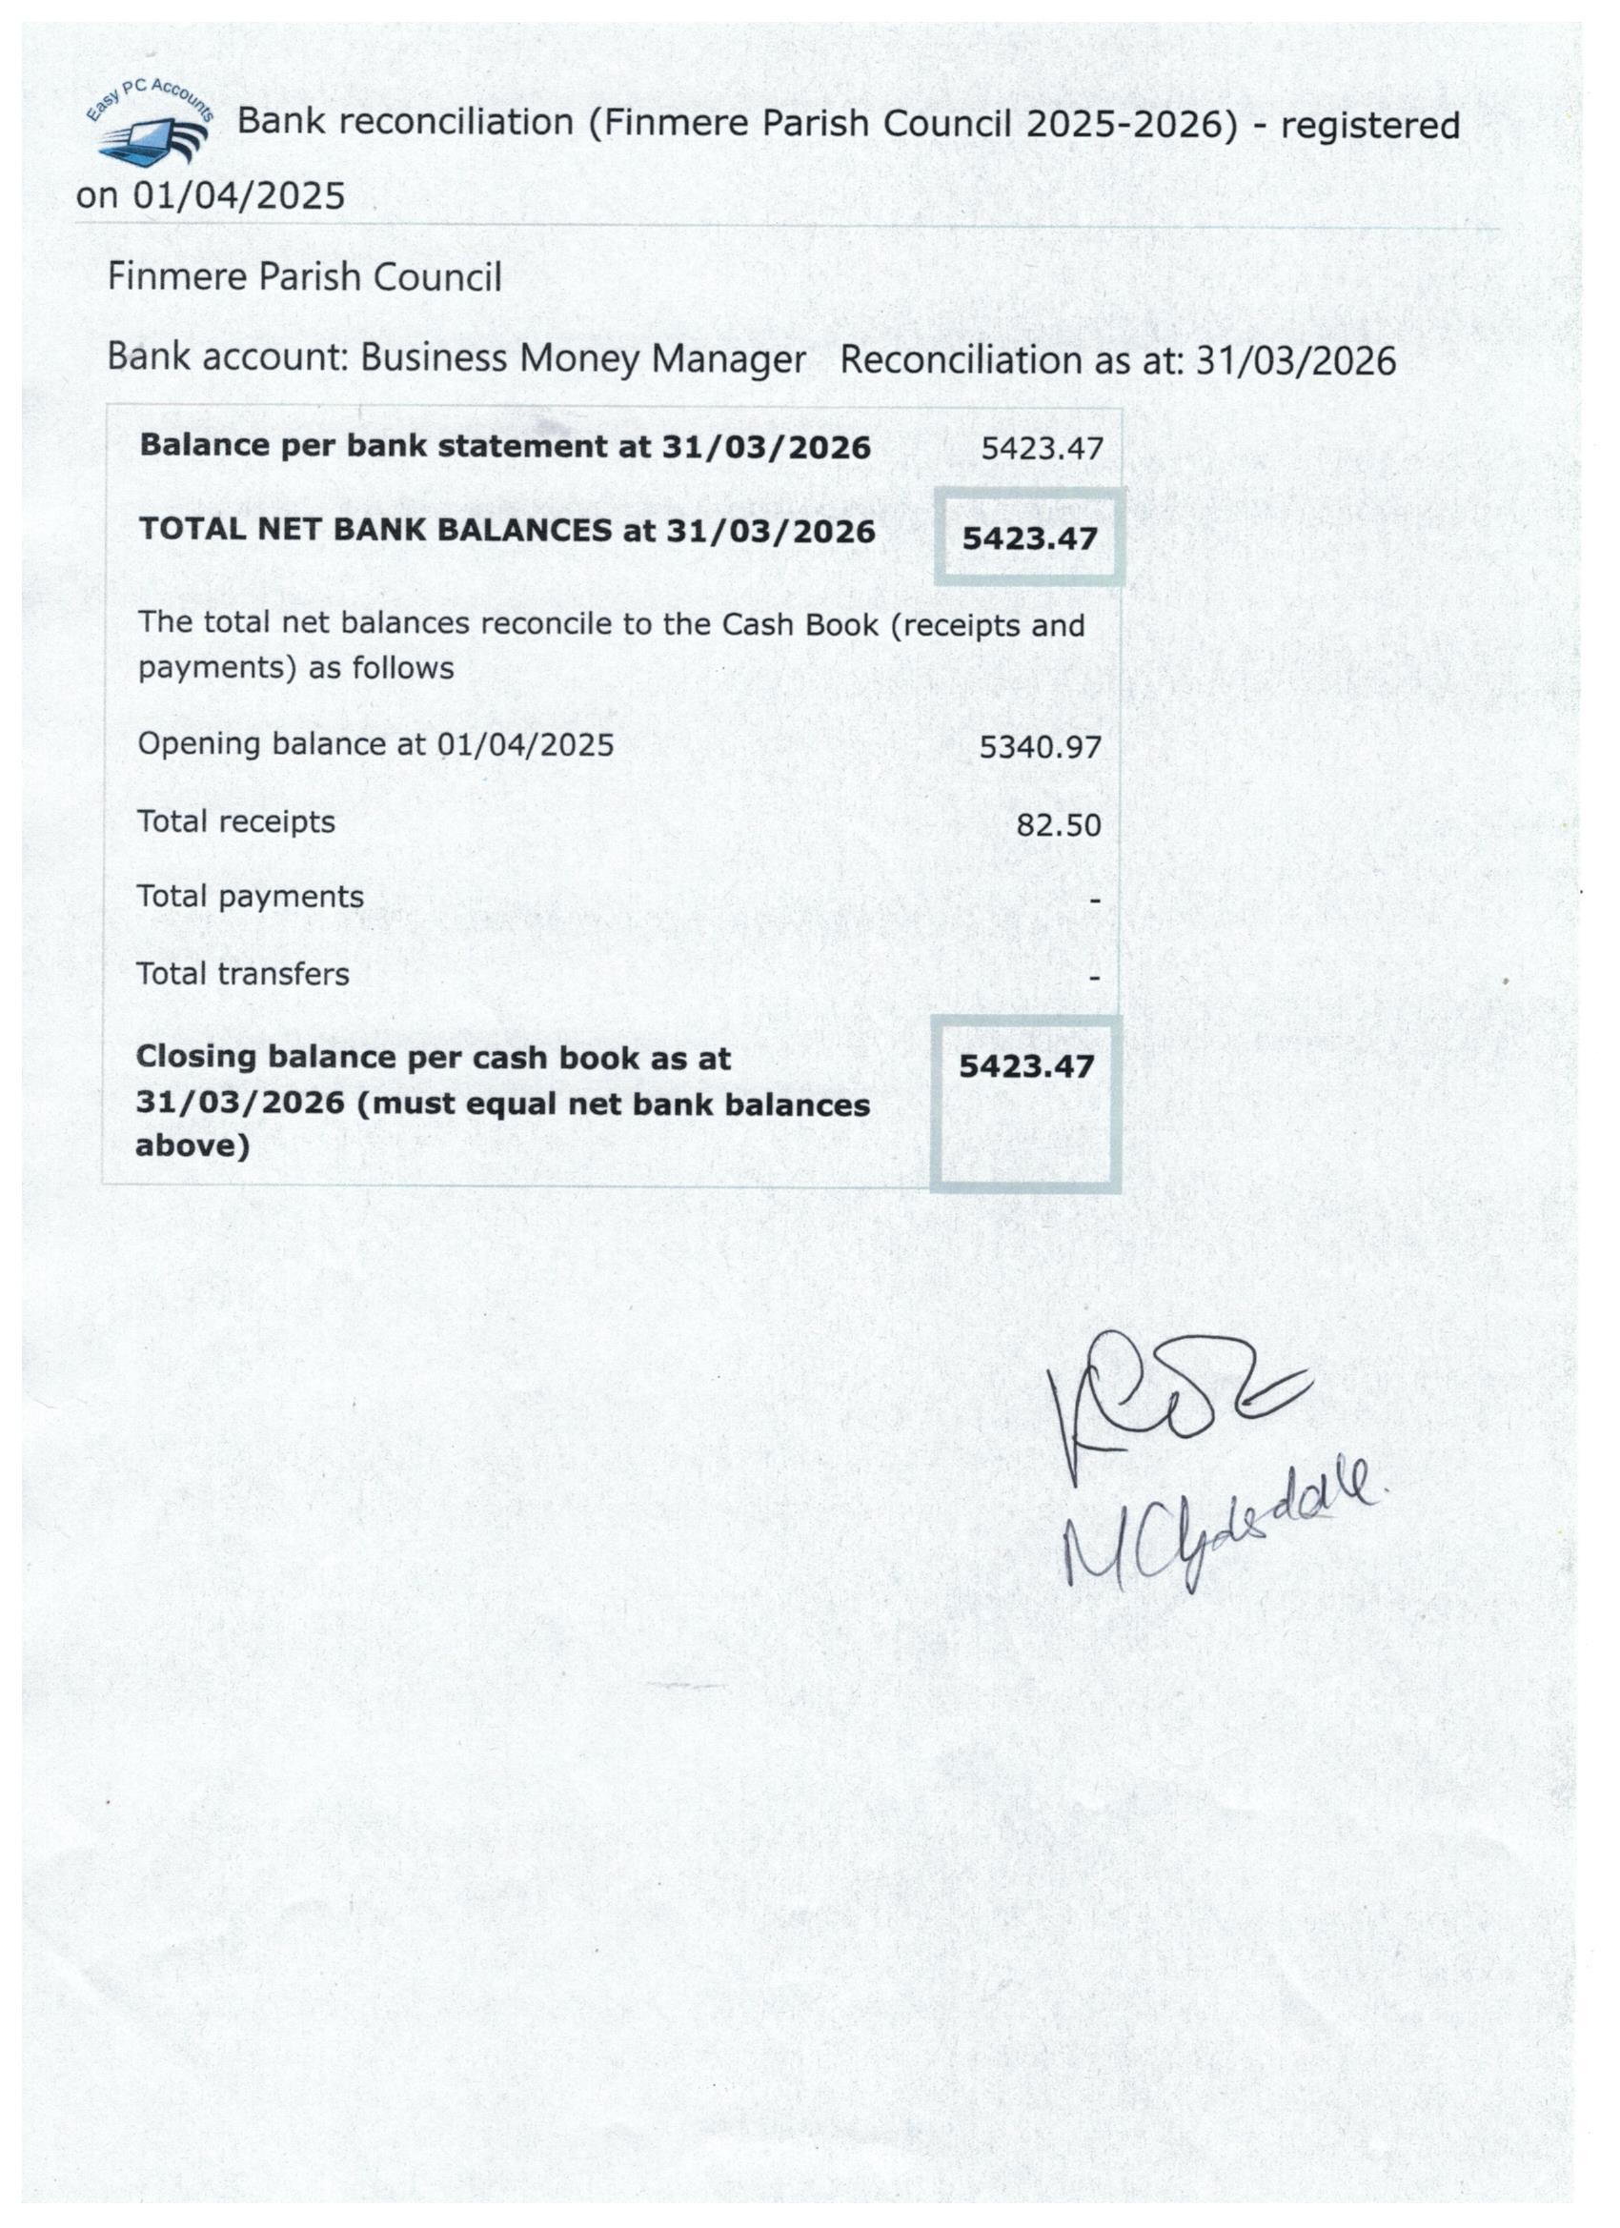

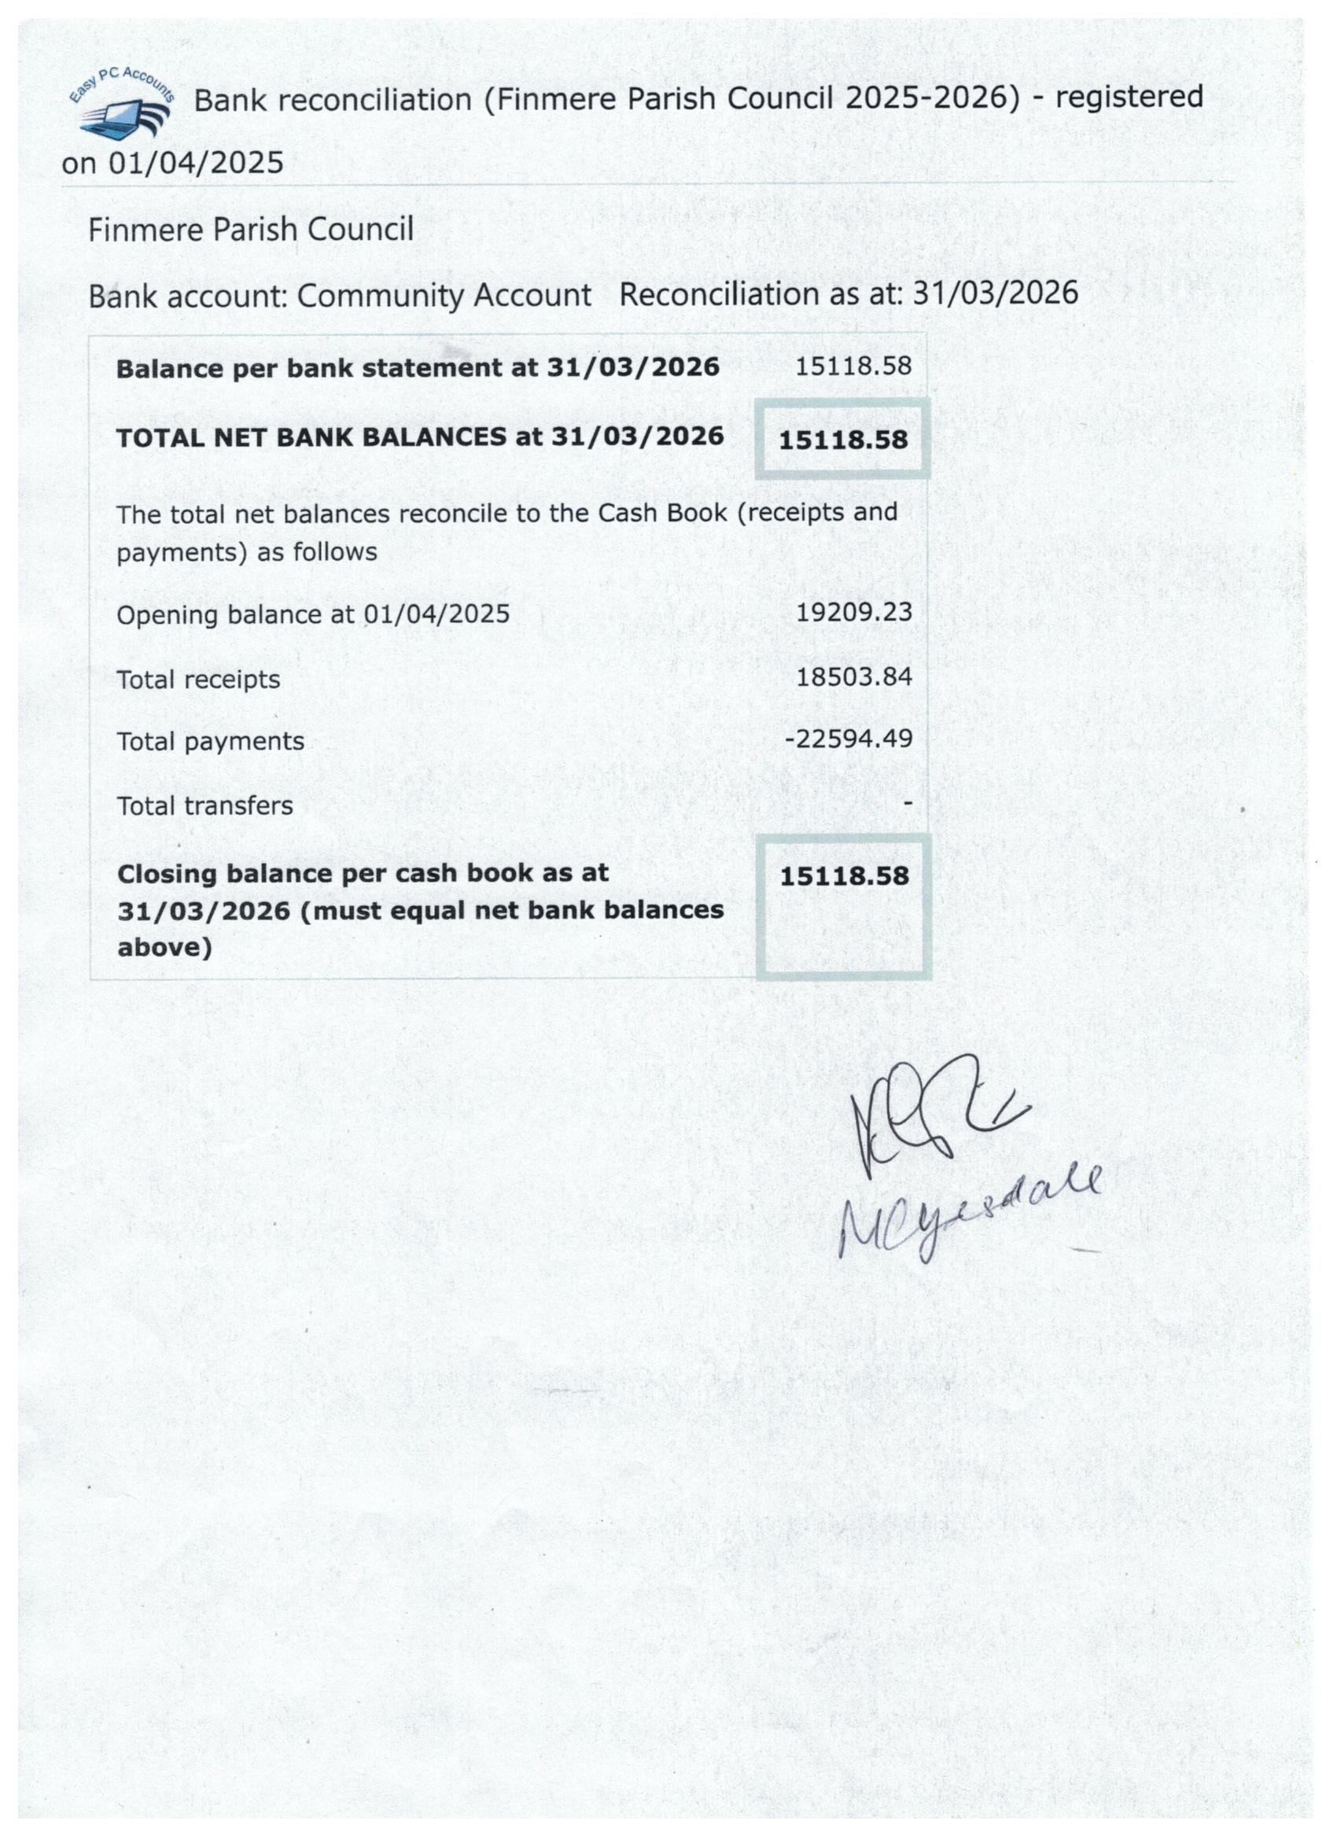

Finmere Parish Council Receipts and Payments Account – Year Ended 31 March 2026
2024 - 2025 Transactions Receipts 2025 - 2026 Summary Receipts / Payments 2024 - 2025 2025 – 2026
£14,600.00 Precept £15,300.00
£1,253.08 VAT Refund £369.73 Balance brought forward £18,503.94 £24,550.20
£101.74 Bank Interest £82.50 Add Total Receipts £21,082.54 £18,586.34
£760.76 OCC Grass Cutting Allowance £760.76 Less Total Payments £15,036.28 £22,594.49
£737.36 Sports Club Grass Cutting Payment £760.00 Balance Carried Forward £24,550.20 £20,542.05
£455.00 Capital Income £1.00
£375.00 Sports Club donation £0.00
£740.80 Sports Club Insurance Payment £713.10
£158.80 Refunds £0.00
1,900.00 VHMC Donation £200.00
£0.00 Clothing bin payment (final) £39.25
£0.00 Reimbursement for salt bin £360.00
£21,082.54 TOTAL RECEIPTS £18,586.34

2024 - 2025 Transactions Payments 2025 - 2026 These cumulative funds represented by:-
£975.26 Running costs £4,249.19 31-Mar-25 `31-Mar-26
£3,185.58 General administration £2,464.90
£4,239.64 General admin - salaries £4,212.64 Community Account: Balance £19,209.23 £15,118.58
£1,559.98 S137 (LG Act 1972) Vllge Benefit £1,591.11 Money Manager: General Funds £5,340.97 £5,423.47
£119.00 S144 (LG Act 1972) Enc Visitors £0.00 __________ ____________
£2,400.00 HA S96 Grass cutting £2,535.00 £24,550.20 £20,542.05
£1,765.75 Capital expenditure £5060.24
£405.00 HMRC £870.40
£346.07 VAT £1,611.01
_______________
£15,036.28 TOTAL PAYMENTS £22,594.49 (Chairman) --------MKB------------ (Finance Officer) ------SC--------
Date and Minute Reference: May 5th 2026 – Section 12

