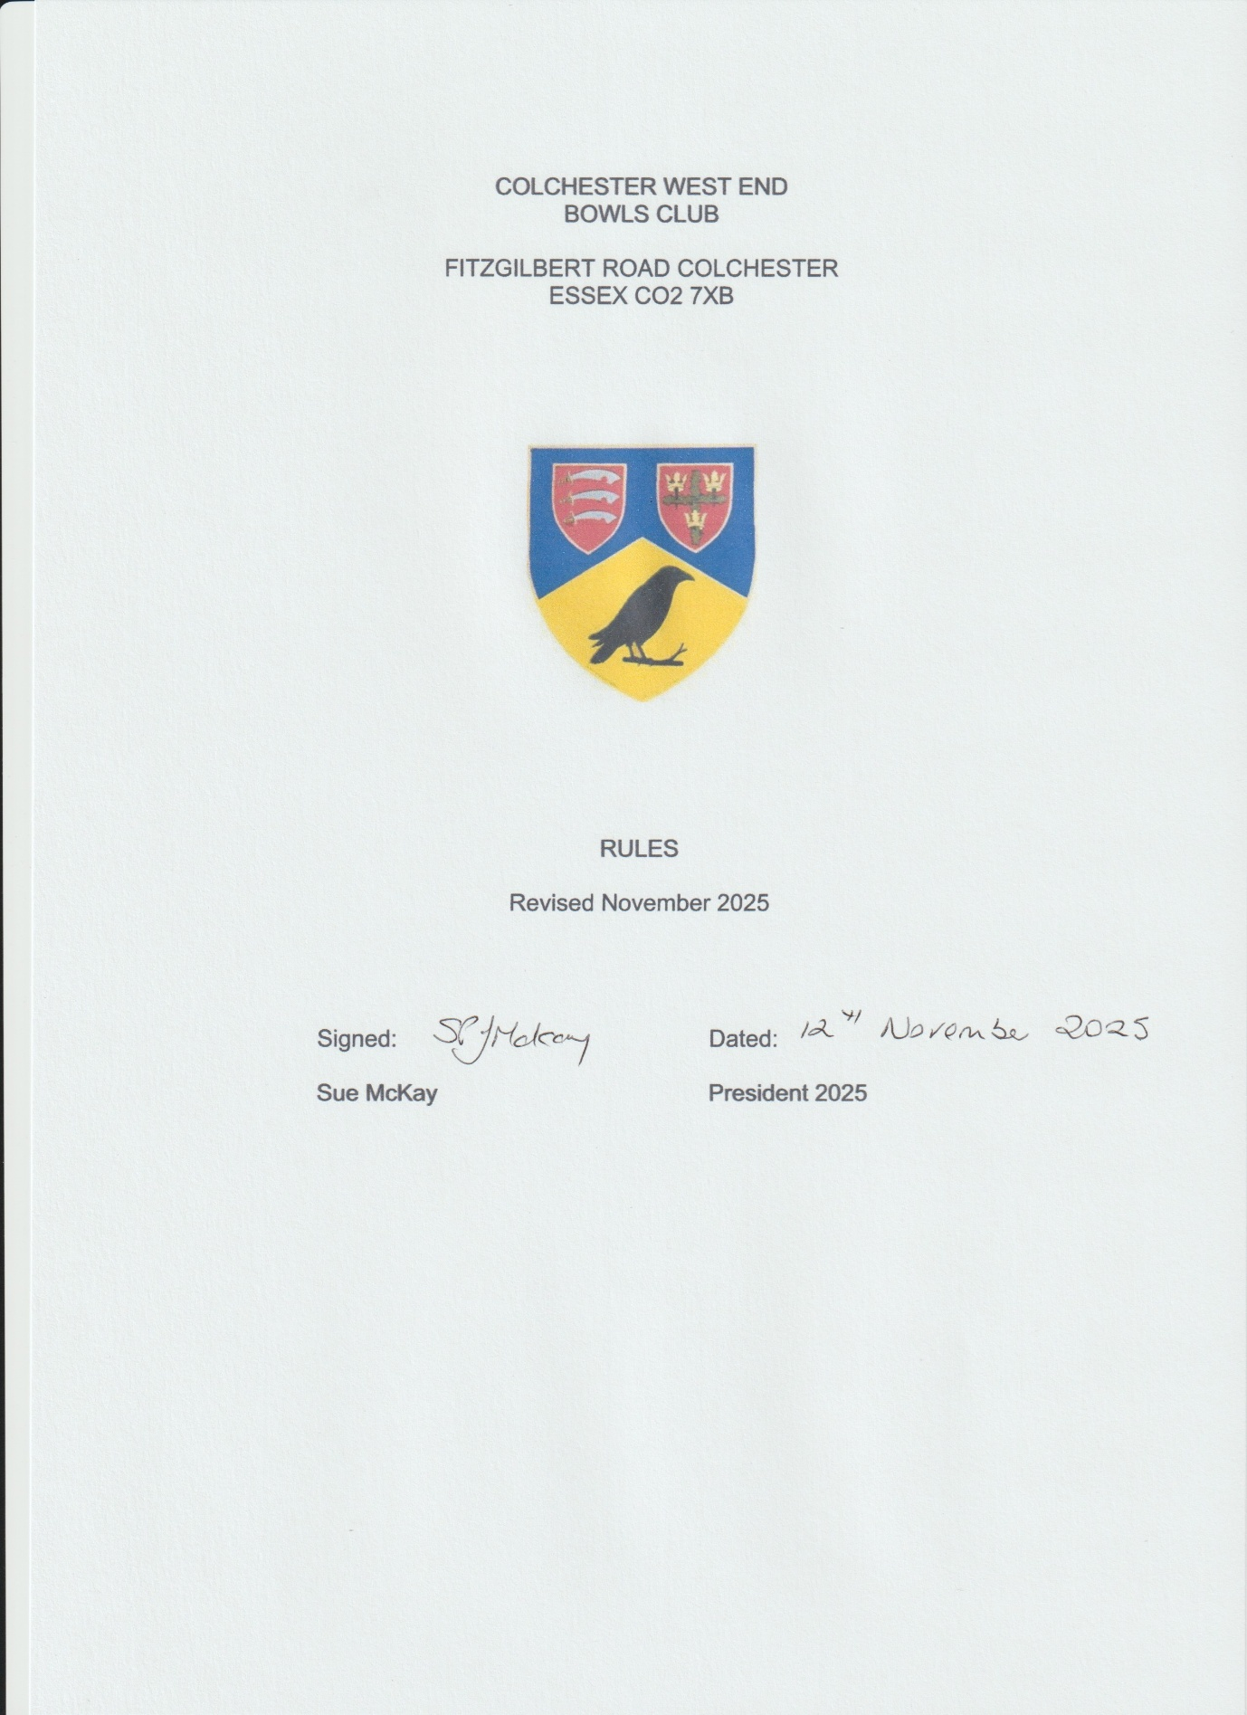

COLCHESTER WEST END BOWLS CLUB RULES

1. NAME

The Club shall be called the Colchester West End Bowls Club.

2. OBJECTS

The object of the Club shall be:

a. to provide facilities for and promote the participation of the whole community in the amateur sport of Bowls.

b. to provide such amenities as are deemed desirable for the game, and the social well being of the Club.

3. AFFILIATION

The Club shall be affiliated to Bowls England, the Essex County Bowling Association, the Essex County Women’s Bowling Association and Colchester Borough Bowling Association and (when required) the London and Southern Counties Bowling Association. The game shall be conducted according to the laws and rules of those Associations.

The Committee shall be empowered to act on behalf of the Club and affiliate to other Associations as it sees fit for the benefit of the Club

4. MEMBERSHIP

Membership of the Club shall be open to anyone in the community interested in the sport on application regardless of sex, age, disability, ethnicity, nationality, sexual orientation, religion or other beliefs. However, limitation of the membership according to available facilities is allowable on a non-discriminatory basis.

Persons wishing to join the Club should submit an application, supported by a proposer and seconder who are members of the Club, to the Secretary, who will deal with the application as required by the Committee.

The first year of membership is in all cases provisional, becoming permanent unless the Committee intervenes.

The Club may have different classes of membership and subscription on a non-discriminatory and fair basis. The Club will keep subscriptions at a level that will not pose a significant obstacle to people participating.

The Committee may refuse membership to or suspend or expel any member only for good cause such as conduct or character likely to bring the Club or sport into disrepute. Expulsion would be effected only after the fullest investigation of the circumstances involved (the member having the right to appear before the Committee to state their case) and upon a two-thirds majority vote of the Committee members present, subject to a minimum of eight concurring. Appeal against refusal or removal may be made to the members.

Honorary Life members may be elected for exceptional services rendered but in no circumstances shall they exceed seven in number. These elections may take place only at an Annual General Meeting after due notice has been given. Life members shall have the power to vote.

5. SUBSCRIPTIONS

Annual subscriptions become due on January 31st.

If the subscription is not paid by February 8th, there can be no assurance that the member's name will appear in the handbook for the current year.

If the subscription is not paid by February 28th, it will be assumed that the membership has been relinquished and the Committee may transfer it to a waiting applicant at a subsequent Meeting without notice.

The Committee shall recommend to the Annual General Meeting, for a decision, the fees and subscriptions to be set for the current year.

A member's subscription shall entitle a spouse or partner to enjoy the social facilities of the Club. For clarification this does not extend to use of snooker facilities where social membership is applicable.

6. ADMINISTRATION

a. Officers
Officers shall consist of a President, Captain, Ladies Captain, Vice-Captain, Hon Secretary, Hon Assistant Secretary, Hon Treasurer, Hon Match Secretary, Hon Competition Secretary, Green Ranger, Bar Manager, ECBA Delegate, ECWBA Delegate, Catering Manager and Social Secretary. Two trustees and two auditors are also nominated.

All shall hold office for one year and be eligible for re-instatement. All shall be nominated, elected, or confirmed at an Annual General Meeting.

b. Other Post Holders of the Club
Other responsible positions, but not Officers of the Club shall be designated by the Committee and posted in the handbook. All shall hold office for one year and shall be eligible for re-instatement. All shall be nominated, elected, or confirmed at the Annual General Meeting. Any post holder of the Club who is not an assistant to an existing Officer can at any time present reports in writing to the Committee via the Hon Secretary.

c. Committee
The Club shall be governed by the Committee. The members of the Committee shall comprise of, the Officers of the Club, the Immediate Past President and three ordinary members.

The three ordinary members shall be elected at the Annual General Meeting, one per year for a three-year term. Ordinary members shall be eligible for re-election to that vacancy at the end of the three-year term.

The retiring President will retain a seat on the Committee ex-officio, for one year only, immediately after vacating the chair.

Where other post holders are designated as "Assistants" to an Officer of the Club, then that Assistant may attend a General Committee Meeting in place of the designated office holder and have the right to speak and vote.

The Committee shall have the power to fill any vacancies occurring during the year and may augment the Committee by co-option to serve any special purpose.

The Committee may appoint further Officers for any purpose deemed necessary by issuing a byelaw.

All Officers, with the exception of the auditors and trustees, are ex-officio members of the Committee, with powers to vote. The trustees are entitled to attend Committee Meetings but not to vote.

A quorum for the Committee shall consist of the President or the elected chairman in his absence, plus a minimum of six full Committee members.

d. Management
The general and financial management of the Club shall be entirely in the hands of the Committee to whom the Officers shall be responsible.

At any time, a Sub-Committee may be established by the General Committee and shall be chaired by a member of the Committee. Normally, a Sub-Committee would have a designated lifetime as agreed by the General Committee. Signed minutes of Sub-Committee Meetings shall be maintained by the chairman or his nominated deputy with copies to the Hon Secretary for Club files.

The Secretary shall keep signed minutes of business conducted at the Annual General Meeting and Committee Meetings, and make such minutes available to members. Annual General Meeting minutes shall be confirmed at the next Annual General Meeting and signed by the President.

The Treasurer shall keep an account of all transactions on behalf of the Club and shall submit the accounts to the auditors at the close of each financial year, which shall end on 30th April. The Club shall maintain a bank current account and the following Officers shall be authorised to sign Club cheques: two from the President; Captain; Treasurer and Secretary.

No person shall receive, at the expense of the Club, any commission, percentage, or similar payment on or with reference to the purchase of intoxicating liquor by the Club. No one associated with the Club may make any private gain from activity in or related to the Club.

All surplus income or profits must be reinvested in the Club. No surpluses or assets will be distributed to members or third parties. This rule does not prevent donations by the Club to charities or to other clubs that are registered as Community Amateur Sports Clubs
Any member of the Club may at all reasonable times inspect all books, accounts and other records, and shall be entitled to receive such information as they require as to the finances of the Club. Copies of the accounts shall be available for members at the Annual General Meeting and for fourteen days before the Meeting.

e. Committee Meetings

A Committee Meeting shall be held as often as necessary but at least bi-monthly, and all matters under discussion shall be recorded and retained by the Secretary. The Committee will make decisions on the basis of a simple majority vote. In the case of equal votes, the Chairman shall be entitled to an additional casting vote. Such minutes shall be read at the following Committee Meeting and, if confirmed, signed by the Chairman.

f. Winding Up

In the event of the full members resolving in General Meeting to wind up the Club, the assets of the Club shall be realised by the Committee and a balance sheet shall be prepared showing the assets and liabilities of the Club. After discharging all debts and liabilities of the Club, the remaining assets of the Club shall be given or transferred to another Community Amateur Sports Club, a registered charity or the sport’s governing body according to the wishes of the majority of the full members of the Club. In the event of any question arising as to the balance sheet, the certificate of the auditors of the Club shall be conclusive.

7. GENERAL AND SPECIAL MEETINGS

The Annual General Meeting shall normally be held in November on a date to be fixed by the Committee.

A Special General Meeting may be called at any time by the Committee or by a written requisition signed by one fifth of the total number of members entitled to attend and vote. Any such requisition shall specify the objects for which the Meeting is required and no other business shall be transacted at such Meeting.

Twenty of the members of the Club shall form a quorum at either the Annual or Special General Meeting, and no want of a quorum after the chairman has opened the Meeting shall make a Meeting incompetent to transact business.

Non-playing members are entitled to speak but not entitled to vote unless they are Officers of the Club, or are a designated other post holder as designated by the Committee and elected by the Annual General Meeting.

Decisions made at a General Meeting shall be by a simple majority of votes from those entitled to vote attending the Meeting. In the event of equal votes, the Chairman shall be entitled to an additional casting vote.

a. Notice of Motion

Any notice of motion or matters for the agenda for the Annual General Meeting must be in writing and in the hands of the Secretary, not later than October 1st, before the Meeting.
Any notice of motion for a Special General Meeting must be in writing and sent to the Secretary and such Meeting shall be convened within the following 40 days.

b. Notice of Meeting

The Secretary shall give at least 14 days' notice of any Special or Annual General Meeting to all members in writing.

8. VISITORS

Visitors from other Clubs, invited for fixtures or other activities, may be admitted to the Clubhouse and sold intoxicating liquor for consumption within the Club.

Members shall have the privilege of introducing a friend as a visitor. The name and address of each visitor and the name of the member introducing such visitor shall be entered in the Visitors Book, and all expenses incurred by or on account of visitors for refreshment or otherwise at the Club, shall be defrayed by the members introducing them. Visitors, excluding members’ spouses/partners, may only attend the Club for social activities excluding organised Club events, on no more than four occasions in any one year. Sales may also be made to persons attending private functions organised or sponsored by a member with the approval of the General Committee.

The following conditions shall apply to applications for approval of such functions:

a. Twenty eight days’ notice, in writing, stating the nature of the function, the numbers expected to attend, and the hours during which is to take place, shall be given by the member.

b. The application shall be considered at a Meeting of the Committee being held less than fourteen days before the function.

c. A member applying for approval of such a function who is a member of the Committee, shall withdraw after giving information to assist the Committee in arriving at a decision.

d. The Committee may refuse such application without giving reasons, or approve it in such terms as shall be deemed appropriate.

e. The member responsible for the function shall ensure that the names people attending are recorded in a book. The member must be responsible for the conduct of those attending within and in the vicinity of the Club as if they were his guests.

9. DISPUTES

Any dispute shall be dealt with by members of the Committee available at the time of the event. If the matter cannot be satisfactorily resolved in those circumstances, it shall be referred to the next Committee Meeting for a decision.

10. COMPLAINTS

Any complaints concerning management and any suggestions for improvement shall be made in writing to the Secretary.

Any member wishing to complain of the actions of another member shall make such complaint in writing to the Secretary.

11. DRESS

Players and markers shall wear smooth-soled and heel-less footwear whilst on the green. Dress on the green for all players shall be white or club coloured shirts above the waist, and navy blue, white or coloured below the waist – as notified by the Captain or Match Secretary. In matches and competitions, all players must be similarly dressed above the waist in club coloured shirts. Coloured shirts, trousers and shorts must be approved bowls sports clothing.

On occasions when there are meals and/or drinks with opponents after Club games, Club players shall be expected to remain in their playing shirts for that period until the visitors have departed. It is not a requirement for male players to change in to shirt, tie and blazer.

Where the Club is hosting a game on behalf of another Association, the Association shall determine the dress code to be adopted by players arriving at the game and for any social activity including meals after the game.

The above is to be relaxed for players undertaking a roll up on the social evening (Friday evenings) only. e.g. to not require white / club shirt, to not require white / navy blue trousers. Bowls shoes are would still be required.

12. USE OF CLUBHOUSE AND BAR

a. The Clubhouse will be open as required by members, and the bar open as arranged by the Bar Manager.

b. The permitted hours for the sale and consumption of intoxicating liquor shall be in accordance with the license issued by the Local Authority Licensing Section.

13. USE OF THE GREEN

It is to the members' advantage that they take the greatest care of the green, which shall be open for play from May 1st to September 30th.

Priority use of the green will be in the following order:

National and County competitions
Borough League and competitions
Sudbury League and competitions
Club competitions and roll-ups.

The fitness of the green for play is at the discretion of the Groundsman or Green Ranger, who may order ground sheets to be used. Otherwise, the decision on the green rests with the Captain or any member of the Committee. If in doubt, roll-ups should be abandoned.

Smoking is not allowed on the green, or banks.

14. REGULATIONS AND BYELAWS

Consistent with the general or universal rules here laid down, and as may be necessary for the development and well-being of the Club, the Committee shall have power to make regulations to supplement those rules here which relate in particular to the domestic organisation of the Club, and to frame bye-laws to change and adapt the latter, as circumstances require.

All such regulations and byelaws shall be posted at the Club, and form part of the Club Rules.

15. ALTERATION OF RULES

Beyond the limited initiative of Rule 14, these Rules shall not be altered except by resolution passed at a General or Special General Meeting of the Club. Any alteration or amendment must be proposed by a Full Member of the Club and seconded by another Full Member. Such alterations shall be passed if supported by not less than two-thirds of those Full members present at the Meeting, assuming that a quorum has been achieved. Due notice must be given to members of any proposed alterations.

16. HONORARY SOCIAL MEMBERS

Should a member become unable to bowl, because of age, disability or illness, the Committee is authorised at any time to offer that member continuing admission to the Club as an Honorary Social Member.

Should a member die, whose partner is not a member but has been closely associated with the Club, the Committee is authorised at any time to offer the partner continuing admission to the Club as an Honorary Social Member.

Such action as the Committee may take under these rules to be notified to the subsequent Annual General Meeting.

17. JUNIOR PLAYERS

Junior players are those who have not yet reached their 25th birthday by 30th April of the year of membership application to be changed in line with Bowls England definition of Junior players.

