HOCKWOLD VILLAGE HALL Committee
MINUTES FOR MEETING
11th August 2025 / 3:00 PM / VENUE: Hockwold Village Hall
Hockwoldvillagehallsecretary@gmail.com
Committee Members Present: Sue Annear, Colin Holman, Chrissy Cottell, David Sismey,
Maria Day, Gina Sizer and Guest Attendees: Fire Risk Advisor: Raymond Lane
125. Welcome from Chairperson - SA -. Sue A thanked everyone attending for their personal time and attending another meeting for Hockwold Village Hall.
126. To receive and approve apologies for absence - SA - Emma Owner and Hilary Cox both sent their apologies.
127. Approval of Previous meeting minutes of the 7th July 2025 - SA GS Proposed – MD 2nd. Everyone approved.
128. To receive any declaration of Interest for any voting on today’s agenda - SA - No declaration of interest received for today’s meeting.
129. FSC - Fire Safety Committee Update: - DS/RL
  - Sealed Unit update - Sealed Unit now in place – 20mm Unit not 24, so needed additional work. Rest of committee thanked DS and RL for their hard work/time.
  - New Notice Board update –DS and RL put this notice board in place. CC will check which documents need to be in noticeboard legally. Poster stating where all other documents can be found. GS will inform any relevant hirers, if they wish to advertise their event to produce advertisement and GS will insert in notice boards.
It was discussed who had keys - GS, DS, CC
  - Update on any potential funding for Fire Safety Improvements – CC – with HC not able to attend today, we are not aware of any possible funding update. SA suggested that SA and CC get together and put together a summary of where we are as a committee to take to PC.
  - Update on Holes in the Boiler Room and Electricity Cupboard required from the FRA – RL/CA – We have not got any further forward at the time.
  - Update Kitchen Bin – DS black bin hanger now in place.
f) Update Fire Alarm requires testing once a week – Mondays 4pm – we held another training session at 4pm during this meeting. Rota will be put in place for next meeting.
g) Padlock Keys – DS and GS have keys
h) Smoke Detector Update from RL – Only quote received so far have quoted for 10 smoke and 1 heat detector. We discussed this may be too much and RL will also query with Fire Risk Assessor that smoke detectors are actually required as other information appears to state not. RL will investigate further.
i) SIGNAGE update – RL – All signs arrived and apart from 3 all in place. Assembly point, Noticeboard, Meeting room external sign – peeling externally so not able to apply sign. The peeling was discussed and decided that the surface to be peeled off completely and we applied sign to Galvanised exterior. DS will obtain prices for new door panels.
j) FRA – Action Plan Figure Update – RL

To be started 9
In Progress 11
On Hold 10 Due to financial situation
Completed 27

Total - 57

130. Lettings Update - GS

Bakeaway believe they are now sorted for Hockwold, but will be back in touch if they need us going forward.

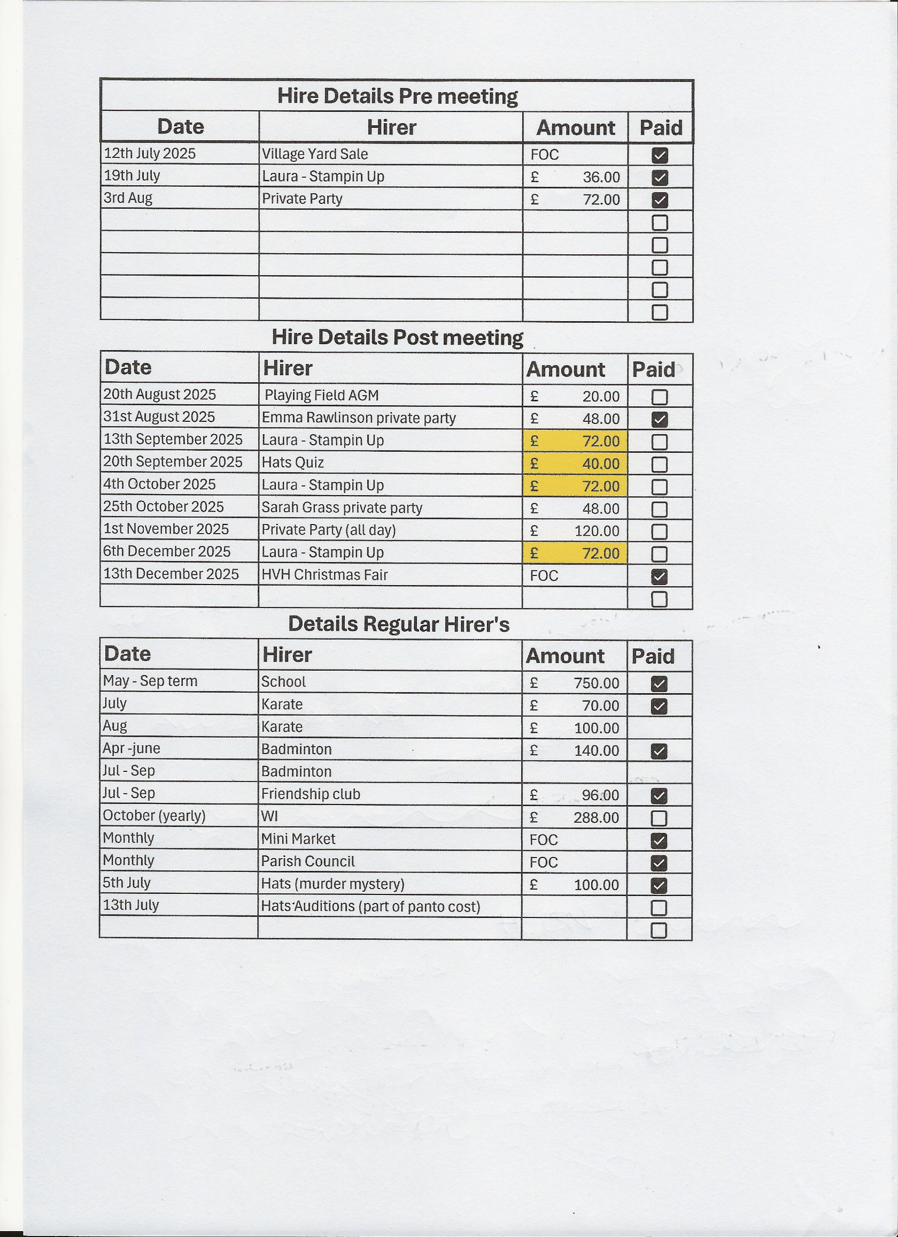

131. Financial Update - CH
Please see Statement of Accounts Below. We look like we may still be short against budget for rental value. Also, our costs have been much higher to what was budgeted, due to the number of work/improvements made so far this year.
Last water bill was much higher than previous quarters. Will check next bill and if still the same we need to find out why. Ie: Is it that the men’s urinal auto flush is now working? Does the flush time need amending? Will update next meeting.

132. Bill of Accounts – CH
a) CH Discussed the Bill of Accounts below. CC Proposed Approval GS 2nd – Everyone agreed
b) British Gas smart meter now appears to be working.
c) DS gave CH £15.00 cash for the sale of the old benches
d) DS Issued CH with an Invoice for the Gutter Brackets Total £8.39 – GS Proposed – MD 2nd and all approved.
e) DS issued CH with an Invoice for a New First Aid Kit as previous kit material was all virtually out of date. Total £23.99 – SA Proposed – CC 2nd and all approved.
f) CC informed CH to expect Invoice for LED Lighting, work being carried out 12th August and Boiler service which is due this month.
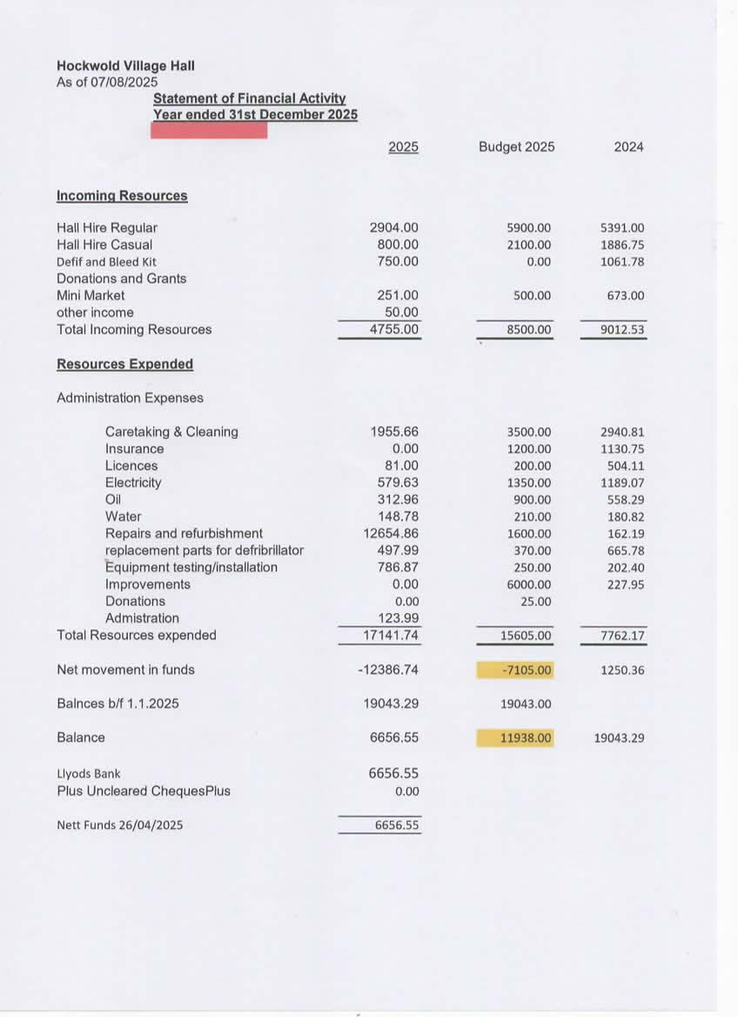
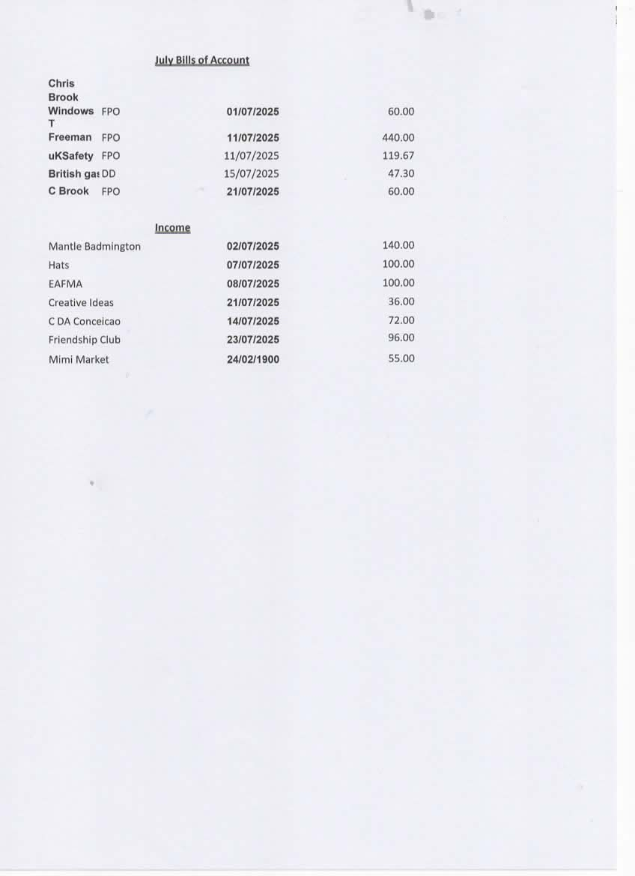

133. Yard Sale & Christmas Fair Update – GS

GS Informed the committee that the Yard Sale made £160.00 for the hall. Well done GS
GS Update on Christmas Fair – Poster designed by GS – CC proposed approval – SA Seconded all agreed.
Posters will go up on noticeboards soon and GS will also advertise on Facebook.

134. Action List – CC
a) First Aid Kit Update – SA – New kit purchased as out-of-date products in original.
b) Mesh in drains to see if that helps to stop the drains blocking as previous years. – DS
c) Emergency Contractors Update – CC sent out invites to around 30 companies of which so far, a handful have responded. Will follow up and potentially send to others. Update at next meeting.

135. LED Lighting Update – CC – LED Lighting due to be fitted tomorrow. Partly funded from Hockwold Parish Council – These will save us electric over time, brighter and better for the environment.

136. Donation Sample Letter Update – CC - Previously emailed out to committee members. Suggestions received were to add our charity number and the easy fundraising link. These amendments were made. GS Proposed Approval – MD 2nd and everyone agreed. To add to our website and Facebook to start with.

137. Matters Arising – CC
- SA asked if thankyou email was sent to Fengate Fasteners – CC – yes this was completed.
- GS asked about an A-Board required to have signs up informing people of car park needed for event. Etc: CC to obtain prices.
- SA – Can we ask Bunnings to clean extractor fan whilst towers were being used to fit new LED Lighting – CC said she would ask.

138. To be added to Next Agenda/Meeting - CC
- Initial wish us to look at what we are paying for: Cleaning Material/Toilet Rolls etc:
- Constitution and Governance Documents
- SA member of public has asked her about CCTV at the hall for playing fields. However, there are legality issue’s to not allow this.
- SA member of public mentioned about the front area, where the wall used to be is a bit unlevel, possibly unsafe and untidy.

Meeting Ended at: 16.55 Hours

Next Meeting Date: 8th September 2025 3pm HVH

7th July Meeting Minutes – Signed Off with Committee Agreement GS Proposed – MD 2nd – All agreed.

Signed Sue Annear: 
Signed C Cottell: 

