Aylesham, Shepherdswell & coldred ,Eythorne & Elvington |  | February 2021
Information provided by: | PCSO Emma Carmichael, Dover Community safety unit.

Crimes of note:
- 02.02.2021- Fraud- Eythorne -Victim reported receiving a call from an automated service, they were requested to press option one, due to the victim being suspicious they hung up. No money was sent. This is a common tactic for opening a phone line to keep listening in.
https://www.actionfraud.police.uk/
In February we received 6 calls for fraud in the Parishes listed above. How may have gone unreported is likely to be more than double.

- 03.02.2021 – Criminal Damage - Church Hill in Shepherdswell. Damage was caused to Garden gates and a fence, no other access was gained to the property.

- 05.02.2021 – Suspicious event – Central Boulevard, Aylesham. 3 males with torches seen on the scaffolding at approx 17:30 hours. Build site theft is very high value and happens very regularly. Please report anything online or to 101. If it looks suspicious it usually is.

- 06.02.2021 – Remains of a large Cannabis cultivation were found in the gateway of a field in Barfreston . This is now the 6th lot found in and around the areas of, Aylesham, Shepherdswell, Adisham and Littlebourne. Any information with regards to drug supply please report to 101 or online at the Kent Police Website.
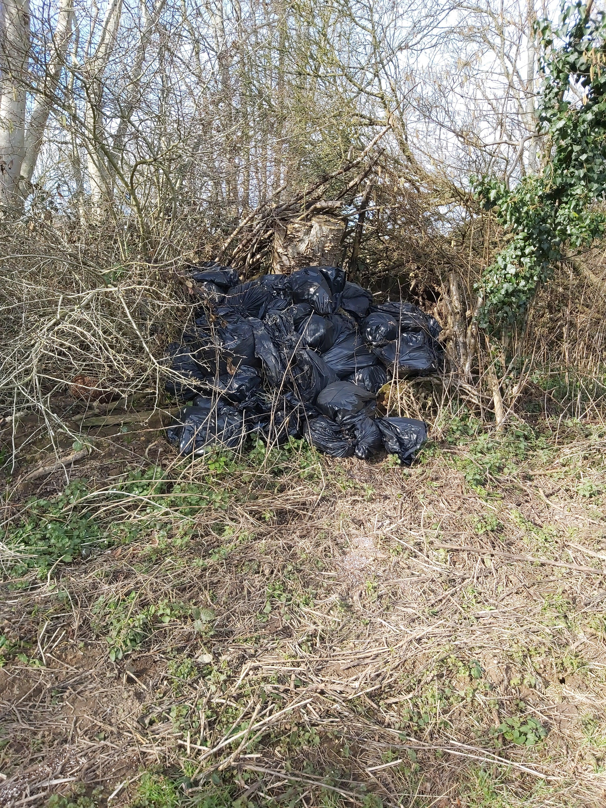

- 19.02.2021 Nightingale Lane, Nonnigton. Vehicle Seized for no Insurance.

- 22.02.2021 – Sunshine Corner Aylesham. Burglary not recent. The Victim had been staying away. On their return they found access had been gain to their premises. A window was broken.

- 24.02.2021 – Terrace Road Elvington. A vehicle had its passenger window smashed. No items taken.

- 25.02.2021 – Market Place Aylesham. 1 Male arrested for assault and Racial comments. Our community shops don’t deserve this kind of behaviour. If you witness this please get in touch or leave your detail with the shop keeper.

- 28.02.21 – Snowdown Collery, Snowdown. Criminal damage. Access gained to the site, Graffiti on the old buildings within. These building are dangerous, the do contain aspestos so although it’s a nice site for nature it is not safe.

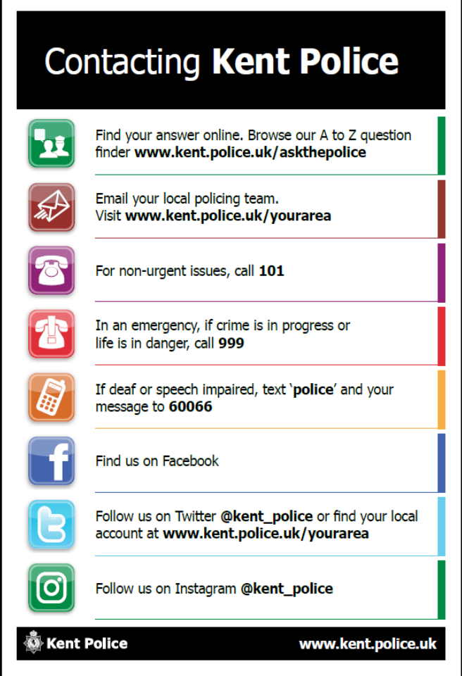

Anti-social behaviour and other incidents of note:
This year has been quite a year for off road Vehicles and Motor bikes. The Snowdown Colliery and Tilminstone pitt seem to be quite attractive areas again. A lot of these users are all road legal and insured but not all of them. Some are causing a lot of damage to farmers land. Any vehciles seen of this nature can still be reported to 101 for intel purporses.

We have received 18 calls this month for nusience vehicles. Op feilding, targetting the nusience bikes will return when Op Brock has been stepped down. Thank you for the calls and efforts made at providing evidence to us. This does all help. With the help of ring door bells we have gained a lot of information around this.

- 08-02.2021 – Nusiance Vehicle by Sunshine Corner Aylesham, a lot of 4x4’s and motorbikes were driving dangerously in the snow. Ring door bell footage helped us I.D the drivers.

- 08.02.2021 – Nusiance youths in outside the Premier in the Market Square Aylesham.

Items of good work:

19.02.2021 Dover Community policing team seized a vehicle for no insurance on Nightingale Lane, Nonnington. They were deployed to the area due to the number of calls for Nusiance Vehicles.

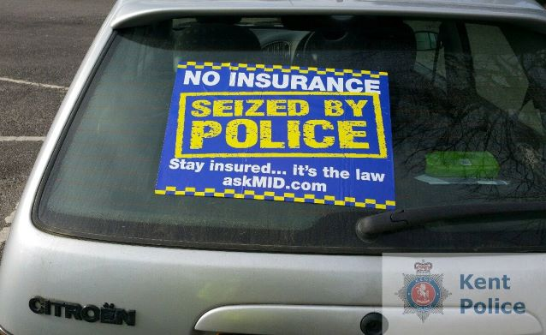

So this month we saw quite a few inches of snow. What a pretty few days that was. It doesn’t stop us coming out and patrolling the local areas. It usually ends up been a very busy time for the police and all emergancy services.
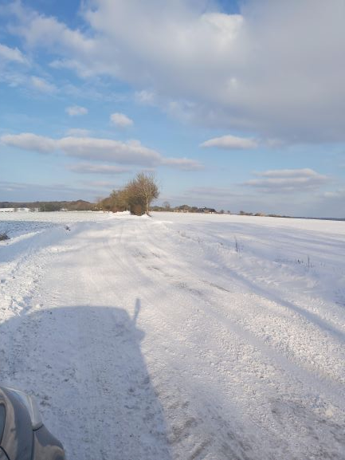

As PSCO’s we are jack of all trades. We came across a tree blocking half the road on Shepherdswell Road, what do we do? Knock on the door of a local resident in the hope a team of strong men live there. Much to our dissapointment there wasn’t but we did manage to aquire 2 very small saws!! We started the mission of sawing the tree, it felt like we would be there for hours.
Then came our saviour, a man with a chainsaw in the back and his very own huscavana safety trousers and helmet!
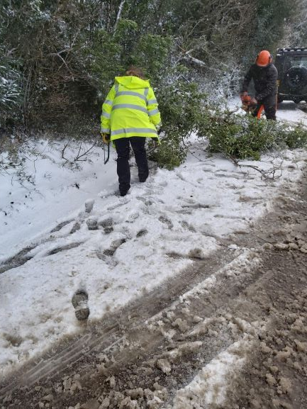

I’d like to take this opportunity to thank the communities we work in for the help we always receive from you its much appreciated in these challenging times.

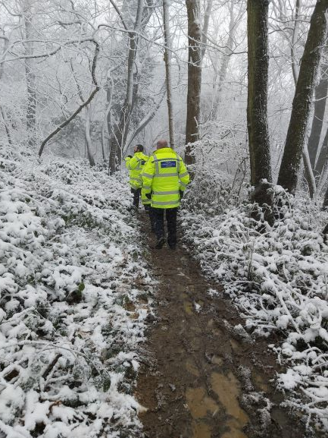

Searching for a male reported to be sleeping in the woods. Although we are coming into warmer climates please be aware of Operation Swep. Severe weather emergancy protocol.
https://www.dover.gov.uk/Housing/Housing-Needs/Homelessness/SWEP-Rough-Sleepers.aspx

Updates of previous reported issues:
Ongoing high visibility patrols have been maintained in and around the villages of Aylesham & Nonnigton,Eythorne & Elvington, Shepherdswell & Coldred for this period and will continue.
Kent Police Community Safety Unit, in conjunction with Dover District Council Community Safety Unit remain jointly working together targeting nuiance vehicles in our rural communities, proactively targeting and disrupting those responsible for nuisance riding in the Dover District
When reporting incidents of anti-social, nuiance and / or suspicious behaviour please consider the advice below:
- The Time/ Day/ Date/ Location of the incident.
- Names of or if unknown, a description of the offender, as full as possible, including clothing.
- Any vehicle markings, such as registration numbers and a full description of the vehicle, including make/ model/ vehicle type, colour, any distinctive markings or damage.
- If images (stills or CCTV) can be obtained at no risk to the informant, please email these to your local officer or CSU.dover@kent.police.uk

Speeding

Update: PCSO’s will be trained to use the speed gun. They will be deployed to areas where speedwatch stats shows there to be a speeding problem.

For further information and statics relating to the wards listed, please visit the Kent Police website and select the appropriate area.

https://www.gov.uk/coronavirus

