Photographs of the Kirkandrews-on-Eden School
These first three photographs are thought to show the outside of Kirkandrews School in the village itself in the house now called The Cottage.
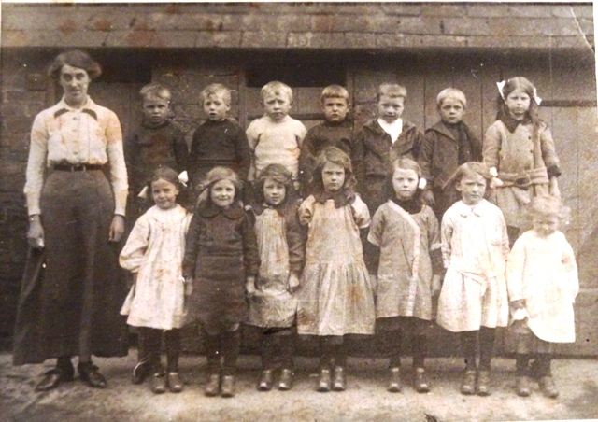
Photograph showing the outside of Kirkandrews School in Kirkandrews village
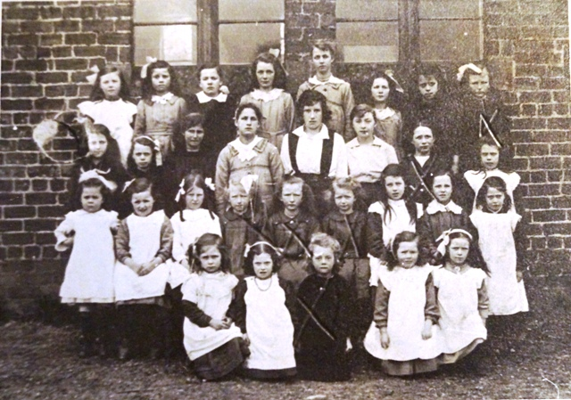
Photograph showing the outside of Kirkandrews School in Kirkandrews village
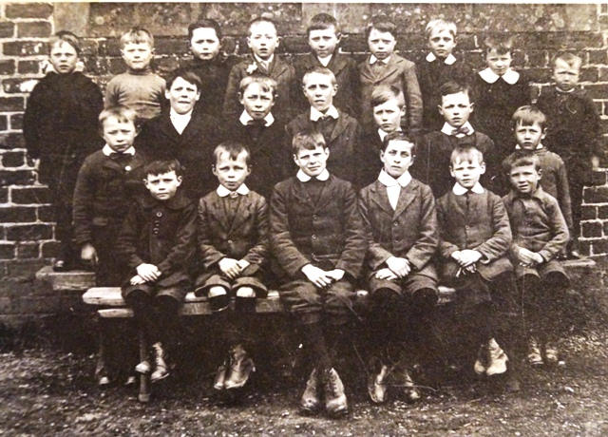
Photograph showing the outside of Kirkandrews School in Kirkandrews village
All other photographs are of the School after it had moved from Kirkandrews village to the Ols School house near Beaumont Parish Hall.
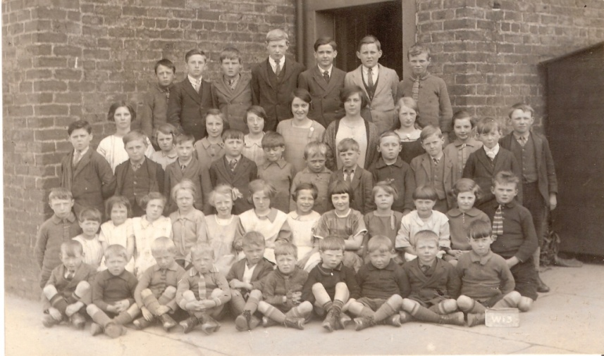
Kirkandrews-on-Eden School. Photograph taken 1927.

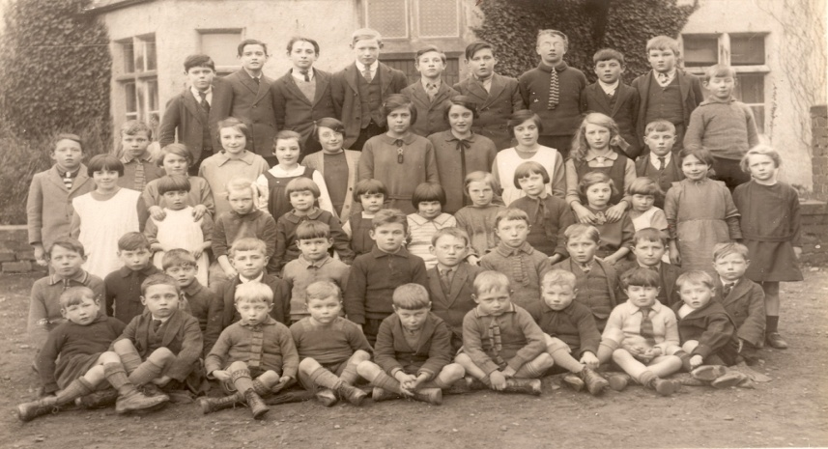
Kirkandrews-on-Eden School. Photograph taken 1929.
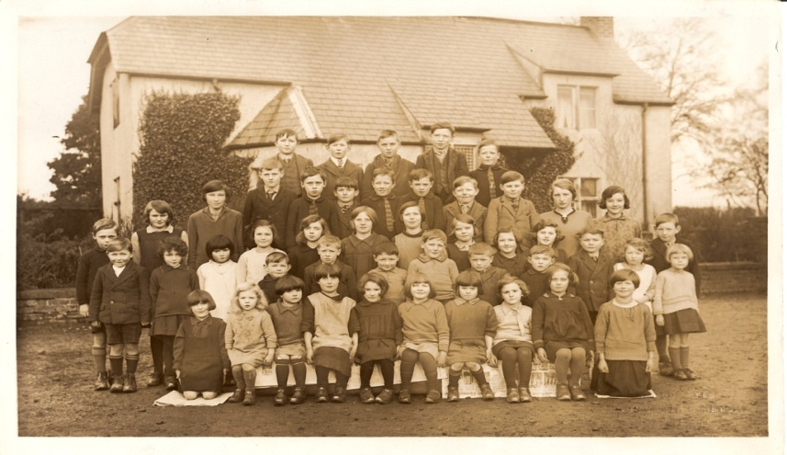
Kirkandrews-on-Eden School. Photograph thought to have been taken 1929.
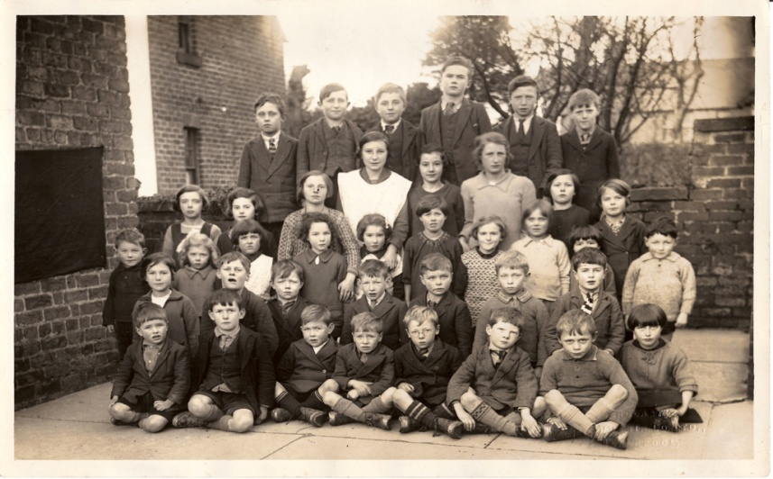
Kirkandrews-on-Eden School. Photograph taken 1930.
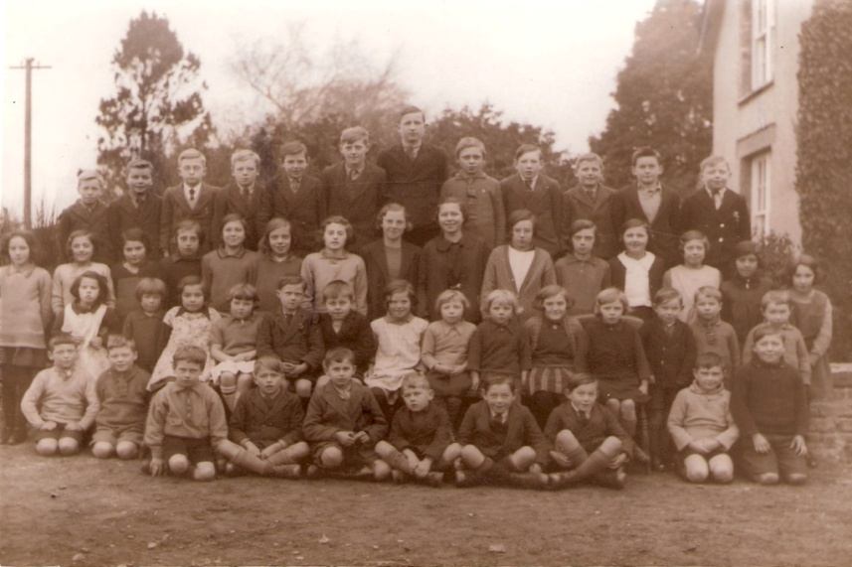
Kirkandrews-on-Eden School. Photograph taken 1933.
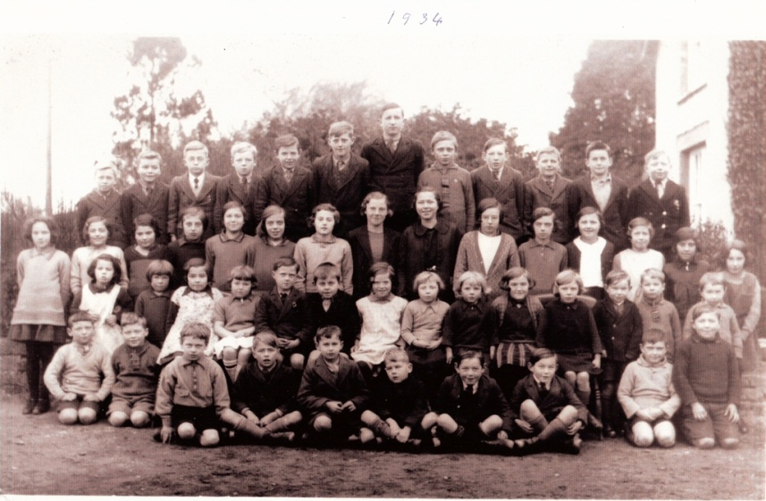
Kirkandrews-on-Eden School. Photograph taken 1934.
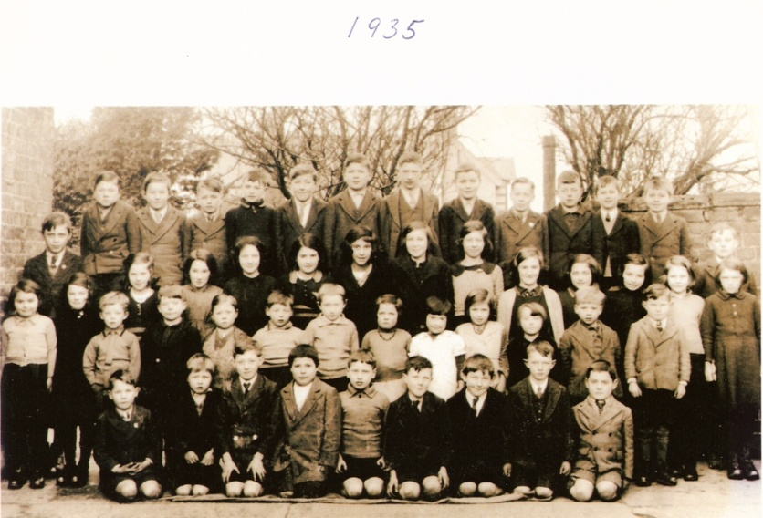
Kirkandrews-on-Eden School. Photograph taken 1935.
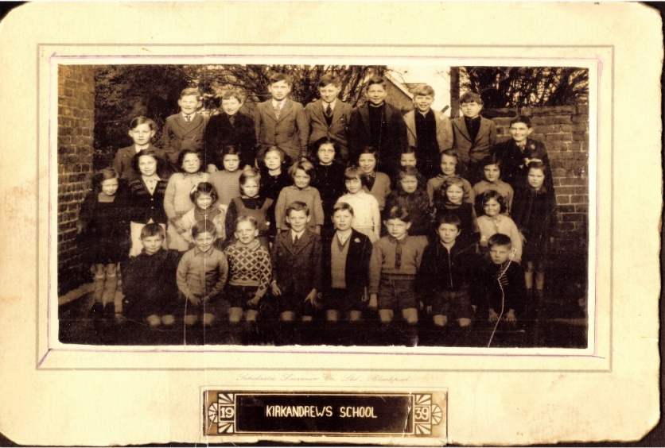
Kirkandrews-on-Eden School. Photograph taken 1939.

