GLOUCESTER CITY BOWLING CLUB
Founded 1907


Helpful Information For
new Members

Version: July 2024
Gloucester City Bowling Club
Helpful information for new members
Introduction
Bowls is a simple game, but it can take years to understand all the intricacies and variations that are part of the game, especially within a diverse club such as ours at Gloucester City. Behind the smooth running of the Club there are rules and regulations set out in a ‘Constitution' and there are committees, instructions, and a dress code! Initially, this is a lot to take in, so we have produced this booklet/information as a general guide to help members, new and old, of the basics of how the Club works.
How does the club work?
- The Club is run by the General Committee who are appointed each year at an AGM, normally held in November. They meet at regular intervals throughout the season and during the winter months. This committee oversees all aspects of the Club, sometimes making tough decisions, but all for the good of the Club. The Minutes of these meetings can be found in the Minutes folder on the main noticeboard.
- The Friendly, and Glevum league games have a selection committee, who meet at regular intervals to choose the teams. This committee also make selections for touring games.
- There are also mid-week triples games held. The mid-week triples captain will make the selections.
- Club volunteers conduct maintenance of the green and surrounding areas. This group of people work incredibly hard all year round and provide us with the beautiful surrounds that you see. The Club welcomes anyone at any time to volunteer their help in this area of the Club's management. Please do not wait to be asked!
- The Bar is an essential part of the Club where we socialise with other Club members and visiting teams. It is also an essential source of income and is run totally by Club volunteers on a rotational basis.
- This club, as well as many other clubs, hold a raffle after friendly, league and touring games. Sometimes a ‘spider’ is held before a touring game, this is on the all-weather green. The cost for raffles is £1, all of which goes towards club funds.
- At the beginning of the season, we hold the Spring Meeting where everyone meets to pay their club fees, collect their Fixture card, and complete their club Competition forms.
- After the end of the season, the club holds a presentation evening. Friends and family are all welcome to see the winners and runners-up receive their trophies.

How do I gain access to the club and green?
All members are given a code which will allow you to open the padlock for the main entry gate, side gate and waste collection gate. Each member is also given a key fob to gain entry to the clubhouse. There is also a spare key fob kept by the main entrance door.
- To enter the Club, you will need to deactivate the alarm system with your given key fob. The key fob pad is on the wall on the left side of the door. Tap your fob on the pad and the door will be released. Once inside you must touch the key fob pad, on the left-hand side to deactivate the alarm.
- If you are last out and have checked that no one else is on the premises, even if you did not open any doors, you must check all doors are closed, and that all lights have been turned off (check the toilets).
- You can then reset the alarm by touching the key fob pad. Please wait for the alarm beeps, before you close the door. Please DO NOT slam the door closed.

Playing Opportunities

- When you become a member of the club, you will be asked to adhere to our policy of wearing a club shirt, with navy shorts or trousers for any games. Orders for these items can be found on the general noticeboard. Due to the variance in sizes, we do not keep stocks.
- Club night takes place on Wednesday evenings, weather allowing. This is a fun, more casual affair with members turning up when available, playing in various positions making the evening entertaining and the chance to meet other members of the Club.
- Having a 'roll-up' is possible from 12pm provided there is a rink available. Before taking to the green, just double check the RED rink-booking folder so you do not use a rink that has been pre-booked. Casual dress acceptable.
- Rinks can be booked by all members who are playing club or county competitions. When booking a rink, it is important to observe the rink 'priority' GUIDELINES list which is found in the red folder.

Friendly Matches
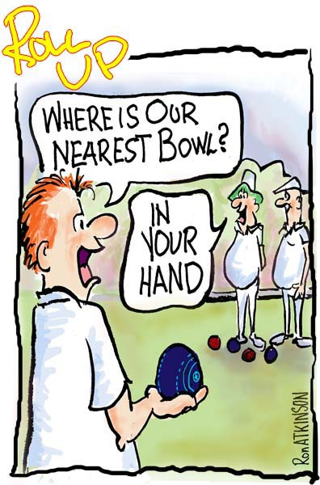
- There is an extensive fixture list both for ladies and men as well as mixed matches and mid-week triple games.
- If you want to be considered to play any of these games, please put your name on the availability sheets on the Club’s noticeboards. The relevant Captains/selectors will select the teams and then put the selection sheet back on the noticeboard. They will also post them on the Group WhatsApp.
- If you become unavailable, for ANY game, please do not scrub your name from the sheet once rinks have been selected. You must call the captain as soon as possible so a replacement can be organised. The captain’s phone number is printed on the selection sheet for that game.
- For home and away games players should arrive no later than 15 minutes before the start of play.

League and Cup Team Matches
- The relevant Team Captains will select league and cup game players, normally from the strongest players in the Club. Consideration will also be taken on their availability and eligibility. Team sheets and game details are posted on the respective notice boards. Dependant on opponents, the strongest team will be selected.
- If you are not selected and put as a reserve, please do not scrub your name off as you made be needed on the day. It is courteous to call the captain to let them know you are no longer available. Reserves will always be considered for the next game but may not always play. Again, it is always the captain’s decision and must be respected.
- The ladies league home and away games are normally played on a Tuesday evening, except in exceptional circumstances whereby the date may clash with a ladies County game, then the game will be mutually re-arranged.
- The men have two league teams; A and B, with two rinks in each league and play on Sunday Mornings. If you are new and are interested in being considered for selection, please talk to one of the team captains. The selection board is by the gent’s toilets.
- There are numerous Club team competitions played during the season and selection is conducted by the captains/selectors. The times and format of these competitions are often varied and not in the fixture book, so it is wise to check the notice board for dates and times. Notification is also posted on the Group WhatsApp.

Individual Competitions

- After you have chosen your Club competition at the beginning of the season; draws are then conducted and posted on the notice boards along with play-by-dates for each round. Please adhere to the Competition Rules that are given to everyone when entering.
- The finals are played over a weekend at the end of the season and the winners of these will have their name put on the Club honour’s boards. Trophies will be presented at the Club Presentation Evening and then returned to the trophy cabinet.
- The player’s name on the top of the draw is known as the challenger and responsible for contacting their opponent to arrange a day and time to play. For a singles match, the challenger is also responsible for organising a marker who will umpire the match. Cards are already printed ready for you.
- Please remember if playing at home, that rinks must be booked. Check the Guidelines in the rink booking folder.
Safety?
- The Club has 3 safeguarding Officers at the Club, all of which are named on the Club noticeboard. Please contact these members should you have the need to.
- There is a first aid box available, which is well signed in the entrance hall. There is also a defibrillator available with members trained in the use of.
What do I wear?
- As a general guide, games during the day are played wearing Club colours i.e. Club shirt above the waist and Navy-Blue shorts/trousers below.
- For rolling up, it is important to be smart and be respectful of any other activity being hosted by the Club.
How do I improve?
- We currently have a Club coach, Rob Ellis, who is always happy to give help and advice at any time.
What else goes on?
- We host County matches, and welcome touring sides from around the country. These are both men's and ladies’ teams which generate extra money for the Club, but this also means a vast amount of extra work for the Club, which we rely on members volunteering to help.
- During the winter months we have a monthly quiz plus other social events to get members together.

How do I find out more?
Fortunately, there are places and people that you can go to, to find out more about the Club, its games, organisation, and bowls in general.
- The members’ fixture card is complete with all the information about fixtures, your officers and contact details.
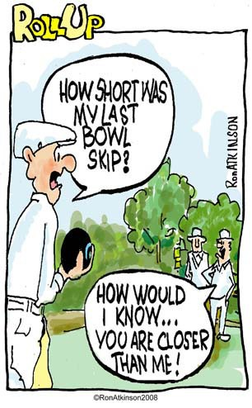
- If you have any issues or questions, please direct them to the Club Secretary who will be pleased to deal with them or take them forward to the General Committee as appropriate.
- The notice boards during the season provide you with a wealth of up-to-date information about Club activities and bowling around the county.
- If you have an email address and have registered it with the Club Secretary, updates and other useful information is distributed in this way.
- If you are a Facebook user you can also join our “friends” on our Facebook Page, just search for Gloucester City Bowling Club.
- The best way of all to get to know about bowling, and what the Club has to offer, is to get down to the Club, play bowls and talk to the other members.
Enjoy your bowls!

