PETROCKSTOWE PARISH COUNCIL
Parish Clerk: Fiona Lowe
Phone: 07989 638315 E-mail: petroc.clerk@hotmail.com

Dear Councillors
You are duly summoned to attend the Petrockstowe Parish Council Planning Meeting
to be held at 6.00pm on Tuesday 20th February 2024, at Baxter Hall, Petrockstowe,
to discuss the following business.

AGENDA

- Apologies of Absence

- Declarations of interest

- Planning Council is asked to discuss the below planning appeal and inform the Clerk of its comments to forward to Torridge District Council. Any planning applications received after the distribution of this agenda will also be considered.

Our Ref: 1/0075/2024/FUL
Date: 31st January 2024
Proposal: Construction of No.3 dwelling with local occupancy restriction.
Location: Land To The South Of Rectory Rise, Petrockstowe, Devon,

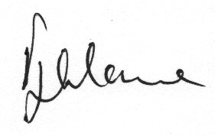

Fiona Lowe
Parish Clerk
13/02/2024

