Stretton under Fosse Parish Council
Minutes of Meeting
Held on Tuesday 11th July 2023
at 19.00pm at Stretton Under Fosse Village Hall

Present:
Chair: Sue Hartshorn
Councillors: Cllr Davidson, Cllr Ogden, Cllr Smith
Town Cllr: Cllr Gillias
Clerk: Cllr Davidson acting as Clerk
Public: None

- Apologies for absence
Cllr Daniell, County Cllr Warwick, Clerk Lindsay Foster

- Declarations of Interest and Requests for Dispensation
None
- Public Participation
None Present

To approve Minutes of May Meeting
Proposed by Cllr Hartshorn. Approved by all.

News from Rugby Borough Council (RBC) and Warwickshire County Council.
  - Cllr Gillias highlighted that attendance by Parish Cllrs at the Cross in Hand Lorry Park Meeting would be very welcome to highlight any concerns re increased commercial traffic.
  - Cllr Gillias - a “Shared Prosperity Fund” had been allocated, which would invest in sports and leisure facilities. Decisions to make grants are decided by an independent prosperity committee rather than the council.
  - Cllr Gillias shared that there have been issues with parking machines not functioning properly in Rugby, should anyone receive a fine because of this they could gain his assistance in making an appeal against the fine.

Finance
The cheques below were agreed unanimously.
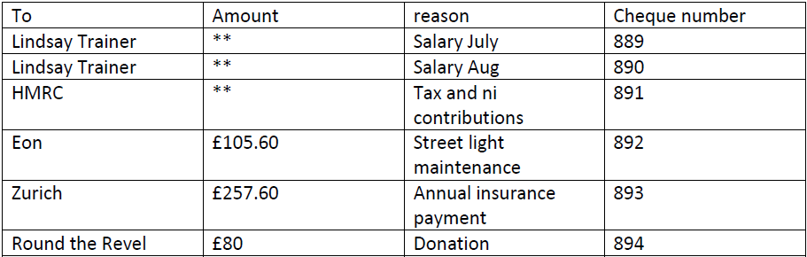

- Planning
R23/0620 at 2 Main Street stretton under Fosse, Rugby, CV23 0PF – Erection of a partition wall and door in a bedroom, swap the facilities downstairs WC and utility room, plus additional fitted cupboards in the kitchen. The Cllrs were unclear why this matter required planning permission but have no objections to these internal changes within the property which have no impact on the Parish or other Parishioners.
- Streetlighting

- Cllr Hartshorn highlighted that we have one streetlight that is on all the time, and one that remains broken. We pay a maintenance charge to EON but are not convinced of what is being done. Cllr Hartshorn will contact EON to pursue this, in extreme if there is no maintenance being done there should be no charge.
- Cllr Smith reminded the meeting that our electricity costs are an estimate based upon the time of usage, number of lights and wattages, hence we should apply for a reappraisal of this cost when we have lower wattage LCD bulbs have been installed.
- Cllr Smith is getting no response from the contractor who quoted to replace the streetlight brackets and bulbs. This contractor did offer the best value and was recommended by other Parish Councils. Cllr Davidson agreed to take on the chasing of this contractor to see if any progress can be made before we seek another contractor.

- Millenium Tree and Seats
A tree was planted for the Millenium and a metal cage put around it to protect the tree in its early growth, the metal cage now needs to come off. We are unclear if the tree has a plaque to identify it and on who’s land the tree is on. Cllr Hartshorn and Cllr Ogden agreed to investigate, as a plaque to identify and commemorate the tree would be desirable. Further the benches at either end of the village were sited at the same time, we need to clarify if these are on our asset register and discuss maintenance plans and costs at a future meeting.
- Training
The Cllrs present agreed that training to aid our role as Parish Councillors would be desirable, and Cllr Hartshorn agreed to discuss this with the Clerk and bring suggestions to the next meeting.

Items for next meeting

- Training
- Streetlighting
- Millenium Tree and Seats
- Poors Land Update
- Would it be better if we changed the meeting to a different Tuesday in the month to aid attendance by Cllr Gillias and Cllr Warwick?

Next meeting 12th September at 7.00pm to be held at the Village Hall, flowed by 14th November unless we choose to change this as above.

Meeting Closed 20.30.

