Farnborough Neighbourcare

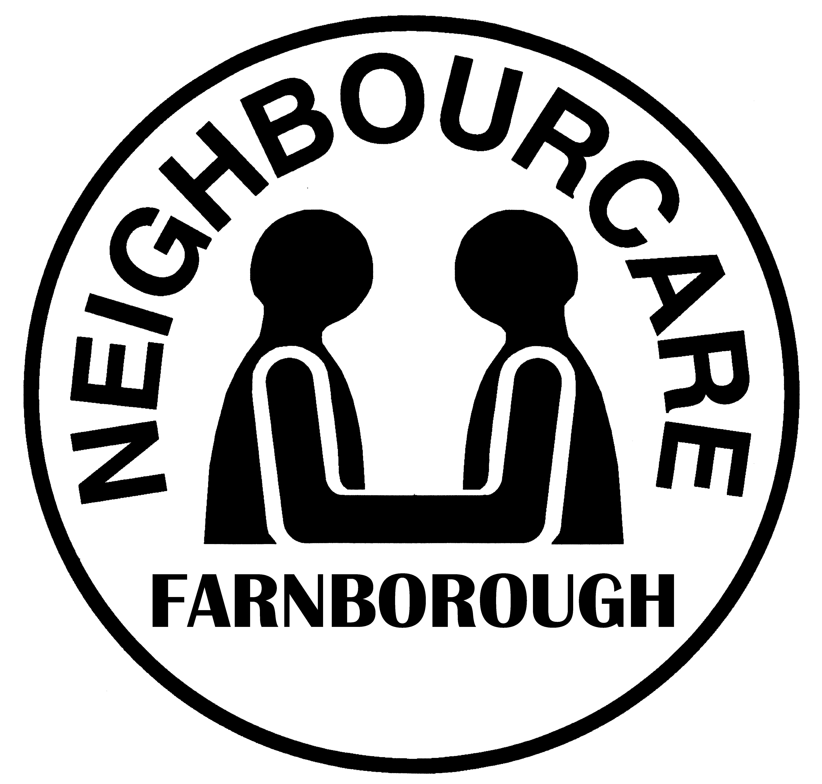

Risk Assessment - Client

In order to make sure that we can meet your needs, it would be helpful if you could answer the questions below. Please note, Neighbourcare clients are expected to have a reasonable level of mobility e.g. can walk to and get in/out of the car with minimal assistance from the driver.

Please delete as appropriate

1. | Do you need assistance walking?  Do you use a walking aid? If so please state which kind.  Please note, drivers are unable to accommodate wheelchairs in their cars, but can use the wheelchairs available at your destination. |  | Yes | No
2. | Do you need assistance to get in or out of a car? |  | Yes | No
3. | Do you need to sit in the front of the car? |  | Yes | No
4. | Do you have a Blue Badge? |  | Yes | No
5. | Do you have any health issues that we should be aware of  e.g. difficulties with sight, hearing, speaking or memory. Please state. |  | Yes | No
6. | Do you have any other special needs? Please state. |  | Yes | No
7. | Do you need a carer/relative to accompany you?  If so, do they have any special requirements e.g.walking aid. |  | Yes | No
8. | Any further information? Please list anything that will assist us to help you. |  | Yes | No

Signed: .......................................................................................... Date ....................................................

Print Name: ..................................................................................

Thank you for completing this questionnaire. Please inform the Neighbourcare office if your circumstances should change or if you have any concerns about the service we provide.

