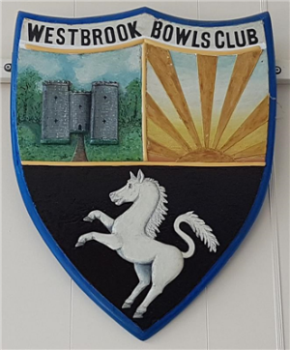
WESTBROOK BOWLS CLUB

Are You Interested in Playing Bowls?

Come Along to One of Our Open Days to See What’s Involved and Give It a Try, We’ll Even Make You a Cup of Tea or Coffee


Saturday18th^{th} April: - 10:00 – 12:00 & 14:00 – 16:00
Sunday 26th April: - 10:00 – 12:00 & 14:00 – 16:00
Sunday 4th May: - 10:00 – 12:00 & 14:00 – 16:00
https://www.hugofox.com/community/westbrook-bowls-club-15171/home

