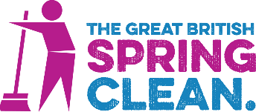

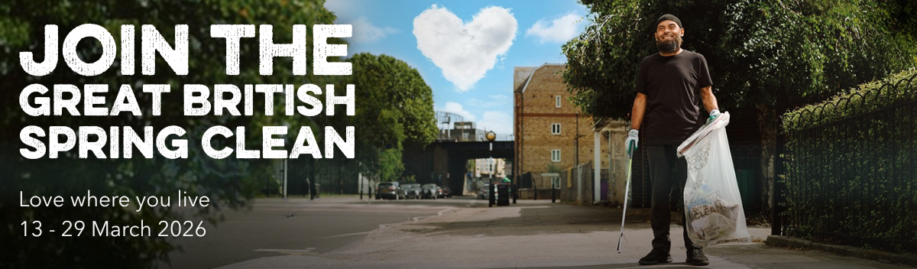

Ready, set, go! It’s time to show you love where you live…
3-2-1 and ACTION!

The Great British Spring Clean launches today, with more than 350,000 bags already pledged to our Big Bag Counter. It isn’t too late for you to join the action!

People across the country, from families, to community groups to schools, councils, and businesses are preparing for their litter-picking events.

And new for 2026, our special interactive map feature on our website will help you to find Great Big Spring Clean events close to you.
Sign up and pledge your bags

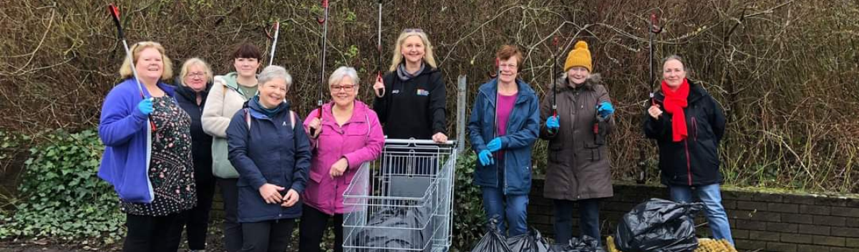

Town council wins our Outstanding Organiser GB Spring Clean award
The Great British Spring Clean Awards recognise outstanding efforts to tackle litter and care for communities.

Well done to Cramlington Town Council which demonstrated exceptional environmental leadership during last year’s campaign and has won the Outstanding Organiser category in the 2025/26 awards.

Despite challenging weather conditions, the council rallied an impressive coalition of community groups, businesses and local councillors to collect over 200 bags of litter, doubling their initial pledge!

They provided equipment, publicity and waste collection services, removed participation barriers and enabled widespread community involvement.

Working alongside Litter Heroes Ambassador Jill Brown, the council not only transformed their town's appearance but also contributed valuable data to Keep Britain Tidy.

Minister Mary Creagh, shows her support for #GBSpringClean!
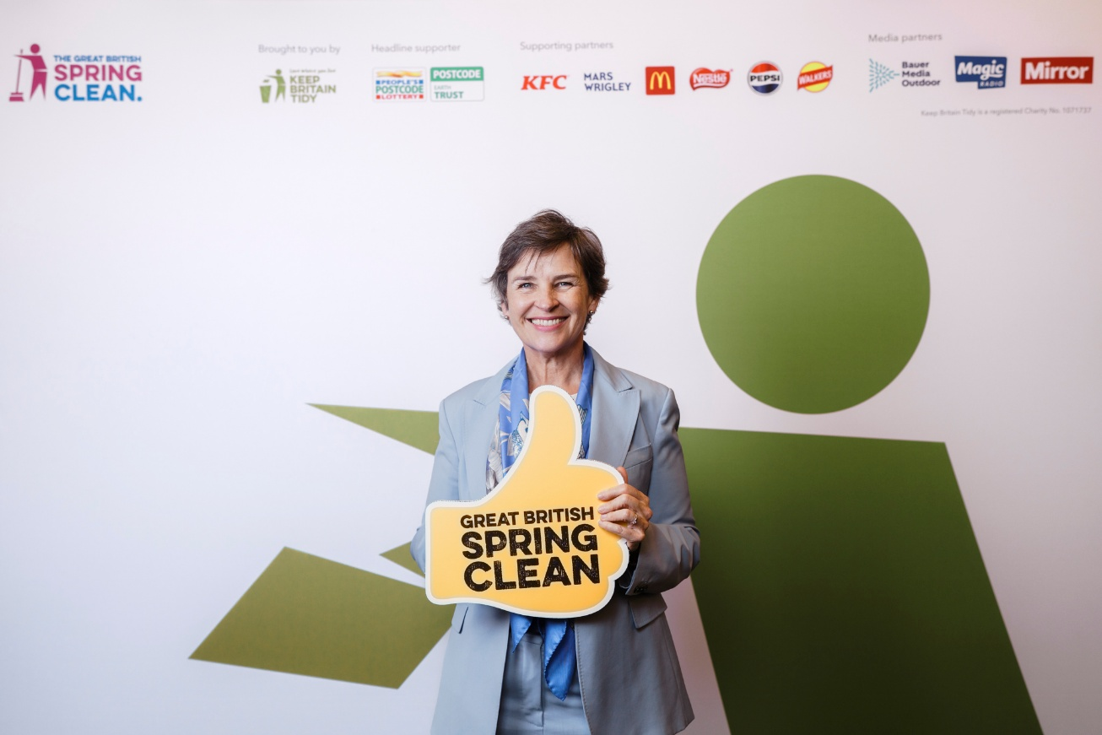
“The Great British Spring Clean has become the nation’s biggest mass-action environmental campaign. Since 2016, millions of Litter Heroes have pledged to pick more than 4.5 million bags of litter. This extraordinary collective effort shows the very best of community spirit in action.”

Minister Mary Creagh CBE, speaking at the Great British Spring Clean launch event at House of Commons, in March 2026.
Make your pledge today!

