
The Parish Council of Irchester
Clerk  Nikki Daft PSLCC  45 Park Road  Irthlingborough  Northants  NN9 5PW |  | Telephone 01933384180  irchesterpc@gmail.com

Dear Councillor 20th February 2018

You are hereby summoned to attend the Ordinary meeting of Irchester Parish Council to be held in the Village Hall, School Road Irchester on Wednesday 28th February 2018 at 7.15p.m.

Yours faithfully
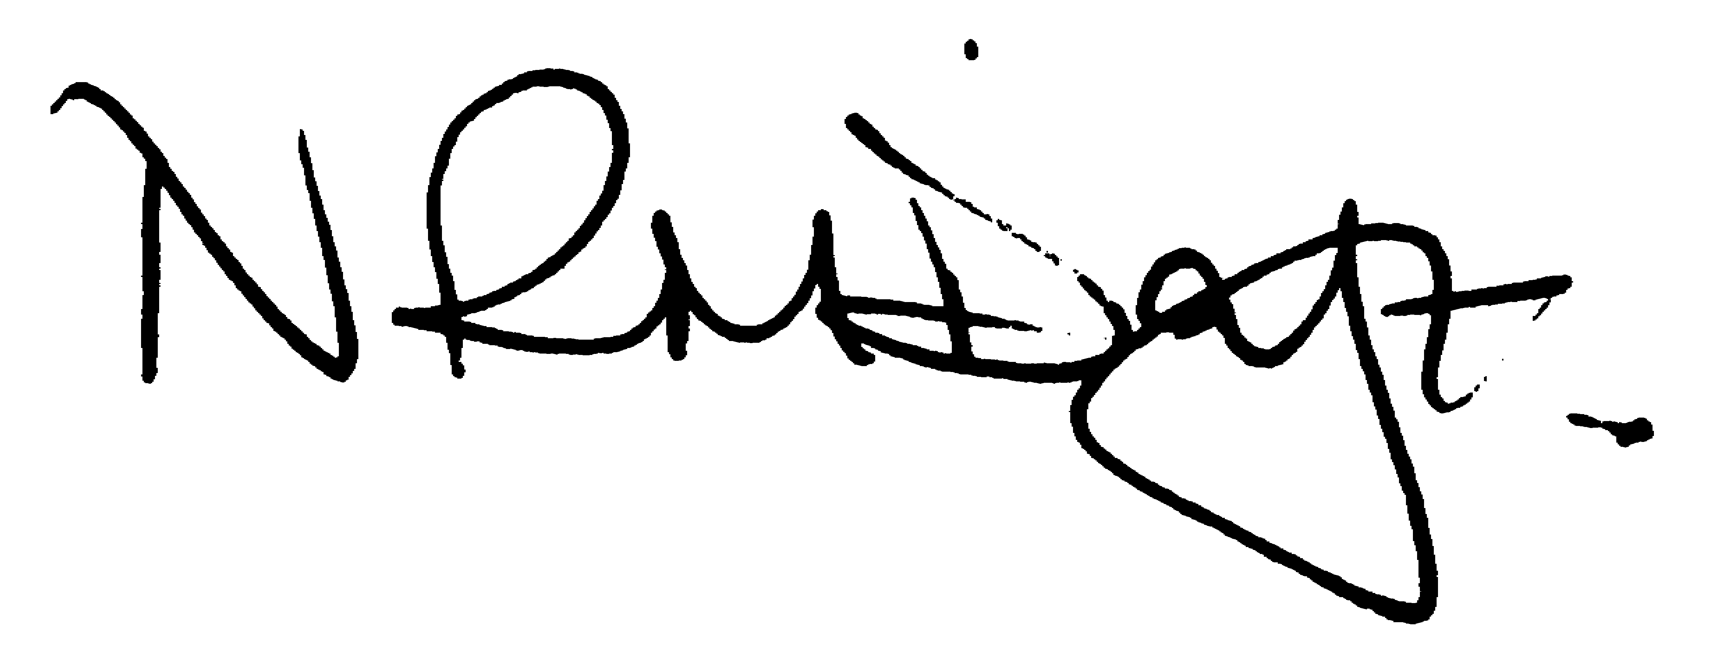

Nikki Daft – Parish Clerk

AGENDA

APOLOGIES AND ACCEPTANCE OF APOLOGIES

17/115 NOTIFICATION OF ANY DISCLOSABLE PECUNIARY INTERESTS OR OTHER INTERESTS
Only in respect of matters which are to be considered by members below. (Disclosures previously declared and registered need not be repeated).

- To receive declarations of interest
- Councillors to declare any personal interest in any items on the agenda
- Councillors to declare any personal and/or prejudicial interest in any items on the agenda and to inform the Chairman if they wish to speak on the matter during public participation

17/116 PUBLIC QUESTIONS, POLICE REPORT AND NCC UPDATE

Public participation may continue until for 15 minutes after which the public must not take part at any other time during the meeting. Request should be made to the Chair if any member of the public wishes to make a recording of any part of the meeting. All audible sounds to be switched to silent unless otherwise agreed at the start of the meeting. A report only can also be given by the Police and NCC representatives

17/117 MINUTES - To approve the minutes of the meetings held on 31st January 2018 as a true record.

17/118 RESOLUTIONS AND ACTIONS - MATTERS FROM PREVIOUS MINUTES

- Tree Memorial – ordered
- Flag pole – service ordered
- Surveys ordered
- SO’s amended and sent to councillors
- St Dr – path and drain reported 925036 and 925037
- Precept request sent to BCW
- Respond to Polling Stations

17/119 FINANCIAL/POLICIES

- To Approve Payments for February 2018 details sent to councillors via email (Clerk)
- To receive information regarding the current financial statement – reconciliation statement sent to councillors via email (Clerk)
- To agree the authorisation of the bacs payments
- To discuss improving the parish council financial transparency and recommend a working party of the whole council to discuss it with a view to having a finance sub committee (RE)

17/120 RECREATION GROUNDS

- To receive and agree the reports/repairs/damage to the recreation grounds (JD)

17/121 HIGHWAYS

- To agree any items that need to be added to the next agenda

17/122 LITTLE IRCHESTER/KNUSTON - To agree the Highway Warden report, previously circulated. Matters arising will be added to the next agenda. To discuss the following problems that have arisen in the village:

- To discuss the cost of parts for the flag pole in Little Irchester
- To discuss the request from Wellingborough Neighbourhood Watch for a contribution towards the signs which were damaged in Little Irchester

17/123 PLANNING - To discuss any planning issues
- WP/18/00083/FUL – Ramp to front – 169 Arkwright Road
- WP/18/00084/FUL – Extension to front – 57 Norman Way
- WP/18/00089/VAR - Variation of condition 2 of planning permission ref: WP/17/00245/FUL - to allow for changes to layout and window locations - submission of revised drawings -11 Townwell Lane, Irchester

17/124 NEIGHBOURHOOD PLAN - To receive an update on the progress of the NHP

17/125 CEMETERY/WAR MEMORIAL

- To receive the Cemetery report and decide if details should be added to the next agenda
- To agree contract monitoring scheme for the gardens with particular reference to the old post office bed and the cemetery bed for children (RE)

17/126 COMMUNITY ISSUES

- To discuss the flag policy regarding lowering the flag on the death of a councillor/previous councillor

17/127 CORRESPONDENCE To consider information received from incoming correspondence and decide on agenda items for the next meeting.

- Email regarding volunteering for Autistic person

17/128 EXCLUSIVE TO PUBLIC AND PRESS

17/129 COMMUNITY ASSETS

- To discuss how the council should proceed in securing Community Assets

17/130 CEMETERY VACANCY

- To discuss the position of Cemetery Administrator

