Supporting documents for Parish Council meeting, 20 January 2026
Agenda item FC205:
A statement by the Locum Parish Clerk, re sports club leases
- Complaints to the Monitoring Officer
On 18 December, the District Council’s Monitoring Officer wrote to the Parish Council as follows:

I have received a number of complaints about Farnsfield Parish Councillors not registering and declaring interests appropriately. Indeed, I understand that the auditors flagged this as an issue. Under our Procedures for dealing with Code of Conduct complaints we have a provision 8(n) which allows me to consider the complaints differently if the complaints suggest a wider problem throughout the authority. I believe this to be the case at Farnsfield. I am therefore writing to you to ask if some training can be provided to all councillors about registration and declaration of interests and also the different types of interests.

In a conversation in the same week, the Monitoring Officer explained to the Locum Parish Clerk that she is not making any further recommendations re the complaints made to her, and that she now considers the matter closed.

- The status of the leases between the Parish Council and the sports clubs
The observations of the Parish Council’s external auditor (PKF Littlejohn LLP) in July 2025 included the following, in relation to non-declaration of interests by councillors:

At one extreme, [the leases] could be deemed (by the Court) to be unenforceable and thus (potentially) the Council may not be in a position to protect its asset appropriately and in accordance with its Standing Orders and Financial Regulations. At the other extreme, the Court could set aside the shortcomings in the decision-making process and consider that the Council would have come to the same conclusion and decision without the councillors with registrable interests taking part in discussions and decision making (and thus the lease would stand and be fully enforceable).

However, the auditor is not a lawyer; accordingly the Parish Council has now taken legal advice, which is as follows, received from Wilkin Chapman Rollits on 15 December:

The Council’s decision to grant the lease may have been tainted by bias, but it is unlikely that there are sufficient grounds to set aside the lease on that basis alone.

This advice to the Council was accompanied by an oral comment that case law in such matters shows that much greater misdemeanours than the above need to have happened before a court is likely to set aside a contract.

It is perhaps unfortunate that the external auditor worded his comments in the way that he did, as it may have given residents an erroneous impression that setting aside the contracts is a realistic possibility.

- Conclusions

I have arrived in Farnsfield Parish at a point where these events are in the past. Insofar as I am able to judge, not having been present, I consider the following to be the conclusions to be drawn:

- The Monitoring Officer does not consider this matter to be so serious as to require any follow-up action beyond some retraining.
- The legal advice is that there is little basis for regarding the leases with the sports clubs as void.
- Conceivably, a tougher negotiation by the Parish Council might have yielded contracts more advantageous to the Council and the taxpayer, but stating that is of little help now, as the contracts are signed and in place – and so we have little option now but to live with them, unless the sports clubs might wish to renegotiate them, but that seems unlikely.
- Thus, though it may be frustrating to residents to read this, there appears to be little mileage in pursuing the matter any further. It is therefore my recommendation that a line is now drawn under these matters, while acknowledging that aspects of the episode were not the Parish Council’s finest hour, and that appropriate lessons need to be learned.

Peter Leppard, 17 January 2026

Agenda item FC206: (but see separate file for YTD expenditure against budget)

Date: 03/01/2026
Time: 20:14
Farnsfield Parish Council 2025/2026
Bank Reconciliation Statement as at 31/12/2025 for Cashbook 1 - Unity Trust Bank

Bank Statement Account Name (s) Statement Date Balances
Unity Trust Bank 8713 31/12/2025 98,195.79

Unpresented Payments (Minus) Amount: 0.00

Unpresented Receipts (Plus) Amount: 0.00
98,195.79

Balance per Cash Book is: 98,195.79
Difference is: 0.00

Clerk/RFO:
Name…………………………………………………. Signed………………………………………………… Date ................................

Chair of Finance:
Name…………………………………………….…… Signed………………………………………………… Date ................................
______________________________________________________________________________________________________

Agenda item FC208: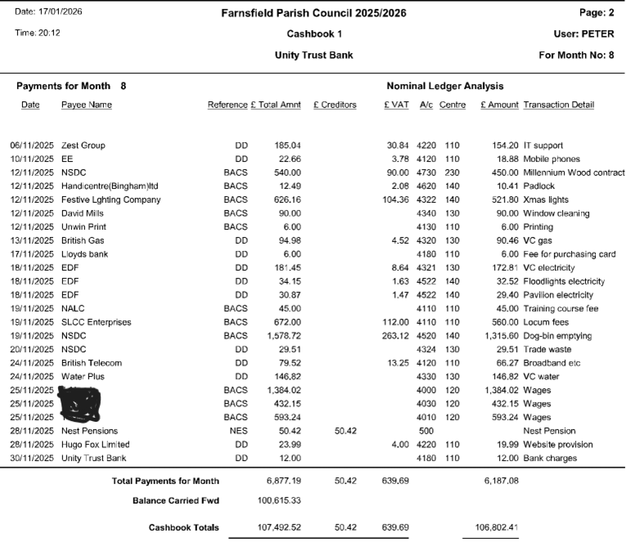
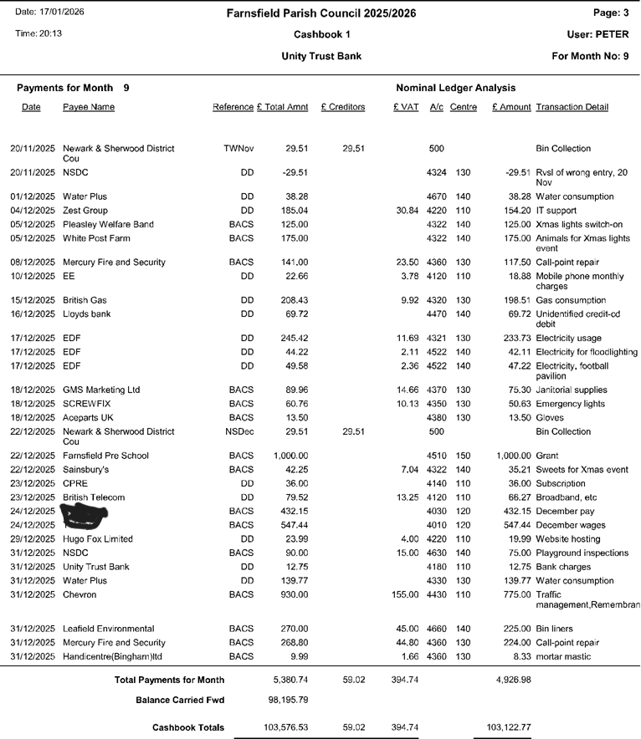

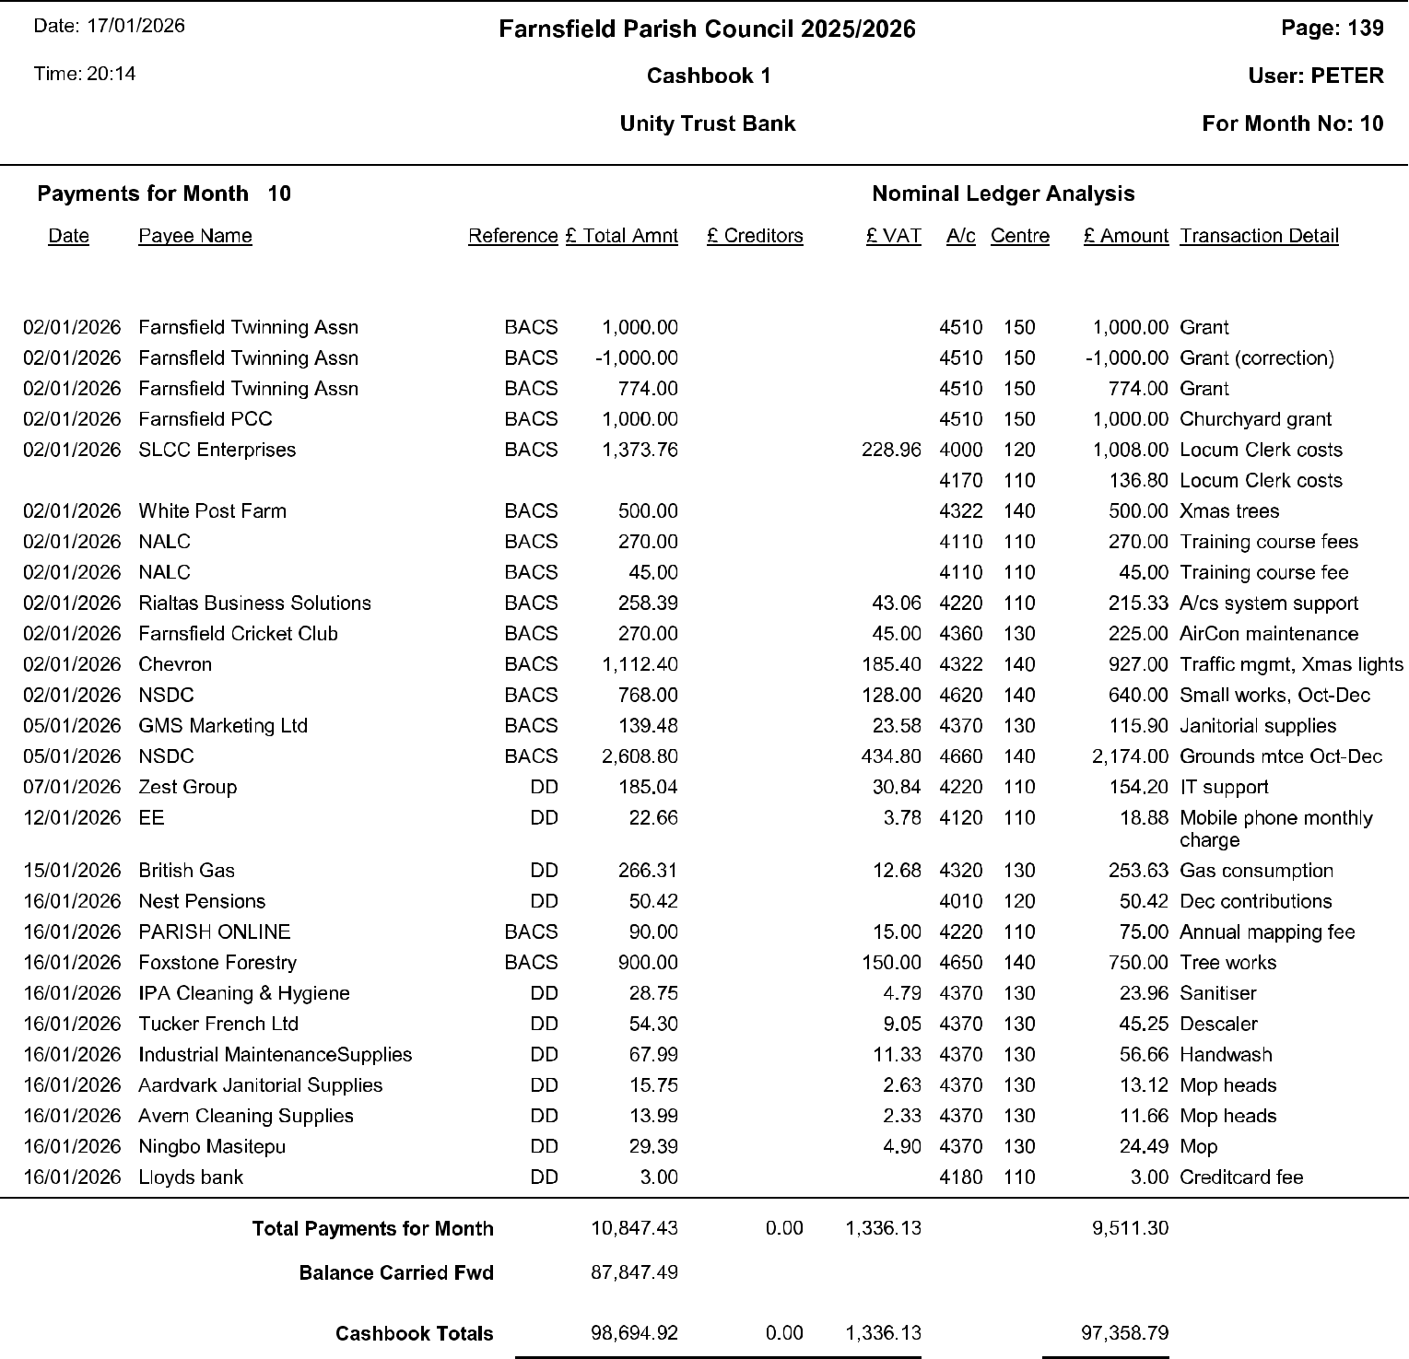

Agenda item FC210:

2026-27 Budget proposal

EXPENDITURE: INCOME & PRECEPT
Expendit Estimated

ure 2025- full-yr
Proposed
Estimated

Actual
26 to
expnditre
Budget
budget
Actual
2025-26 to full yr 2025- Budget
Proposed

2024-25
15.01.26
2025-26
2025-26
2026-27
2024-25
15.01.26 26
2025-26
2026-27

General Administration (excl. Staff)  Recruitment | £635 | £0 | £500 | £0 | £500 | Total Expenditure  less Income: | £248,618 | £97,108 | £145,624 | £131,121 | £171,341
Training | £375 | £1,057 | £1,350 | £1,400 | £2,500 | Precept | £88,906 | £91,129 | £91,129 | £91,129 | £91,129
Phone & broadband | £984 | £732 | £1,030 | £1,000 | £1,100 | Interest | £3,170 |  | £2,000 | £0 | £3,200
Stationery & office items | £496 | £142 | £220 | £650 | £500 | Grants | £6,834 | £15,450 | £15,450 | £0 | £0
Membership fees | £191 | £935 | £1,000 | £1,000 | £1,050 | Donations | £35 | £40 | £40 | £0 | £0
Insurance | £5,441 | £6,293 | £6,293 | £6,000 | £7,500 | Library rental | £3,380 | £0 | £3,380 | £3,380 | £3,380
Farnsfield Flyer | £229 | £0 | £0 | £0 | £0 | VC hiring | £34,683 | £23,684 | £29,000 | £25,200 | £30,000
Travel expenses | £151 | £137 | £650 | £200 | £300 | Lengthsman grant | £1,200 | £1,200 | £1,200 | £1,320 | £1,200
Bank charges | £205 | £114 | £160 | £150 | £200 | Xmas sponsorship | £225 | £200 | £200 | £0 | £225
Audit & legal fees | £3,336 | £16,414 | £25,000 | £10,000 | £10,000 | Acres hire | £1,050 | £890 | £1,050 | £1,050 | £1,100
Chair's allowance | £110 | £60 | £150 | £200 | £200 | CIL | £0 | £3,550 | £3,550 | £0 | £0
IT & software | £6,606 | £2,718 | £3,300 | £3,000 | £3,500 | Allotments | £1 | £436 | £436 | £0 | £400
Election costs | -£329 | £0 | £0 | £0 | £0 | Total income | £139,484 | £136,579 | £147,435 | £122,079 | £130,634
Events | £740 | £1,375 | £1,600 | £3,000 | £2,200 | Net surplus/deficit | -£109,134 | £39,471 | £1,811 | -£9,042 | -£40,707
Grants | £1,290 | £4,333 | £5,000 | £3,500 | £5,000
TOTAL General Admin  Staff costs | £19,937 | £34,310 | £46,253 | £30,100 | £34,550 | Reserves at 1-4-25 |  |  | £245,008
TOTAL Staff Costs  Village Centre | £43,622 | £29,109 | £43,500 | £40,000 | £47,000 | Estimated reserves at 1-4-26 |  | £246,819
VC Gas | £1,849 | £974 | £1,800 | £4,300 | £2,100
VC Electricity | £1,839 | £755 | £1,800 | £2,700 | £2,000
VC Waste disposal | £91 | £482 | £600 | £300 | £650
VC Water | £1,212 | £1,127 | £1,500 | £1,500 | £1,650
VC Window cleaning | £360 | £210 | £360 | £360 | £400
VC Health & safety | £942 | £945 | £1,200 | £1,000 | £1,300
VC Maintenance/Repairs/Renewals | £3,283 | £2,649 | £3,300 | £2,000 | £3,500
VC Cleaning supplies | £626 | £386 | £500 | £440 | £530
Village Health & safety | £606 | £1,873 | £2,300 | £0 | £1,200
Music licences | £1,686 | £427 | £650 | £650 | £700
Licences | £482 | £0 | £0 | £0 | £0
TOTAL Village Centre | £12,975 | £9,828 | £14,010 | £13,250 | £14,030
Village
Xmas costs | £5,585 | £2,448 | £6,500 | £7,500 | £7,500
Loan repayments | £911 | £455 | £911 | £911 | £911
Village facilities | £4,891 | £3,249 | £4,300 | £0 | £10,000
Dog-waste disposal | £2,710 | £2,631 | £2,700 | £2,160 | £2,900
Village electricity | £602 | £1,958 | £2,150 | £1,000 | £2,000
Minor works & maintenance | £2,999 | £7,229 | £9,800 | £11,500 | £11,500
Playground inspection & maintenance | £1,100 | £300 | £1,000 | £3,700 | £3,000
Playground renovation | £0 | £0 | £0 | £0 | £1,000
Tree works | £0 | £0 | £1,000 | £4,000 | £4,000
Grounds maintenance (exc. Trees) | £8,192 | £4,973 | £8,500 | £17,000 | £10,000
Acres & pavilion | £25,176 | £168 | £400 | £0 | £500
Football pitch | £0 | £0 | £0 | £0 | £11,000
Hadleigh Park | £572 | £0 | £0 | £0 | £1,000
Millennium Wood | £450 | £450 | £450 | £0 | £450
TOTAL Village | £53,188 | £23,861 | £37,711 | £47,771 | £65,761
S106 expenditure | £80,274 | £0 | £0 | £0 | £0
CIL expenditure | £38,100 | £0 | £4,150 | £0 | £10,000
TOTAL EXPENDITURE | £248,618 | £97,108 | £145,624 | £131,121 | £171,341

