 | Discussion Point | Agency | Comments | Date of Achievement | Actions

Flood Warnings
1. | Accessing flood warnings | SC | If group email can be created, then SC can supply a group log in for all to access time view information. | Before next MAM | Action: NFF to set up group email for SC to supply group with log in.

Development of 5 houses in Bache Mill (20/03100/FUL)
2. | The first 2 properties have now been sold. Additionally, work has recommenced on the 2 semis (plots 3&4). Has the developer produced any details for the provision of compensatory flood storage for the first 2 properties?  Drainage of the surface water from the road  Historically all the water would flow into the meadow from the roadway around Plots 3&4 driveways. The council would maintain drainage ditches in the verge to enable this.  What will happen to this water going forward? | SC/SCH | FlAG reported that work has resumed, but SC was unaware that the developer had become active again. SC mentioned that the developer should have informed the planning team before restarting the work. | Before next MAM  Update at next MAM | ACTION: SC to inform planning and enforcement about active developer.  ACTION: SC to update DFlAG regarding development issue.
Drainage Matters
3.a | There are issues with drainage under the road - B4368/Diddlebury Bridge | SCH | There is planned work to improve this area, but as of yet there is no start date. | Update at next MAM | ACTION: SCH to update if there is a start date for drainage works.
3.b | A wall has broken and partially collapsed in Bouldon. What can be done about this? | SCH | Works are planned for 26th August. | Update at next MAM | ACTION: SCH to update on wall repairs.
Slow the Flow Project
4. | Natural Flood Management | SC/SWT | SWT was unable to attend the MAM. In their written response, they mentioned they are currently engaging with local landowners and are awaiting the finalisation of landowner agreements before sharing further details.  DFlAG noted that SWT has been facing challenges in involving the Wrigley family. SC suggested setting up a meeting between DFlAG, SWT, and the Wrigley family to explore ways to move things forward. | Update at next MAM  Before next MAM | ACTION: SWT to update on slow the flow project work in area.  ACTION: NFF to help facilitate meeting between DFlAG, SWT and Wrigley estate.
Flood Response Plan updates
5. | FRP Updates | SC/NFF | WSP has been contracted to develop the road signage scheme, with Much Wenlock being the first community to adopt it. The scheme will then be rolled out to other communities. Due to the layout of Diddlebury, it’s likely that road closures won’t be possible, but caution signs could still be provided.  The issue regarding the school was raised. It was clarified that the school should have its own emergency plan, and this would not fall under the DFlAG's responsibilities. However, it could be beneficial for the DFlAG to supply the school with informational leaflets ahead of the flood season. SC mentioned that the EPU might have relevant materials, and if not, NFF could assist in developing them. | Update at next MAM  Before next MAM  Before next MAM | ACTION: SC to give update regarding the Road Signage Scheme.  ACTION: SC to check if EPU could have information leaflet to be shared at local school.  ACTION: NFF/DFAG to look at sharing flooding information leaflet with school.
Date for next MAM:

Acronyms
EA | Environment Agency | FlAG | Flood action group | NFF | National Flood Forum
STW | Severn Trent Water | MAM | Multi-Agency Meeting | NFM | Natural Flood Management
SC | Shropshire Council | SCH | Shropshire Council Highways | PFR | Property Flood Resilience
FC | Forestry Commission | FRP | Flood Response Plan
Useful contact information to note
Risk to life | Emergency Services | 999
Report a sewage incident (overflowing sewer) | Severn Trent Water | 0800 783 4444
Report flooding on roads or blocked drains | Shropshire Council | 0345 678 9006 (Emergency) or via Fix My Street
Report issues with River Severn | Environment Agency | Significant blockages in the river should be reported on 0800 807060
Report issues with Railway drainage | Network Rail | 03457 11 41 41
Report flooding on roads or blocked drains | National Highways | For non-emergencies: report.nationalhighways.co.uk  For emergencies: 0300 123 5000

Archived Questions and Comments
We reported two service requests on the Shropshire Council website on the 4th of November in Middlehope (see plans below)  -SR-176871-J5Q8L2: clearing of 3 manholes. | Manholes have been cleared.
We want to be able to contact the Highways team for reporting blocked drains, floods etc., and we used to be in direct contact with Andy Keyland.  What is the best way to report blocked drains/flooding?  What are the actioning timescales in response to issues reported via the Shropshire Council website? | If it is a larger wider issue, do it through the FAG and MAMs.
A regular schedule for cleaning drains and gullies is necessary rather than the present ad hoc arrangement. Would it be possible to see the scheduling for cleaning of drains and gullies? | SC has stopped using the contractor and is now doing an in-house maintenance system.  The contractors were not paid enough to make it worth it and now the in-house team is doing it properly and mapping it.  The system is learning which places need clearing more often through their notes and fix my street so they can do smarter maintenance.  This data will take a few years and local knowledge to get to where SC wants to be.
What are the plans for clearing drains/manholes in locations where the vehicle cannot reach (e.g. D2 at Middlehope on the plan below)? | Will go in by hand. This was not in the previous contract so now this will be done.
Could we have a copy of the full report from the Steering Committee on Slow the Flow including the section from Cardiff University on the efficacy of leaky dams? | NFM project has come to an end, it was designed to collect information about NFM. SC was hoping that this would give evidence NFM reduces flood risk further down stream meaning that the government would fund work such as this.  Still waiting on the full report.  They are hoping to use this study to gain funding for NFM in Corvdale as Corvdale is the best understood catchment for NFM so they are keen to use NFM here.  The SFI grants are hopefully going to state public money for public good to this should encourage farmers to get onboard with NFM  Other carrots such as green funding might encourage farmers to maintain the dams for up to 9 years.
When will work commence on the installation of further leaky dams in the Pye Brook catchment? | Answered above. Officially the project is at an end but SC is hopeful for further funding in the future.  EA is working alongside the SC and is looking at the River Teme more holistically. Flood issues, wildlife, water quality, fish passage. This is a project EA will keep the group up to date about this periodically. The Cardiff report will support this.
Are sandbags freely available at the Craven Arms Highways Depot?  Can we collect say 20 of these? Who do we contact there? | Yes, first come first serve immediately before storm events at the depot.  John will look at talking to the parish council. Needs to have a good place to store them and a plan on how to use and distribute. Parish council sign something and SC can provide flood sacks instead of sandbags.  Action: NFF to send the flood response plan to SC.
Whilst works were being carried out near Karray Cottage in Lower Corfton by Highways on 18th September 2020, it was agreed that new Manhole covers were needed as open manholes are dangerous.  The gully near Corfton Manor which was cleared out then is now blocked again. | Manhole Covers may have been completed.  A ditch has been cleared further up the hill which is SCH responsibility.
The drainage investigations at Peaton Strand have been completed. Could we have an update on the outcome of this investigation and any necessary actions required following this? | Being done in tandem with Q5. SCH is waiting on a price and it will be done soon.
There is a dangerous hole by the road in Bouldon which needs urgent action. The stream's retaining wall is crumbling. Can you please tell us when this will be repaired?SCHSCH in discussions with the landowner about removing a tree as part of the work | SCH in discussions with the landowner about removing a tree as part of the work to realign and reinforce the retaining wall with armored rock.
a. Level gauges on two streams in Corvedale.  b. Can alerts go to more people?  Can alerts be sent via mobile phone messages/texts, landline phone call, as well as by email? | SC has list of 3 people signed up to alerts.  Chair has asked in both Google Groups but heard no response from the general group.  Chair has put article in parish magazine.  SC made it clear its an open invite so people can be added whenever.  Chair is pushing the information and people are to contact him to get logins for website.
The stream coming down Corfton Bache emerges by the hedge line of the B4368 west of Warwick Cottage. The chamber here is open and needs improvement. Could we have an update on this? | Not a safety issue.  Would prefer to fence it than cover it.
a. -SR-176867-H8K5M0: debris in culvert and ditch.  b. Could we please have an update on these reports?  There are also known flooding issues near Preens Barn (see plans below). When will these be attended to? | Assist Clive with contacting those known to flood – preferably before floods set in to help with plans/flood responses
c. The watercourse below the Karray Cottage Summer House requires maintenance work.  Could we have a progress report for this work and a timescale for any further works? | Summer house area – ditch to be cleared by the owner.  The watercourse by summer house is a riparian ownership issue between Karray cottage and the landowner on the other side
a. Proposed development of old Poultry Sheds in Lower Corfton (Reference is 16/03628/FUL). We raised queries on the drainage at the top end arising from run off via a stream from the B4368 (subsequent variation ref 20/02197/VAR).  b. Is there a revised plan for onsite drainage and for drainage of the access road, and can we please see these plans?  The approved drawings at present are: CP DA-401 rev B and  CP GA-400 rev D | They are keeping the buffer zone clear.  SC has looked at the drains and believes that they will be fine.  SC gave a plan drawing.  Still no change on developers’ side – planning permission running out.  FAG will take it up with new developers once they find out who it is.
a. Regarding the location of the level gauge to a point above Bouldon: once it is in place, we need to set lower and upper alert levels.  b. Could we have an update on when this will be installed?  c. How will this level gauge be powered? | New drains have been put in by Pye Brook.  19x20inches (50x50cm roughly)  Need Parish or Town Council to store and distribute during an event.  Parish Council don’t want to fund Flood Sack Storage. SC – Could work with NFF to engage Parish Council with the group and response plan.
Bouldon Farm is prone to flooding from the Pye Brook. A scheme was designed to alleviate this some years ago but funding was not available at that time. Could we have an update on this?

a. How large are Flood Sacks and how many would the village be expecting to receive?
A small channel at the bottom of the road between Bouldon House and Bouldon Cottage becomes blocked by gravel off the highway. During flood events, it is filled by run-off. Is this something Highways could look into/clean? | 6” deep and wide – negligible impacts
FixMyStreet  a. How much is the FixMyStreet app/website being used by Diddlebury residents for reporting drainage issues?  b. What impact (if any) is it having? | Number of discussions held on highways issues reported on FixMyStreet.
Middlehope Area | 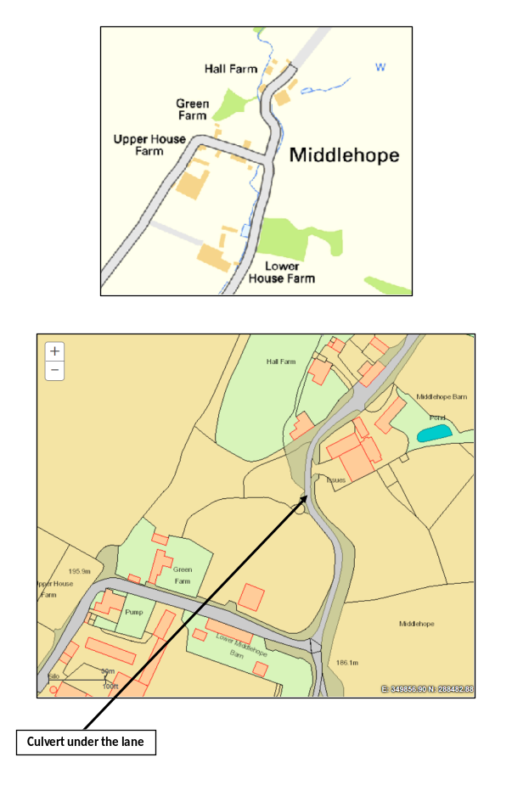
 | 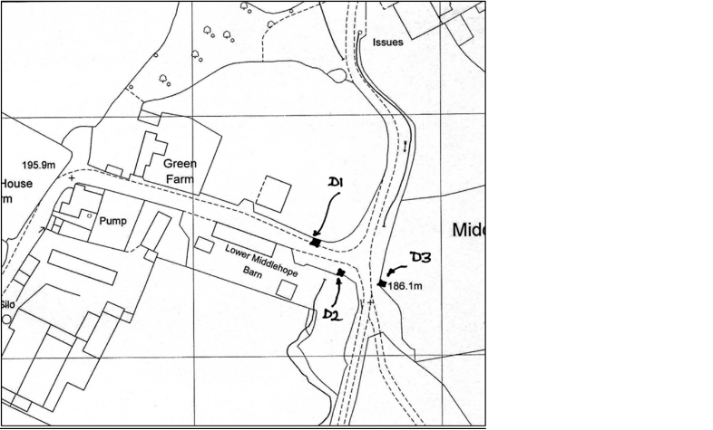
Preens Barn Area | 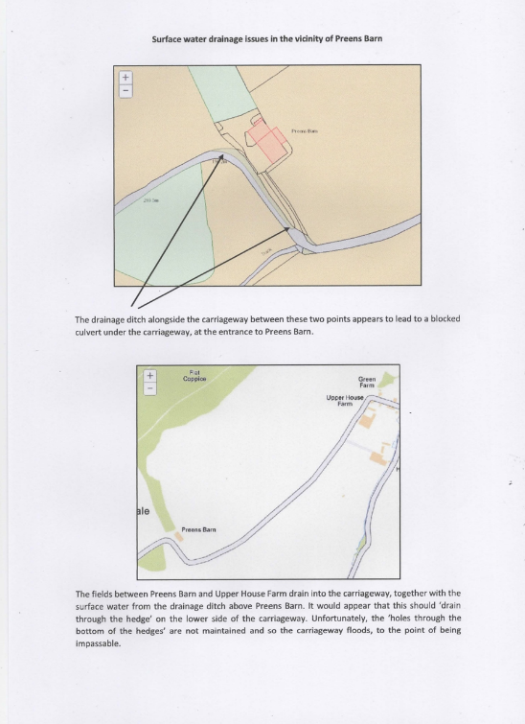

Maintenance Activities
Drains D1 and D3 need to be checked and cleared by machine.
Drain 2, which is inaccessible by machine, needs to be checked and cleared by hand.
The culvert under the lane and the stream both upstream and downstream of the culvert needs to be cleared of the ‘rubble’ that was washed down during the winter of 2020 – 2021. This is reducing the capacity of the culvert under the lane and in addition it is reducing the capacity of the open drainage ditch either side of the culvert

