WILMINGTON PARISH COUNCIL

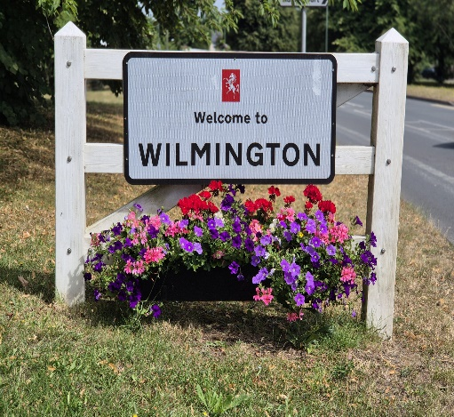

Agenda for the Meeting to be held on Wednesday 1st July 2026
at Oakfield Park Pavilion, Wilmington commencing at 7.00pm
AGENDA
Prior to the Meeting the Chairman to draw attention to the protocol regarding the audio and visual recording of the Meeting or of any part thereof

It is hoped that the Beat Police Officers for Wilmington and Joydens Wood will be present to discuss policing issues across the Parish
- Apologies for Absence/Non-Attendance
None at the date of distribution
- Declarations of Disclosable Pecuniary or Prejudicial Interest

To receive any Declarations of Disclosable Pecuniary or Prejudicial Interest.

- Public Participation
To note or respond to any concerns raised or questions asked by residents in writing or in person prior to or at the Meeting

RECOMMENDATION – That any matter be noted; accepted as an ‘Urgent Item’ for discussion at the Meeting or deferred to a subsequent Meeting of the Council

- Kent County Council and Dartford Borough Council Reports

To receive verbal reports from the Parish Representatives on Kent County Council and Dartford Borough Council

RECOMMENDATION – That the verbal reports be noted
- Minutes of the Previous Meetings
To approve and adopt the Minutes of the Meeting held on 3rd June 2026
RECOMMENDATION – That the Minutes be approved and adopted as true records

- Urgent Items

The Chairman to announce that the inclusion in the Agenda of the ‘Urgent Items’ as tabled had been agreed

- Finance

- Financial Statements

Having been circulated to Members in advance of the Meeting, to approve the Financial Statements for the month ended 30th June 2026

RECOMMENDATION – That the Statements be approved

- Insurance
To note that, based on an annual charge of £370.54,a pro-rata additional premium of £137.05 has been paid to provide cover for the recently installed MultiPlay at Chestnut Grove
RECOMMENDATION – That the matter be noted

- Matters Arising from Previous Meetings of the Parish Council (Not covered Elsewhere in the Main Agenda)
- Wilmington Fair 2026

- Having been circulated to Members in advance of the Meeting, to note receipt of the Minutes of the Meeting of the Fair Committee held on 16th June 2026
- To note that the official opening of the 2026 Fair has been brought forward to 1.30pm
RECOMMENDATION – That the matters be noted

- Chestnut Grove

To consider the exclusion of the press and public for the following items of business on the ground that it involves the likely disclosure of exempt information as defined in Paragraph 4 of Part 1 of Schedule 12A to the Local Government Act 1972

- Public Rights of Way Warden

As agreed at the June Meeting of the Council, to consider seeking a volunteer or volunteers to undertake regular inspections of the Public Rights of Way across the Parish

RECOMMENDATION – That the Clerk acts in accordance with the decision made

- Waste Collection

- To note that –

- attempts to acquire a new contractor to collect the Parish Council’s waste from Oakfield Park has proved unsuccessful with the restricted road access given as the reason for the negative responses
- a month’s extension to the contract with the existing Contractor has been negotiated and
- the Parish Council has been registered as a Lower Tier Waste Carrier at no cost but that access to the Transfer Station may be denied as depositing ‘Animal Waste’ is prohibited

- To discuss alternative methods of the disposal of the Parish Council’s waste

RECOMMENDATION – That the matters be noted and that the Clerk acts in accordance with any decisions made

- Items for Discussion

- Grant/Donation Applications

To consider any Grant/Donation applications received

RECOMMENDATION – That the Clerk acts in accordance with the decision made
- Delegated Authority
To agree that, in the absence of an August Meeting of the Council, delegated authority to make a decision on any matter be given to the Chairman and Vice-Chairman in conjunction with the Clerk during the period to the Meeting of the Council on 2nd September 2026
RECOIMMENDATION – That the delegated authority be agreed
- South & South East in Bloom Competition

To receive a verbal report from Councillor S Narwan on the judging of the South & South East in Bloom Competition on 12th June 2026

RECOMMENDATION – That the verbal report be noted

- Planning Applications for Consideration and to Note Any Agreed Comments or Observations submitted to the Planning Authority prior to the Meeting

Note – In relation to Item (iv) to consider the Draft Response circulated to Members in advance of the Meeting

- DA/26/00641/FUL Casa Mia, Garden Place, Wilmington

Erection of a first floor side extension above the existing garage

- DA/26/00623/FUL – 64 Tredegar Road, Wilmington

Erection of a single storey side/rear extension

- DA/26/661/FUL – 32 High Road, Wilmington
Provision of an extension to existing vehicle crossing onto B258
- DA/26/00572/FUL = 189 High Road, Wilmington
Change of use and conversion of existing former school building to 8 flats and the erection of 5 x 3 bed detached houses along with new wheelchair accessible ramp, enlarged vehicle access, car parking, cycle parking, refuse store and extensive landscaping (including communal area)
RECOMMENDATION – That the Clerk submits any agreed comments or observation to the Planning Authority
- Chair’s Updates

To receive any updates from the Chair.
RECOMMENDATION – That any updates be note

- Parish Ward Matters Raised by Members

To receive any Ward Matters raised by Members
RECOMMENDATION – That any matters raised be noted and, where a decision is required, for the Chairman to agree that it be accepted as an ‘Urgent Item’ or that it be included on the Agenda for the October Meeting of the Council

- Items to Note or Endorse the Actions Taken

- Dartford Borough Council Planning Decisions

- DA/26/00370/FUL – 12 Rowlatt Close, Wilmington Permission Granted
- DA/25/01465/ADV -10 Birchwood Parade, Woodside Drive, Wilmington Express Consent Granted
- DA/26/0464/TPO – Wilmington Manor Nursing Home, Common Lane, Wilmington Consent Granted
- DA/25/01464/FUL - 10 Birchwood Parade, Woodside Drive, Wilmington Permission Granted
- DA/26/00469/CDNA – 194 Birchwood Road, Wilmington Details approved
- DA/26/00157/VCON – Former Lynch Plant Site & Ambulance Station, Hawley Road, Dartford Variation of Conditions Permitted
- DA/26/00529/LDC – 21 Birchwood Road, Wilmington Certified Lawful

- Dartford Borough Council Planning Appeal Lodged
None
- Dartford Borough Council Planning Appeal Decisions

None

- Kent County Council Planning Applications

None

- Kent County Council Planning Decisions

None

- Other Items to Note or Actions Taken Endorsed

To note or endorse other items received or actions taken as appropriate being –

- having been circulated to Members in advance of the Meeting to note receipt of the Crime & Police Commissioner’s June Newsletter
- having been forwarded to Cllr M Peters as the Parish Representative, to note receipt of the notice of and the Agenda for the Public London Green Belt Council Meeting on 25th June 2026
- to note that, having ascertained ownership of the land at the rear of Langworth Close from the Land Registry, the owner has been advised of the damage to the boundary fence

Following publications are available for Members –
None

