SEEND PARISH COUNCIL

Draft Minutes

Minutes of the meeting held on Tuesday 27th May 2025. This meeting was held in the Community Centre.

Present: Cllr Bridget Johnson (Vice Cahirman), Cllr Jackie Hamblin, Cllr William Lack, Cllr Paul Manning,
- Cllr Helen Robinson- Gordon, Cllr Phil Springate, Cllr John Williams, Cllr Martin Wiltshire, Clr Pamela Ackerman, Cllr Jamie Halliday

Also Present: 3 Members of the Public, Cllr Tamara Reay & The Clerk

Agenda Item | Detail | Action
Apologies for Absence | Cllr Debbie Savage
2025/065  Declaration of Lobbying  - Declaration of changes to the Register of Interests  - Declaration of interest in items on the Agenda  - Requests for Dispensation | (i) - There were no changes of declarations to the Register of Interests  (ii) - There no were declarations of interest  (iii) - There were no requests for dispensation.
Local Councilor’s Matters | Cllr Reay provided the following updates on local matters:  Cllr Reay advised Councilors that due to the elections and a change of leadership party her role within Wiltshire Council has changed. Cllr Reay will continue to work with and support the Parish Council.
Minutes of the Previous Meeting | The Minutes of the meeting held on 12th May 2025 were circulated to all Councillors.  Acceptance of the Minutes of this meeting as an accurate record was proposed by Cllr William Lack and seconded by Cllr Pamela Akerman. Except for Debbie Savage who was not present at this meeting, all Councillors present voted in favour. A shortened version of this month’s minutes to be placed in Spotlight. | Clerk
Matters Arising Not Already on the Agenda | None
2025  Items for Discussion from Members of the Parish | None
2025  Local Highways & Footpath Infrastructure Group (LHFIG) | Bell Hill Crossroads  Due to an accident a New wooden pedestrian Bollards have been broken. The Clerk has met with Wiltshire council Highways who are arranging a replacement, a new set back location and will provide additional reflective bands to be installed on all bollard. The council is awaiting a installation date.  A361 Pavement - The Stocks to Bell Hill Crossroads  Debris from overhanging trees has made some parts of the pavement difficult to transverse. The pavement is being used more than previous due to at least one family having children attend the toddler and primary school. Cllr Reay agreed to progress the clearing of this pavement with Highways.  The Stocks – Request for a review of the 50mph Speed limit  Cllr Reay has raised this issue with the cabinet member for Highways (Nick Holder) and agreed to meet with the Highways Engineer to establish a way forward  The Clerk to email highways to seek a advisory replacement fraight sign at the bottom of Cain Hill.  A date for the next LHFIG meeting will be schedules after the May elections and we are awaiting the new date. | Clerk  Cllr Reay  Cllr Reay  Clerk  (actioned)
2025  Speedwatch | New Mobile SI  Wiltshire Council advised they no longer provide steel poles for SID’s. Councillors agreed that the new SID would initially not require its own steel pole as it is expected to be deployed around the parish using existing street furniture for support.  Initial location could be The Stocks so that vehicle speeds could be recoded to identify what need there is for traffic calming. The results will be shared with Cllr Reay in support of her quest for a review of the current 50mph Speed limit at this location.  The Clerk to contact local councils to see how they record the results from their SIDs. | Debbie Savage / Speedwatch  Clerk
2025  Neighbourhood Plan / Wiltshire Local Plan | A Neighbourhood Plan Review team is to be set up to review the NHP and for Seend parish Council to be able to be forward thinking. Its initial remit will be to review the existing Plan and provide a list of suggested changes for consideration.
2025  Planning Matters | Sommer Place  PL/2025/04070  No Comments
2025  Devizes Area Board | Next Area Board meeting will take place on 30th June at Needham House, Devizes. | Pamela Akerman / John Williams
2025  Items of Correspondence | The Clerk to send a letter to the owner of Ivy lane. | Clerk
2025  Parish Steward | The Clerk to request the Parish Steward undertake the following work:  Adjust the catch on the gate at the top of Love Lane by Circular Seat to negate the need to lift the gate on closing.  An application to apply for the community pay back scheme has been submitted. | Clerk
2025  Allotments | An Allotment has become available at Bell Hill. The clerk to promote the availability. To be eligible applicants must have a permanent resident in Seend. Interested applicants should contact the clerk via email.
2025  Parish Council Vacancy | The Council will promote the opportunity for Co-opting new councilors. Social media post, web site, press release in spotlight will be completed.  Recommendation by Cllr Pamela Akerman to provide a flyer for the spotlight magazine. Cllr William Lack and Cllr Helen Robinson- Gordon approved 50.00 spend on flyers. | Clerk
2025  AGAR – Annual General Accounts Review | AGAR – Annual General Accounts Review  - Annual Governance Statement  The Clerk to send a copy of the Accounting Statements to the External Auditors | Clerk
2025/081  Financial Matters | Financial Matters  - Payments  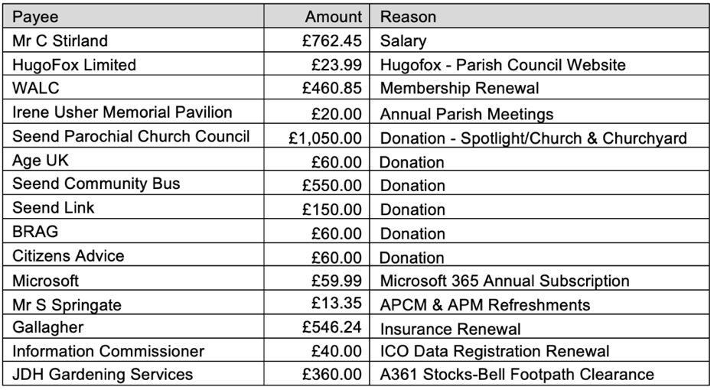  The council to note the new Clerks salary was not within the payments showing.  - There are no planned Clerk Debit Card payments forecast for the next month.  - Change of Signatories Bath Building Society  Terry James and Jackie Hamblin haven been removed from the account and Debbie Savage and John Williams to be added  - Donation Payments  Seend Parochial Church 520.00 Support for the parish magazine  Seend Parochial Church 225.00 Church Restoration  Seend Parochial Church 340.00 Churchyard Maintenance  Age UK 65.00 Charity Support  Seend Community Bus 570.00 Maintain Community Services  Seend link 150.00 Maintain Community Services  Citizens Advice 65.00 Charity Support  Total donation payments made so far in 2025-2026 amount to 2,000 under the current legislation, the maximum donations permitted by this Parish Council during this financial year is 10,056.60
2025  Date of Next meetings | The Chairman thanked everyone for coming and closed the meeting at 20.45pm  The next Parish Council meeting is;
  Meeting | Date | Time | Venue
  Parish Council Meeting | Tuesday 24th June | 7.00pm | Community Centre

…………………………………………………
xxx (Chair)
Date: 27th May 2025

