PETROCKSTOWE PARISH COUNCIL
Parish Clerk: Fiona Lowe, Rose Farm, Petrockstowe, Okehampton EX20 3HQ
Phone: 01837 811749 E-mail: petroc.clerk@hotmail.com

Dear Councillors

You are duly summoned to attend the Petrockstowe Annual Parish meeting to be held at 8pm on Tuesday 19th April 2016, at Baxter Hall, Petrockstowe, to discuss the following business.

AGENDA
- Apologies To receive any apologies and approve reasons for absence.
- Public Session
- Chairman’ Report
- Financial Report To be approved
- Next Meeting. To confirm the Annual General Meeting is to be held on Tuesday 17th May.

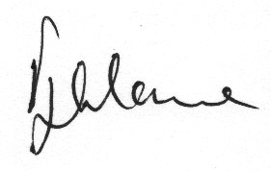

Fiona Lowe
Parish Clerk
13/04/2016

