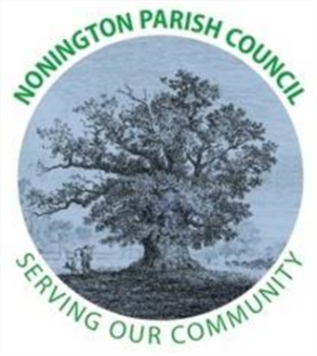

NONINGTON PARISH COUNCIL
Email: noningtonparishclerk@outlook.com Website: www.noningtonpc.org.uk

TO: ALL MEMBERS OF NONINGTON PARISH COUNCIL
Councillors are hereby summoned to attend an Ordinary Meeting of the Council to be held on
Wednesday 1st April 2026 at 7.00pm in Nonington Village Hall

A G E N D A

- Chairman’s Welcome and Apologies for absence

- Declarations of Interest

- Confirmation of the Minutes of the Meeting held 4th March 2026

- Review of Previous Action Points

- Public Forum

- Finance

  - Statement of Financial Standing
  - Grants

- Planning

- Highways and Footpaths

- Playground, Field and Pond

- Councillor and Police Reports

- Items for discussion not on the Agenda

  - AGM
  - APM – Annual Parish Meeting

- Date of the next meeting: Wednesday 6th May 2026

