Beaumont Parish Hall Fun Day 2002

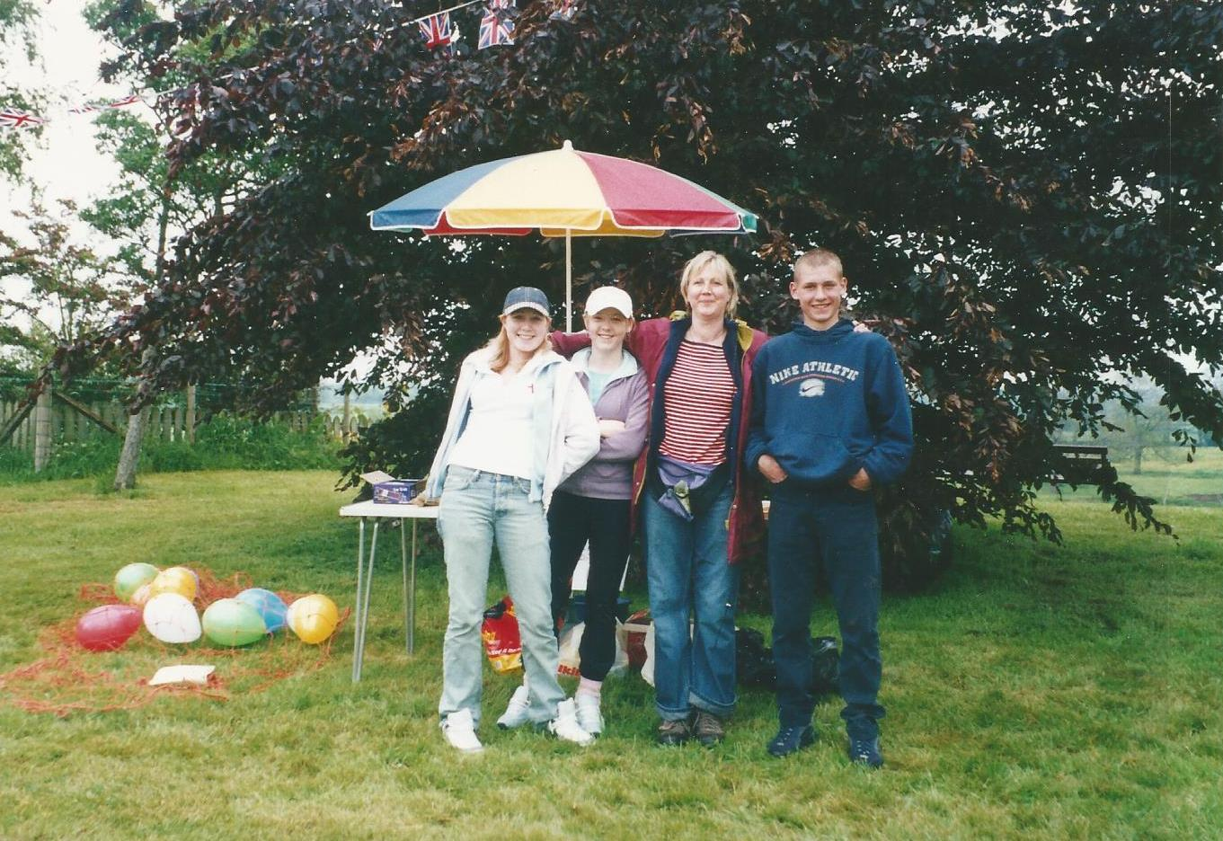

Beth Riley, Amy Hapin, Corrine Riley. Aaron

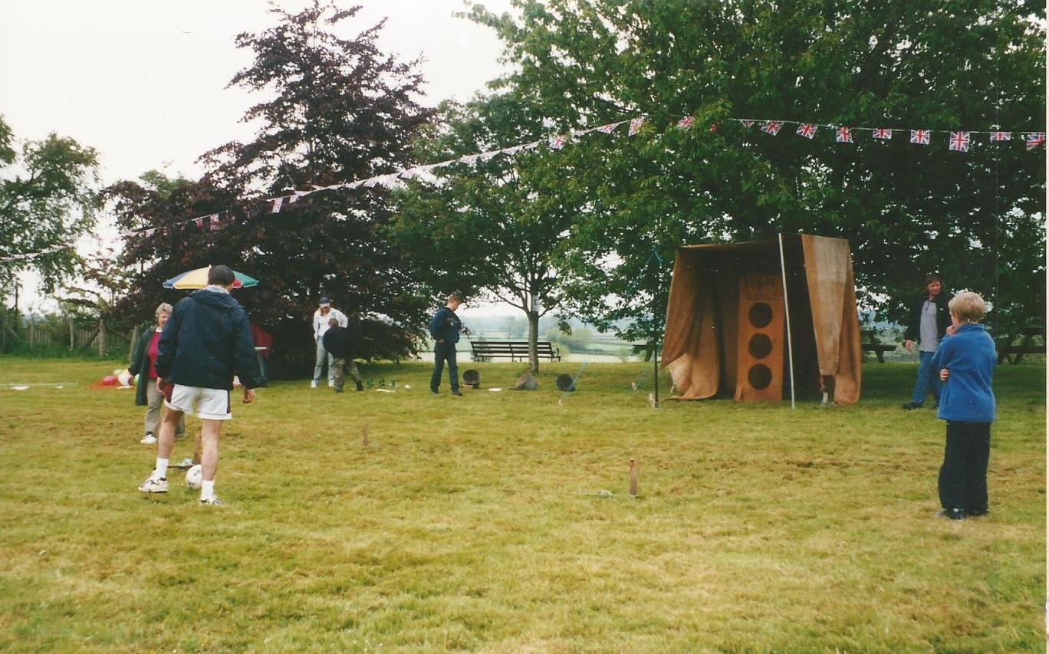
“Beat the goalie” with Rona Salkeld possibly thinking of having a go.

