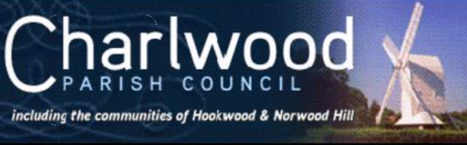 | Locum Clerk to the Parish Council:  Mrs Claire Minter  Email: Clerk@charlwoodparishcouncil.gov.uk

CHARLWOOD PARISH COUNCIL - AGENDA

Councillors of Charlwood Parish Council are summoned to attend the
meeting to be held on Monday 16 June 2025 at 7.30pm at Charlwood Pavilion

Signed: Claire Minter, Locum Clerk to Charlwood Parish Council, 10 June 2025

To receive apologies for absence

Code of Members' Conduct - Declaration of Interest
To receive disclosure of any changes to Councillor’s Notification of Disclosable Pecuniary & Other Interests Forms and to receive disclosure by Councillors of any Disclosable Pecuniary Interests and/or other interests arising under the Code of Conduct in respect of any items on the agenda.

Public Notices
- Planning working Group – Tuesday 1 July – 7.30pm, Charlwood Pavillion
- Services & Amenities Committee Meeting – Wednesday 2 July -5pm, Charlwood Pavilion
- Parish Council Meeting – Monday 21 July - 7.30pm, Hookwood Memorial Hall
- Period for exercise of public rights to review the unaudited annual governance and accountability return and accounts for the financial year ending 31 March 2025 from Friday 20 June until Thursday 31 July 2025
- To note and approve new meeting date changed from 15 to 22 September 2025
Public Session (a maximum of 15 minutes)
- To answer any questions from residents within Charlwood Parish Council in accordance with Standing Orders

Acceptance of Last Minutes of annual council meeting and EGM on 3/6/25
- To approve and sign the minutes of the annual council meeting held on 19 May 2025.
- To approve and sign the minutes of the EGM meeting held on 3 June 2025

Planning Highways and Environment
- To approve output from planning meeting on 3/6/25
- To note response submitted on LGW DCO expansion and agree if any action required
- To review update with neighbourhood plan progression and agree action and costs

Services and Amenities
- To approve and sign the minutes of the meeting held on 4/6/25 and agree actions contained within
- To receive new updates since committee meeting and agree if any action required including purchase of new fridge for pavilion, repair to bench in Hookwood and sandbanding for football pitch

Finance Matters – Charlwood Parish Council
- To review and approve the Lists of payments made in May 2025
- To note and approve bank balances for month end May 25
- To note and approve the Internal Audit report carried out 12/6/25
- To review and approve the accounts for the Annual Governance and Accountability Return 2024/25 (AGAR)
- by approving the Annual Governance statement for 2024/25
- by approving the accounting statements for 2024/25
Staffing and Vacancy Update
- To receive update on recruitment process and agree any actions
- To review and agree projects and for council to have a quiet summer to enable new Clerk/ RFO to settle into role

Community Updates
- To review Community Day events and agree if any costs or action required
- To review and approve date for Councillor surgery

Local Government Reorganisation/ Devolution
- To note latest situation and agree if any action to be taken

Meeting/ Training reports from Representatives
To update the Council on key meetings attended in April/ May 2025 and gain agreement on any decision required

Correspondence
To update the Council on key correspondence received in May / June 2025 and gain agreement on any decision required

Clerk Report – see Clerk update
- To review previous minutes and actions and agree if any outstanding matters to be addressed not included in the agenda

Urgent matters at the discretion of the Chair for noting and for inclusion on a future agenda
Please advise Chair prior to the meeting

